

OPRDGrants.org
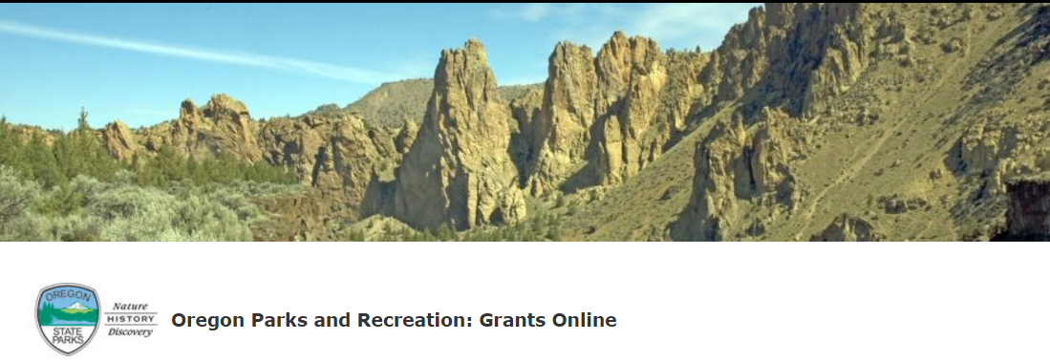
Excellence on Main Awards
Online Application Instructions

Oregon heritage
Oregon Parks and recreation Department
725 Summer Street NE, Suite C
Salem, OR 97301

GENERAL INFORMATION
The following instructions are intended to help applicants navigate the Excellence on Main Awards program online application process. The instructions may not address every possible scenario that could occur, however, you will get the information necessary to navigate the reporting and reimbursement process.
For information on answering actual application questions, please refer to the Oregon Heritage Excellence Award Criteria found here. Contact Kuri Gill at (503) 986-0685 or kuri.gill@oregon.gov with additional questions.
Note: Screen shots and photos within these instructions are samples of what the application process looks like. These shots are from a variety of grant programs and simulated projects. In places where it says “grant” or “grants” this also refers to the awards application. We are using our grants system for the awards nominations process.
SYSTEM REQUIREMENTS
System Requirements: The OPRD Online Grant System requires the following software:
- Browser:
  - Firefox version 17 or higher.
  - Safari version 7 or higher.
  - Chrome latest version.
  - Internet Explorer version 9 or higher. (WARNING: Using Internet Explorer may lead to unsatisfying results. Not all functionality is available in Internet Explorer. To manage grants with a minimum amount of frustration, we suggest you use Chrome, Safari or Firefox browsers. Click on one of these links to download the appropriate browser.)
- Javascript must be turned ON.
- Popup blockers need exceptions for this site.
- If you are not receiving emails from us, please check your spam filters, some filters are intercepting application generated email messages.
Don't know what browser version you are using? The web page fmbip.com will show you which browser and browser version you are currently using.

Contents
GENERAL INFORMATION
SYSTEM REQUIREMENTS
Set up and access your OPRDGrants.org account 1
access application 5
Complete application 7
Submitapplication 14
application status 16
application tips & troubleshooting 17

Set up and access your OPRDGrants.org account

request an account

Important: It is recommended that you request an account as soon as possible. Do not wait until the last minute to request an account or to begin filling out the application. Staff must review and approve your account request before you can access the online application. Requests will typically be reviewed within 3 business days.

- Qualified applicants can request an account by clicking on the Applying tab or ‘this link’.

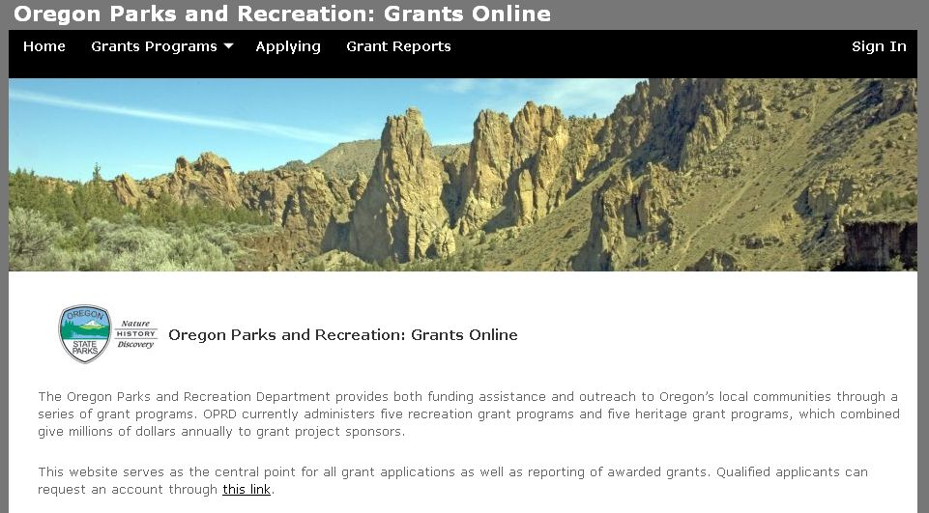
Request an Account Here

- You will then be directed to the Grant System Account Request page.

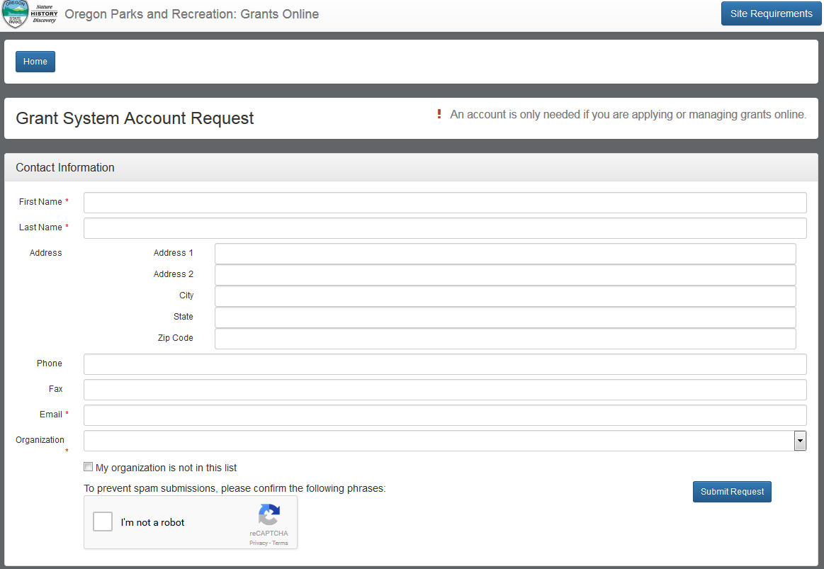
- Enter your name and contact information. Be sure your email is correct as all correspondence and access is through this email address.

- Select your organization from the list. If your organization does not appear in the list, click the ‘My organization is not in this list’ box. If you do not want to submit under an organization you can select ‘Private’ from the options. Check the box for the Heritage Grants.

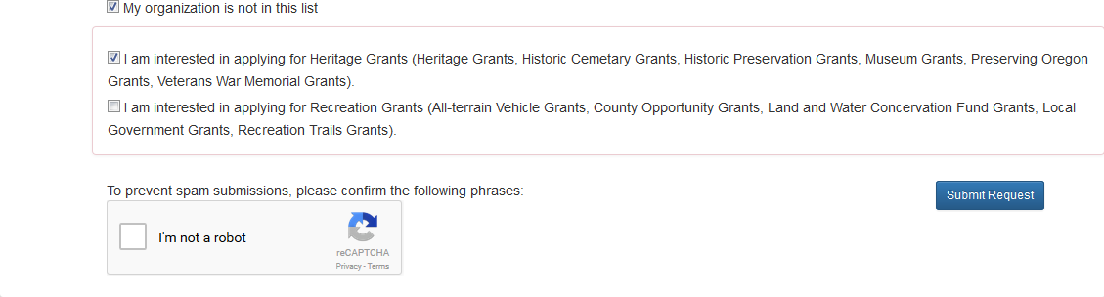
- At the bottom of the screen, check the ‘I’m not a robot’ box

- Click the ‘submit request’ button.

- You will receive a confirmation e-mail from OPRD RecGrants once your request has been processed. Be sure to check you spam or junk folder if you do not see the email.
If you are approved for an account, this e-mail will include a link which will direct you to set your password. Note: This link is only available for a limited time. When you click the link a pop-up box will appear to enter your password. If this doesn’t occur, you may need to turn off your pop up blocker.
If the email you receive does not work for you, click ‘forgot password’ to get a new email sent to you. If you cannot set up your password, contact the coordinator.
Once you have set your password you may begin work on a grant application.

log in (After account is established)

- Visit the Oregon Parks and Recreation: Grants Online site at https://oprdgrants.org/ and click “Sign In” in the upper right hand corner of the page. This will take you to the Grant System Login.

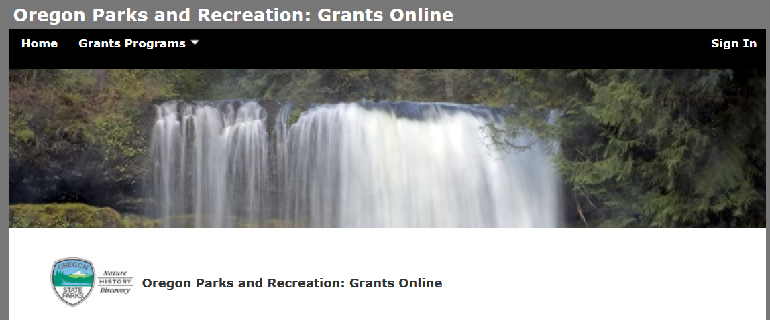

- Enter the same username (your email address) and password used when accessing grant applications.

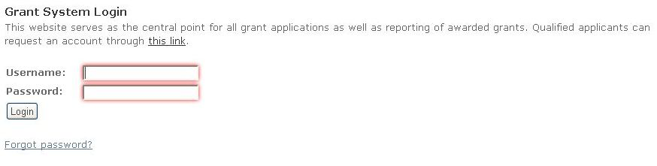

- Once logged in you will be at the Home Page and see:
  - Any organizations you are associated with – most have only one.
  - New applications available for programs with open grant cycles – if any.
  - Panels for all Applications, Projects (awarded grants) and People associated with your organization.
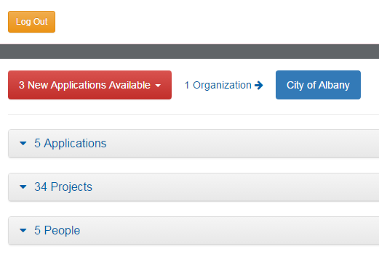
Note: All People associated with your organization can access all applications and projects.

access application
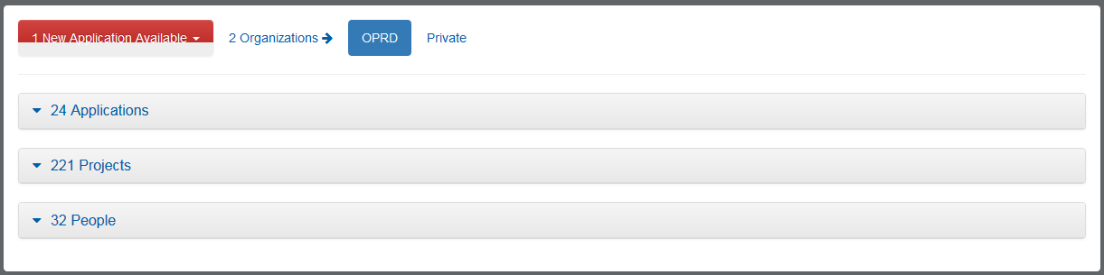
- If you are associated in OPRD Grants Online with more than one organization, then those appear next to the red button.

- If you are associated with more than one organization, select the organization that you are representing for this application. The numbers of available applications may change based on the eligibility requirements of each grant program. If you would like to know more about eligibility or to update your organization’s eligibility for a program, contact the grant coordinator.

- If you are applying as an individual select ‘private’.

- Select the red button to see a drop down menu of available applications. Click on the application you would like to submit. An open application will now appear in your applications tab. You will notice the number change. Choose HAD – Excellence on Main Awards.
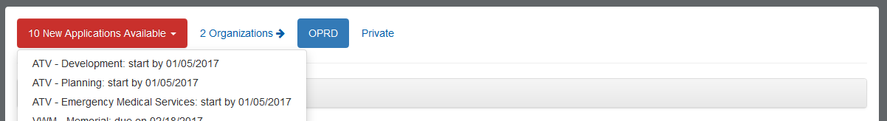
- Click ‘## Applications’ section to see the list of applications and their status. Your new application will appear.
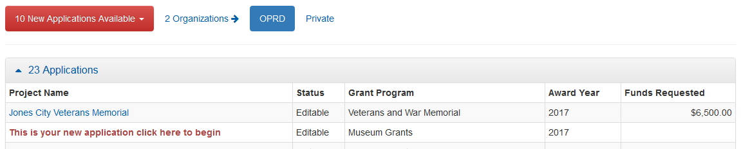
- Select the application anywhere in the text of the project name field to open your application.
- Once you have started an application always open the application through the applications tab, unless you want to create a new application. You may open and close the application as many times as you would like until you submit the application.

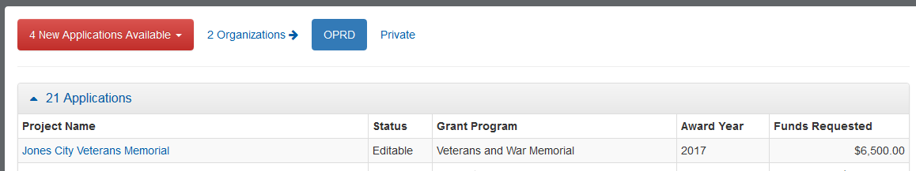

Complete application
- Once you open your application you will be at the Grant Application Page and see:
  - The application number
  - The application type
  - The ‘Edit’ button
  - The ‘Delete Application’ button. Only click this button if you want to completely delete the application, it cannot be recovered. If you accidentally create a new application you do not want to use, please delete it.
  - Project Information section
  - Contact Information section
EDIT button - Needs to be selected every time you want to enter information
  - Supplemental Information section
  - Required Attachments section

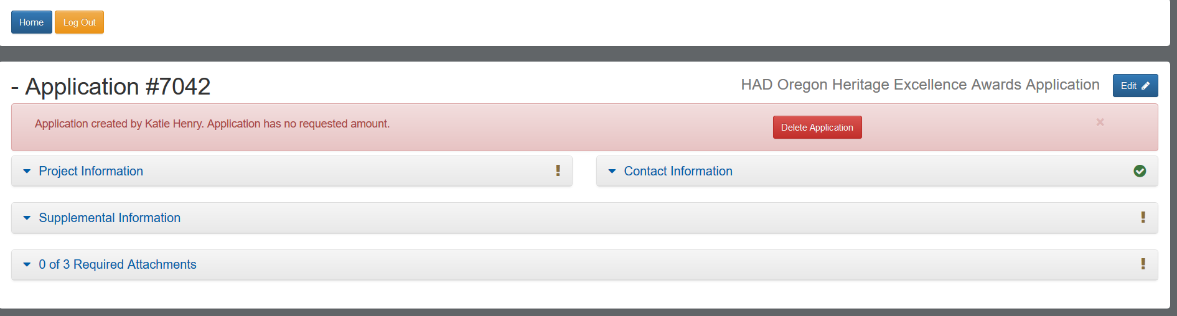

- Select the ‘edit’ button (upper right corner) every time you want to enter information.

- Select each category to enter information into the application.

- Select each section title to expand or contract the section view.

- Items that have a red asterisk are required fields.

- Select ‘Save Application’ as you complete work. This button only appears when in edit mode. You will need to select ‘Edit’ to continue working after saving.

project information
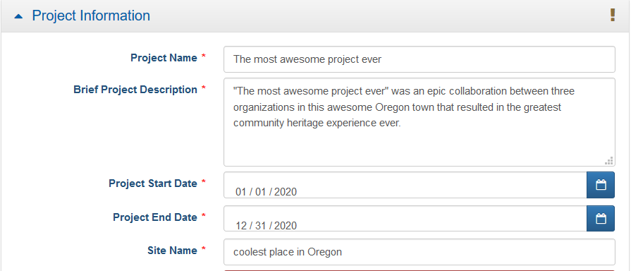
- Project Name: this is the name of the project, organization, or person being nominated

- Brief Project Description: Please keep this brief.

- Project Start and End Date: For the awards, projects should be between 7/1/20 – 6/30/21.

- Site Name: Use the site or community associated with the project, organization, or person being nominated.

- Site City/Town/Area – The location where your organization is located.

- Site County – The County where you or your organization is located.

- Site Description – Put ‘1’ for this

- Site Acreage – The system will only accept round numbers, use ‘1’.

- Latitude and Longitude – You must the system to fill in the Latitude and Longitude using the ‘Find Lat/Lng’ button.
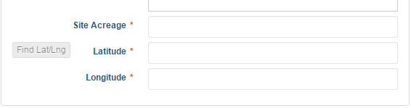
- Click the ‘Find Lat/Lng’ button.
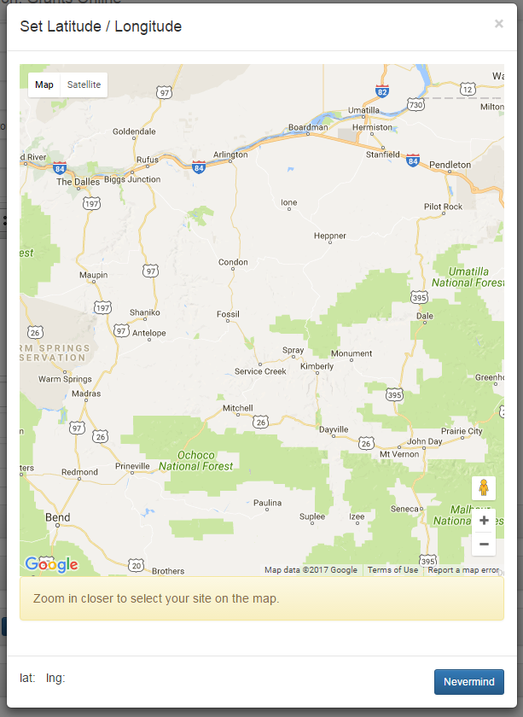
- The map button will pop up. You may need to scroll down to see the instructions and the buttons.
- When you move your mouse to the map, it will turn into a hand. When you click you can drag the map around. Drag the map until your location is in the center. Then click the to zoom in. You may need to zoom in many, many times. Each time you zoom, move your location to the middle of the screen.
- When you are zoomed in enough the instruction information background will change to green and the instructions will tell you to click the map on the site. 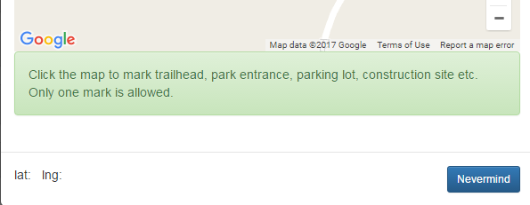

- You will need to double click. A map point will drop. The lat: and lng: fields will fill in and a save button will appear. Click the ‘save’ button and the latitude and longitude will fill in on the application. You will still need to save the entire application to save this information completely.
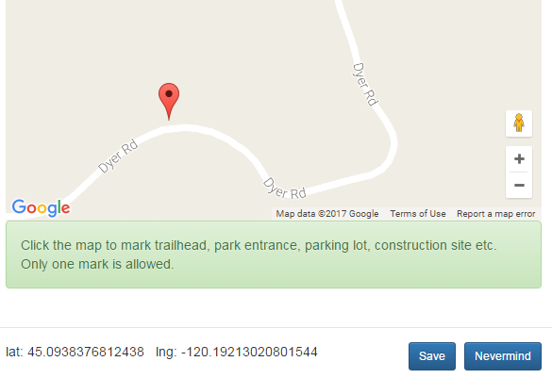

contact information
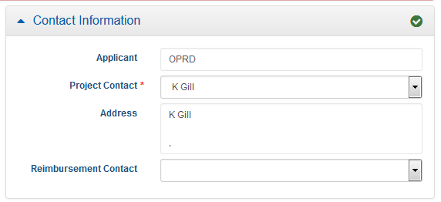
- Enter the project contact as the person who is to be contacted about the results of the nomination. Leave the reimbursement contact blank as there is not a financial process with these applications.

supplemental information

The Supplemental Information section is where a majority of questions in the application are located.
There are several narrative questions in this section. Questions that require a longer narrative response have an expanding box provided. The box will expand as you type until you have completed your response. Brief and concise answers are encouraged.
When preparing narrative answers, you may first prepare, edit and save those answers in another document. You can then cut and paste your answer directly into the application.
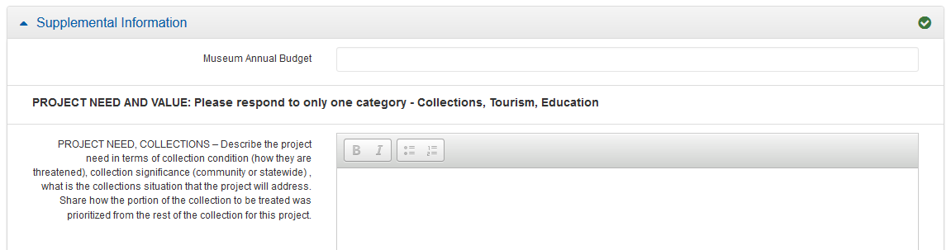

- Select ‘Edit’ in the upper right corner to begin entering or editing information.
- You may save the application as often as you would like by selecting the ‘Save Application’ button. You will need to select ‘Edit’ again to continue working after saving.

Attachments
The Attachments section is where you will upload required supporting documents such as information about the conference, workshop, or training. This includes programs, schedules-at-a-glance, website information, information supporting the receipt of another source of funding such as a conference scholarship. The required documents are listed in this tab and include Letters of Support, Photos, and Additional Attachments. Instructions for attachments:
- After reviewing the list of required attachments, make the items you wish to upload available in a file accessible on your computer. If you need to scan items and save them to a file, do so. Uploaded attachments can be photos, Word documents, spreadsheets, PDFs, etc. Once you have your documents saved to a location of your choice, you may begin to upload document
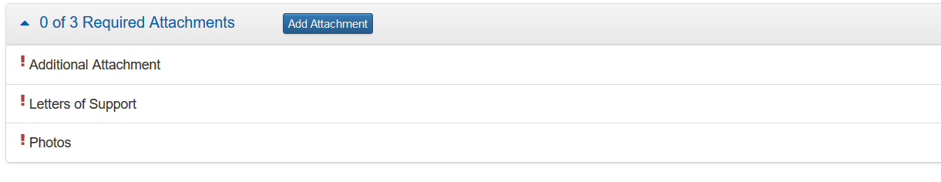
- Select ‘Add Attachment’

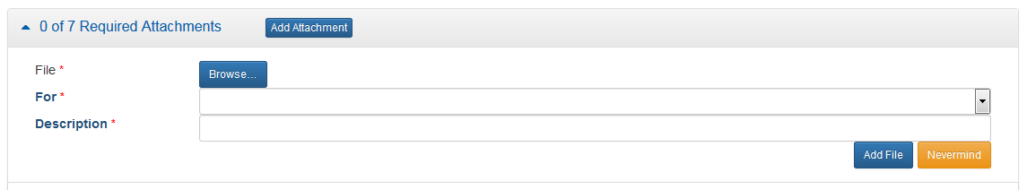
- Select ‘Browse’ to find the file you would like to attach. A window will open to search your device for files.

- Once you select the files. Select to the type of attachment from the ‘For’ drop down. There must be at least one attachment per required file type in the ‘For’ drop down. Enter a short description to explain the attachment. For example, Letter of support from VFW, memorial drawings, site photo, etc.

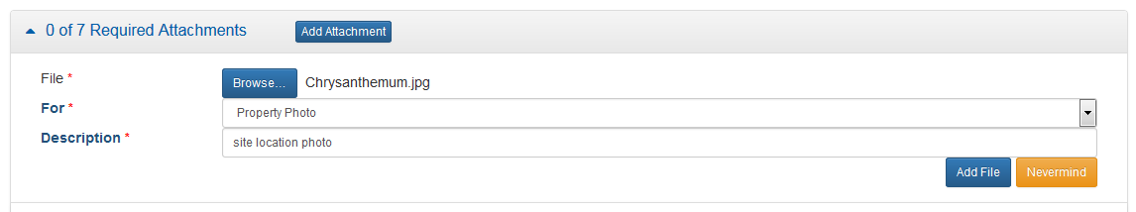
- Select ‘Add File’.

- Once you add a file it will appear in the file type selected.
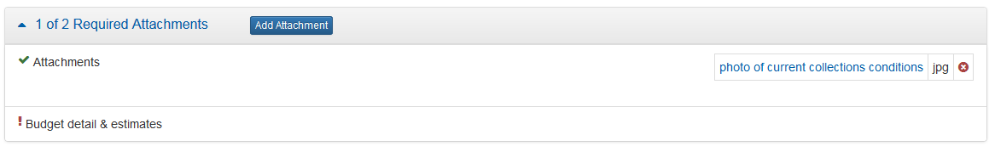
- If you do NOT have any Other – Non-Required Attachments, simply upload a blank place-holder page to fill the position. This will allow you to proceed and submit the application.

Submit application

- Be sure all required fields are complete. Red exclamation points mean there are incomplete required fields. The green check mark means all fields are complete.
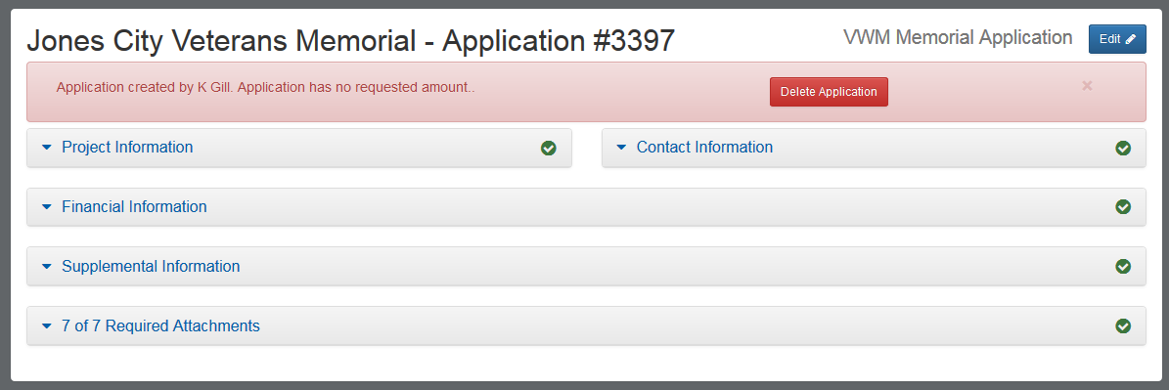
- Select ‘edit’ and then select ‘Submit Application’.

- A window will pop up. If you are ready to submit, check the ‘I agree’ box and select ‘Submit’. You WILL NOT be able to make changes once the application is submitted.

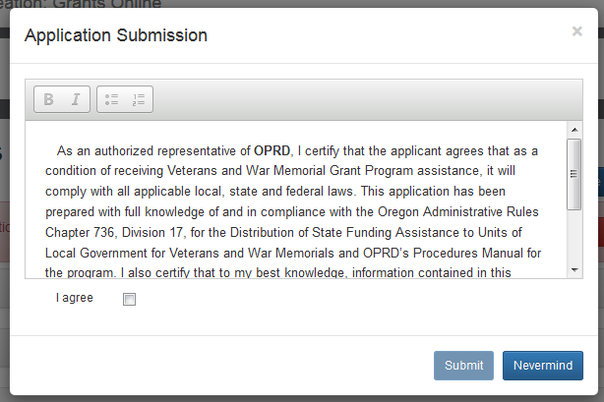
- A window will pop up confirming the application has been submitted. You will also receive an e-mail from oprd.recgrants@state.or.us notifying you that it has been received.
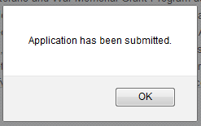
- You application will now have submitted status in your Applications tab. You will not be able to make changes once it is submitted.

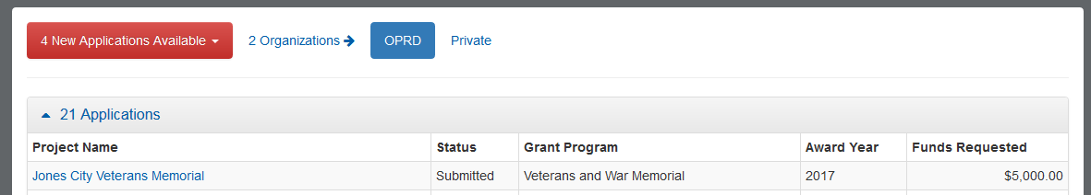
- If you attempt to submit an incomplete application, you will receive a message letting you know which required fields were not filled in or what attachments were not submitted. You must complete all the required fields before your application can be submitted and accepted.

application status

      - You may log on to http://oprdgrants.org/ at any point to check the status of the application. The application status will be one of three depending on where it is in the process.

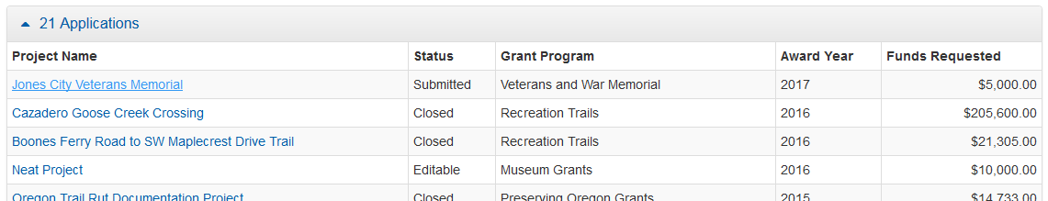
      - The application will be in Editable status while it is still being completed by the applicant and prior to being submitted.

      - Once submitted, the application status will change to Submitted. Please check to make sure the application is in ‘Submitted’ status by the grant application deadline. If the application is not submitted by the deadline, it will be disqualified and will not be considered for funding.

      - Once submitted, OPRD staff will conduct a technical review of the application. If the application is complete and does not require further attention, the status will be changed to Reviewed. When the application is in ‘Reviewed’ status you will not need to do anything unless contacted by OPRD staff.

      - If the application requires updates or changes after staff technical review, you will be contacted via e-mail explaining what changes need to be made. The application status will be changed back from ‘Submitted’ to ‘Editable’ until the updates are reviewed by staff. Staff will work with the applicant until the application is acceptable. After all corrections are approved the status will then be changed to ‘Reviewed’ and you will not need to do anything further unless contacted by OPRD staff.

application tips & troubleshooting

            - Complete as much information as possible in the Project tab before moving on to other parts of the application.

            - Log out of the site if you need to leave your computer for more than half an hour. The system may become unresponsive if you stop working on the application for long periods of time without logging out.

            - Be sure to click Save often while working on the application. You should save your work after completing a couple of questions at a time. You should always save immediately after answering a long narrative question.

            - If you are having problems with the application, check to make sure you are using a browser that meets the system requirements outlined on the first page of these instructions. Sometimes, simply changing browsers will fix a problem.

            - If you are using an acceptable browser and are having problems, try clearing your web browser’s cache. If you do not know how to do this, search your browser’s help menu for “clear cache” or call OPRD Grant Program staff for assistance. After clearing your browser's cache, exit your browser completely before attempting to access the site again. You should periodically clear the cache to allow your browser to function more efficiently.

            - Have needed budgets and documents ready when you log in to begin your application. The application isn’t intended to be a place to work out your budget. This should already be figured out prior to entering it in the application.

            - When preparing narrative answers, it is recommended that you prepare, edit and save those answer in another document. You then can cut and paste your answer into the application. Always save immediately after answering a question that you have put a great deal of time into completing. It is a good idea to double check that your narrative has actually been saved by leaving that tab and coming back to see if the answer is there.

            - If you see a pop up message indicating there was a saving problem, it is likely that your answer did not save correctly. The best thing to do at that point would be to log out, log back in and try again. If you don’t log out first, this could cause more saving problems with the rest of the questions on that tab.

            - It is recommended that you complete the application well before the application deadline date. However, applications will be accepted up until midnight of the deadline date. No applications can be submitted after the deadline.

