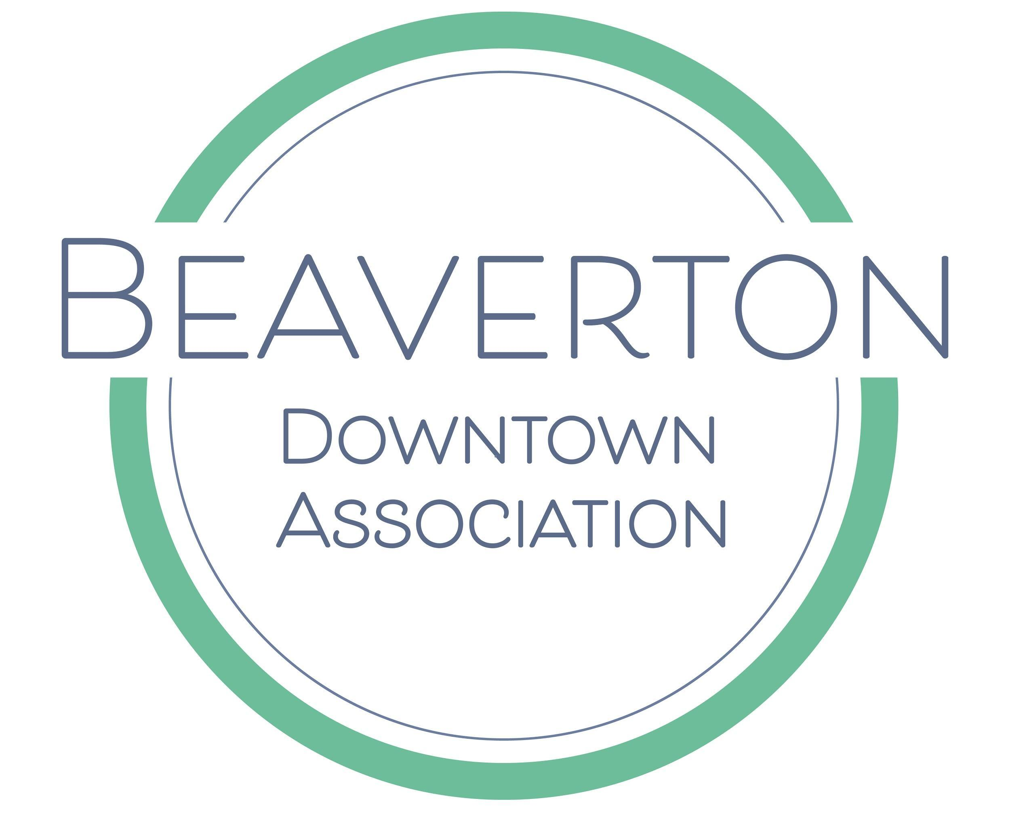
BEAVERTON DOWNTOWN ASSOCIATION
Executive Director Job Description

POSITION TERM: Full-time, exempt, grant-funded position.
SALARY & BENEFITS: $50,000 + insurance stipend (annualized)
WORKING HOURS: Monday through Friday 9am – 6pm but may require some evenings and weekends for committee meetings, city council/local government meetings and BDA events.

OVERVIEW
The Beaverton Downtown Association (BDA) is a nonprofit organization that promotes and supports Downtown Beaverton’s economic, social, and creative vitality through community-driven projects and programs. The BDA seeks a dynamic, motivated Executive Director (ED) to lead the organization’s work promoting Downtown Beaverton and building a thriving downtown stakeholder base. Our current organization has over 50 active volunteers producing four to five events per year.

The ED reports to the BDA’s board of directors, and is responsible for planning, organizing, and directing the daily activities and operations of the BDA, including involvement in the Oregon and National Main Street Programs™, and within the scope of priorities set by the board. The ED represents the BDA on a local and national level and is expected to develop strong working partnerships with other community organizations, businesses, property owners, government, and other downtown stakeholders. The ED works with the board of directors to ensure consistent recruitment and coordination of volunteers, production of successful events and fundraising activities, and oversees financial, operational, and developmental activities.

QUALIFICATIONS
The BDA board seeks a motivated self-starter with a high level of maturity who will proactively build positive, working relationships with a variety of downtown stakeholders. The ideal candidate will be passionate about the mission of the BDA and have experience managing a successful community development and/or economic development initiative. The Executive Director is the sole employee of the BDA and works in close consultation with the board of directors. Normal work hours are weekdays, Monday – Friday, with some nights and weekends expected for activities and events.

The Executive Director is expected to travel to quarterly Oregon Main Street events throughout the state and frequently work in the field visiting business owners and other downtown stakeholders.

The Executive Director develops and maintains administrative systems to keep the board updated on project details, partnerships, and organizational administration.

The Executive Director oversees a budget of approximately $130,000 per year plus any monies related to grants that the BDA advocates for on behalf of downtown Beaverton projects including building rehabilitations.

Applicants should meet these minimum qualifications:
- At least 3 years’ experience managing economic or community development initiatives, or relevant professional experience.
- Proven successful experience in nonprofit administration and/or leadership.
- Outstanding communication skills and the ability to communicate effectively with a wide variety of stakeholders.
- 2+ years’ experience in fundraising and/or grant writing and grant management.
- Experience planning mid to large scale events and/or executing marketing campaigns with a high level of detail.
- 1+ years’ experience directly managing a team of volunteers. Remote volunteer management a plus.
- Established business acumen and developed professional writing skills.
- Intermediate to advanced knowledge of MS Office applications, social media, website content management, and ability to troubleshoot basic IT issues. Familiarity and interest with economic development.
- Experience with the Main Street™ Approach to downtown revitalization preferred.

Beaverton Downtown Associate is an equal opportunity employer. We celebrate diversity and are committed to creating an inclusive environment for all employees.

