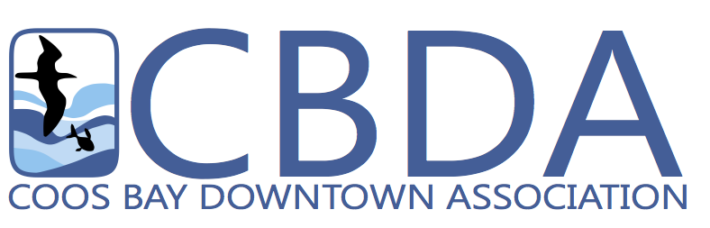
320 Central Ave, Suite 410 • Coos Bay, OR 97420

Phone: (541) 266-9706 • Website: www.coosbaydowntown.org

FOR IMMEDIATE RELEASE

Holly Boardman
541-266-9706
director@coosbaydowntown.org
www.coosbaydowntown.org

REVITALIZATION GRANT AWARDED- COOS BAY

(Coos Bay) Oregon Heritage, a division of Oregon Parks and Recreation Department has awarded a matching Revitalization grant in the amount of $200,000.00 to Corbett Building Investments LLC for work on the 161 Date Avenue building in the Historic Waterfront Heritage Zone in the Front Street District in Coos Bay. The grant will provide matching funds for the rehabilitation of the entire 1930’s building. It will be a mixed used conversion of one large rentable space into four commercial units and two residential units to return the property to a state of utility and preserve the historic integrity of the property. The project will follow and meet the criteria of the U.S. Secretary of the Interior’s standards.

Upon hearing of the award, Heidi Sause of Corbett Building Investments LLC shared her enthusiasm. “By using a model that has successfully earned us recognition from Main Street awards for Best Re-Adaptive Use in 2020 and 2021 this project will add value to the community. We will divide the building’s interior floor plan into more affordable and creative spaces for lease, rather than one large expensive unit. This technique downsizes the economic barriers to entry, attracting new business owners, by lowering their rental overhead. We populate the area with diversity of demographics and quilt together a new neighborhood with more colorful ventures. The new tenants will add to the area, planting the seeds for a vibrant Front Street community. This lot has ample parking for all future tenants, customers and clients on site, without stressing the public parking availability. We are honored to be selected for this award.”

Please join us in celebrating this award at 999 N. Front Street in Coos Bay on Thursday, June 16th at 3:00pm . More information will be coming on a groundbreaking and construction start date.

This project supports the City of Coos Bay’s objective to promote housing and encourage investment in the heart of the City’s Historic Waterfront Heritage Zone. It also highlights the Coos Bay Downtown Association’s advocacy and support for local businesses. Projects like these help those businesses thrive by participating in a vibrant and evolving downtown.

To learn more about The Coos Bay Downtown Association visit www.coosbaydowntown.org and follow us of Facebook. The Coos Bay Downtown Association promotes Coos Bay as an attractive place to live, work, and visit by continually enhancing the quality life of the downtown area.

Oregon Heritage awarded 28 matching grants worth $5,000,000 to Oregon Main Street Network organizations across the state for building projects that encourage economic revitalization. The department funded applications that best conveyed community need and the ability to stimulate private investment and local economic development that best fit within the community’s long-range plan for downtown vitality.

The grant program was created during the 2015 legislative session, and placed with the Oregon State Historic Preservation Office. The legislation established a permanent fund for the Oregon Main Street Revitalization Grant, and provided an initial infusion of funds from the sale of lottery
bonds. The legislature included the Oregon Main Street Revitalization Grant in the lottery bond package approved in 2021. Another round of funding is approved for 2023. The funds must be used to award grants to participating Oregon Main Street Network Organizations to acquire, rehabilitate or construct buildings to facilitate community revitalization. The program also requires that at least 50 percent of the funds go to rural communities as defined by the bill. To learn more about the Oregon Main Street Revitalization Grant or the Oregon Main Street Network, visit www.orgeonheritage.org or contact Kuri Gill at kuri.gill@oregon.gov or 503-986-0685.

###

