Downtown Hillsboro Event Survey Results
Survey time frame: The kickoff of this survey was at the Main Street MeetUp on January 19, 2017. It remained open for five weeks.
Distribution: The survey link was emailed to all Saira’s Hillsboro contacts, posted on Facebook (HDP page and Downtown Hillsboro group), and posted to Nextdoor neighborhoods within two miles of the Civic Center. Paper copies were distributed to various individuals and businesses upon request.
Participants: There were 120 survey responses. Two were removed: one because of vulgarity the second because it was a duplicate. We asked participants to self-identify their affiliation with Downtown Hillsboro. Some selected more than one affiliation.

What were their thoughts on street closures in Downtown?
The inner circle represents the responses of business owners, then moves out to property owners, Hillsboro residents, Downtown workforce, and other, respectively.

Like, because….
...I like the safety to walk in the closed off streets during events.
...they are a great way for people to see the businesses that they drive by all the time.
…they are a minor inconvenience. The current event offering is so important to continue in order to have a healthy and thriving downtown.
… they can increase foot traffic.
…street closures for downtown events make it much more enjoyable for attendees.
…it gives the downtown a safe feel for all and as it is pretty regular, people in the community may start to assume something is going on most weekends.
...I feel that they make the event more enjoyable and safe with crowds.
…limited street closures help accommodate healthy and safe foot traffic to events.
…I like downtown better when the streets are closed.
...I love that it gives us more space and safety for kids.
…street closures are an awesome way to build community by bringing people together outside of their cars.
…it's great when everyone can safely walk around and it's more communal.
...I think downtown should have street closures on a permanent basis -look at the major cities in Europe.
…if we need them to bring business to downtown, let’s do it more.
...I love street closures for community events because I think it helps foster conversations and connections.
...I think 3rd street should be closed as well so that all businesses can benefit.
…it provides a safe environment with plenty of room to walk/get around and helps provide a more relaxed, fun atmosphere.
OK, see benefit/need because…
…they get people to walk around and see more of what's offered.
…it's easy to maneuver around town during closures.
...we are all well aware that MAX is the best way to travel to Downtown.
…people can be free to wander around without impatient drivers who are only looking for a parking spot putting them in danger.
...I don't mind them for special occasions.
…the speed limit DT is slow in the first place, so no big impact.

Ok, if…
…they thought more about the business owner. Programs could be connected with the event to include the businesses, also side streets that encourage attendees to collect prizes, stamps, etc.
… consideration is given to the significant amount of planning and permits involved and coordinating or finding barricades (along with placing them, returning them etc).
…make sure there is enough parking on the side streets.
...they are absolutely necessary.
...notice is given ahead of time. Then it's doable to plan alternative routes. I think there needs to be other notices besides posters on the main roads though.
…just on Main between 1st and 2nd, but try to limit the rest of the closures. I just wish that stalls were in the middle of the street so that they didn't block off storefronts.
... there weren't so many events.
…they allow for alcohol consumption on the streets.
… we try not to schedule too many things at the same time like last year when the farm to table dinner was the same night as the outdoor bag and baggage.
… if we install a two-way street plan. Could leave Main Street a one way. I've lived here 35 years and I hate the present system. I still have trouble negotiating which streets are one way or two way.
…3rd is left open so clients are still able to get to those businesses.
…they are taken down in a timely manner.
...there was a strategy to address getting foot traffic in the dowtown stores when streets are blocked.
…more parking is available.
…there was an improvement to the parking strategy.
...there is adequate redirection and parking.
...they're announced ahead of time and easy to get around.
...parking is readily available.
...local businesses are involved with decisions to close.
...parking was a little easier.
…they make commuity events safer and they are announced in advance with signage at the areas to be closed.
…they are needed for large events and don't close off more than necessary. It looks bad if the space isn't full of vendors or being utilized in another way.
...3rd street is left open. It is very confusing for people and difficult for some businesses when 3rd is closed. It also limits available parking for downtown events.

Don't like because…
…limiting traffic is tough since parking can be frustrating.
...there is far too little parking in the Downtown area to close streets. It prevents some people from reaching the businesses located in the downtown area when events are being held.
...I found it difficult to pick up to-go orders at local restaurants because of the way the streets were closed. A little more consideration to non-event goers that need to access businesses would be nice. I'm sure all could co-exist.
…some businesses who do not benefit from the events, and are even hindered by them.
… street closures hurt my business. I don't mind some but constant street closures will have us looking to relocate outside of Downtown Hillsboro.

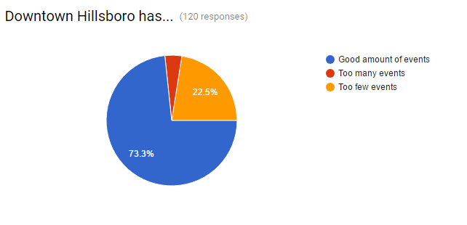

Yes, because…
…they create sense of community
…most all of the events are for families and so important to a healthy downtown.
…the more the better for the businesses.
... there is a good mix of family friendly events as well as cultural pride.
...they engage the community and bring people downtown.
...all of the current events provide something different for different demographics. It's important to uphold every offering -- some are focused on holidays, some are seasonal, and some are traditions that have been longstanding.
…they are well attended and enjoyed.
…the events raise awareness of Downtown.
...I love the block partys.
…they are all hosted at different times during the year and by different organizations.
...art and music touch a person's life and makes it better and thay makes a community better.
…they demonstrate the culture of the city.
...I believe they are right type of events because they are family-oriented. This is long-term what will develop more traffic (memories, shared family interest, repeat visit, next generation, etc) in downtown.
...they are diverse and can include everyone from our community
…I think all the events are splendid.
...I'm a fan of anything that builds community and supports Downtown businesses.
…I believe markets and events like this are essential to building community
…they are the best for locals to buy and sell and meet their neighbors.
...I love love love all the multicultural and family friendly events. I'm so happy living here.
…we love them and it's one of the reasons we love Hillsboro so much!
..we love all the family friendly events. It's one of my favorite aspects of living in Hillsboro.
...the events bring together the community. That should be the goal.
..I believe there is pretty good variety. They also seem to be spread throughout the year which is wonderful.
…they're the ones we go to, so to me, that means they're right!
...I believe they touch a wide range of demographics.
...I think it shows the diversity of the city.

Yes, but…
...we need more vendors to increase public attention.
... it depends on what is trying to be accomplished. The events seem well attended, create a "hometown" feel, give people something to do that is close. If you are looking for events that attract persons in the metro area, diversity, money, new business, - I would say some of the events don't have that effect.
..the focus should be "what type of events get customers in the doors of the businesses". Events such as Tuesday Marketplace or Celebrate Hillsboro, bring a large number of people downtown, but a very small percentage of those people actually go into the shops.
...the event needs to get more customers to eat and shop in Downtown get them to come back to Downtown in the future.
…a lot of them seem like they have the same stuff and vendors.
... I like the variety. I just don't always hear about events in advance.
...some events have a lot of unhealthy food. I would like to see more locally farmed healthy food choices at events. Also can disposable giveaways be banned? Events can demonstrate a level of care for human and the environment by choosing healthy and low-impact ways to celebrate.
…more live music would be great. Events for older crowds, not just family events, would be a great addition, too.
...I would love to see more kid's based events and better advertisements.
…events should draw people from different groups (cultures, ages, interests) together.

No, because…

...something is missing. The events are bringing folks but they are not spending much money. There are no serious events that are sufficient draw for people to spend money (hard to think citizens are just cheap...).
...everything is family this or kid that - nothing for adults to do if they aren't entertaining kids.
…although we do get some sales, for the most part our business does not benefit much from the events.
…most seem to be "family oriented" but not enough for "adults only" i.e. Young couple with no kids or older couples without kids.
…there are lot's of family events. How about more adult type events?
…it seems like a lot of the current events discourage people from entering shops with booths blocking entryways, etc.
...(there are) too many events that close down Main and make it difficult for people to come shop and eat.
…we need more events based on food and drinks - socializing.

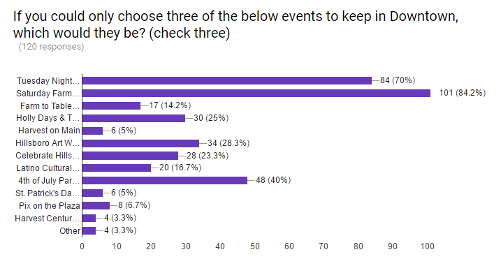

Do you have any other event or campaign ideas to share?
- Carnival (games and fun put on by local businesses)
- Antique event
- Art/wine festvals"
- Drag the gut event (nostalgic car cruising festival)
- Small film
- music events
- Outdoor summer movies that would be entertaining for people without kids"
- Other cultural events to show our diversity.
- Events that support the diversity of the community, supported by the HDP, but with programming from the various communities themselves.
- Car rally (muscle cars),
- Art event (Graffiti On The Street)
- Scavenger hunt
- Amazing race events
- Dog events.
- I would love to see more the Friday evening prior to the Celebrate Hillsboro event.
- Wine and art Festivals
- Antique Fairs
- "adults only" event
- Downtown fair antique
- gift fair
- beer festival
- wine festival
- Health and Wellness events: It could be an evening event where they can do a 30-minute yoga (or other fitness class), get a 20 minute facial, a 30-minute massage and an express mani/pedi!! A night of treating the mind and body well!
- Bring in more music on weekend nights - year round
- Green/environment themed event
- Annual clean up in downtown and adjacent neighborhoods
- Free plays in the plaza.
- Would like to see events like Sunday Parkways in Portland where more streets are closed.
- Would love more buy local campaigns -- like when we had the Waldo or holiday tickets/coupon thing.
- ex. maybe street dances or lot's of tables with board games and food/drink and have a fun night of board games with music
- more street dinners or concerts
- OMSI Science Pub
- Historical tours
- 24-Hour Dance Marathon for Charity.
- Bid on a Basket - people make picnic baskets, they are bid on, and people are encouraged to sit near the fountain or the courthouse lawn and enjoy their picnic while a band plays.
- Knit-A-Thon - Have volunteer knitters (yarn bombers) knit the trees and statues and street lamps of Downtown Hillsboro and encourage the public to join in. It would be an interactive art walk. You could also have a learn to knit/crochet station, themed vendors that sell amigurumi (knit/crochet) stuffed animals, scarves, etc.
- Spring Cleaning Event - Encourage people to bring their unwanted but good condition clothes to donate to homeless youth, teen mothers, and/or battered women's services.
- October Harvest Festival - Pumpkin carving station, cookie decorating, hay bale maze, scare crow competition, and ask the Pie Guy there because Pie and Harvest Fests just go together. "
- Celebrate Hillsboro is already part of a Saturday Market, so there is not an additional street closure involved. Might it be possible to have the Celebrate Hillsboro concept become multicultural and include Latino, Asian, and other cultures now represented in our community?
- How about something like Hillsboro Stories. All year long. Record people's stories like StoryCorps does. Archive the stories. Various events around this. People talking and telling their stories!
- A count down for New Years...I was in Boise this past New Years and watched a potato drop during the count down! Over 9,000 people attended! We should have a Hop Drop as a count down! Something fun the entire family can enjoy.
- Let's bring back Western Days! :) This was a three-day event years ago in which all merchants had sidewalk sales and each offered a different raffle prize. People had to go into each business and drop off their entry ticket for a chance at the prize. It was so much fun when I was a kid!
- Antique fair/ flea market on 3rd
- I think we should identify multiple charities or organizations that help people in need. Then one or two weekends a month list 5 of those groups that the businesses will give a percent to. That way we hit multiple groups of people that want to give. We could either let people pick the organization or do a even split. I think it would be a good opportunity for those groups to have volunteers or pamphlets available speaking about their organization and possible volunteer opportunities. It would be nice if the city or another organization could match or put up door prizes for the 15th customer of a business or something in that manner.
- Historical event

