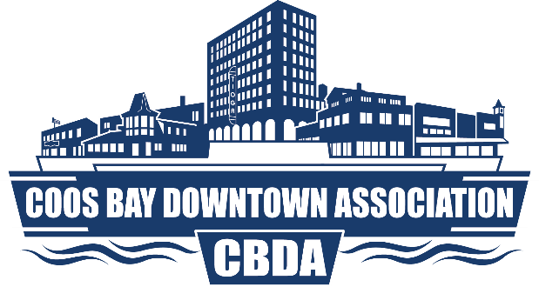
320 Central Ave, Suite 410 • Coos Bay, OR 97420

Phone: (541) 266-9706 • Website: www.coosbaydowntown.com

JOB ANNOUNCEMENT

POSITION: MAINSTREET MANAGER
STATUS: FULL TIME
SALRAY RANGE: $45000 TO $60000. Bonus incentives and benefit package discussed at time of interview.

The Coos Bay Downtown Association (CBDA) is seeking a new Mainstreet Manager to assist this non-profit organization grow and improve downtown Coos Bay. We are looking for someone who has a passion for small business development, who believes in the strengths of this community and has the skills to help downtown Coos Bay flourish.

Qualifications:
- Have significant administrative and volunteer management experience in a nonprofit setting and have experience working with a volunteer board. (Background with a Main Street program is a definite plus.)
- Have demonstrated experience building and managing budgets and overseeing financial systems.
- Be a self-start who is entrepreneurial, imaginative, and well organized, and capable of functioning effectively in an independent environment.
- Have experience working with local government agencies, media outlets, and business support organizations.
- Have the knowledge and experience to manage a large public market.
- Have the demonstrated ability to motivate people and coordinate activities in a volunteer-run organization.
- Have the ability to manage staff.
- Exhibit excellent written and verbal communication skills.
- Have knowledge of and sensitivity to issues confronting small businesses.
- Possess strong computer skills and experience with Microsoft Office and managing a database; and experience managing websites and social media channels.
- Have the ability to work a flexible schedule, including nights and weekends as required.
- Grant writing experience preferred.

To Apply:
Applications for this position will be processed through Cardinal Services (http://www.cardinalservices.com/) under “CBDA Mainstreet Manager”. Please submit a letter of interest, resume and contact information for three professional references by 5:00pm December 22, 2023. The letter of interest should reflect your communication skills, experience, values and passion for downtown Coos Bay, and your interest in the mission and projects of CBDA. Candidates should also come prepared with a 6-month vision of Downtown Coos Bay.

Qualified candidates will be contacted for interviews the week of December 26th – 29th.
To learn more about the CBDA, please visit http://coosbaydowntown.com

