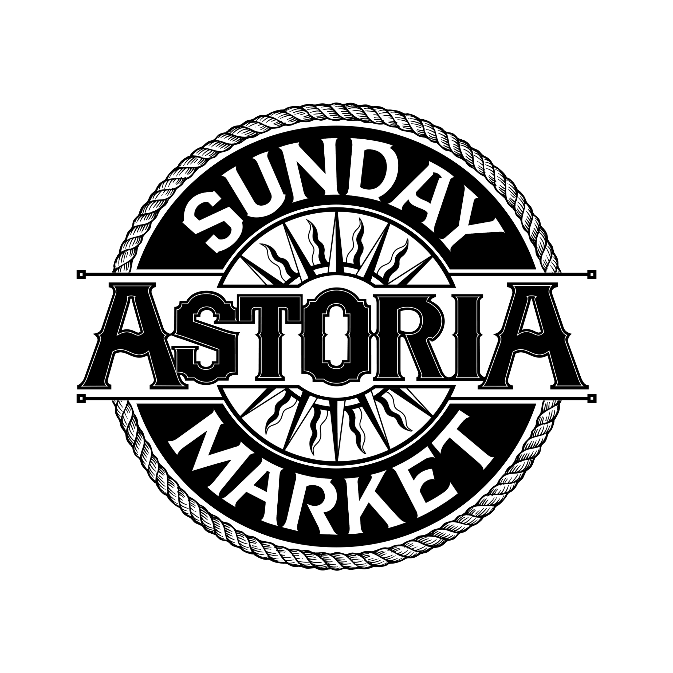
MUSICIAN CONFIRMATION 2023
This notice confirms your scheduled performance at the Astoria Sunday Market Stage. Please review the procedures below and fill in your contact and music set-up information. Return form to Tamara at tamara@astoriadowntown.com with your information filled into blanks. Questions about booking? Contact Misty at tamara@astoriadowntown.com or (503) 440-7168. Questions about sound? Contact Nyklus at astoriateacompany@gmail.com or (503) 791-8983.

To get your bio in ASM’s Market Guide, please return by April 10th. Otherwise, please return ASAP.

Band Name: X

Payment: X

Performance Date: Sunday, date

BAND CONTACT INFORMATION
Please complete and return by email or postal mail ASAP

Band Name (as you would like to see it in print):

Band Contact :

Mailing Address:

Phone:

Email:

Website:

Band Bio + 1 photo (50 words max.): *can also send via email if easier*

Check made to:

Band fees are paid at the end of the Market day starting at 3 pm. Check can be picked up with Market Manager, Misty at the end of market day. Likely found at the info booth.

Entertainment Rules and Regulations

Time: 9:30-10:00 am Move-in (see parking note)

10 – 11 Recorded music

11 – 3 pm Live Performance begins

3 pm Market ends – please do not play beyond 3 pm.

Breaks: Varies Performers manage their own break
schedule. We encourage all bands to play recorded music during their breaks and to be live as much as possible during the market day.

Sales: Allowed, Band merchandise sales are encouraged.

Location: Wells Fargo Bank Parking lot located at 12th and Marine

The band sets-up under the drive-through teller area. Paul St. James is the Food Court Manager and is on-hand to answer questions. Nyklus Stephens will be managing sound on site at the market. Contact Nyklus with more technical music questions, astoriateacompany@gmail.com, (503) 791-8983. Or call Tamara at 503-440-7168.

Parking
One large or two small load-in vehicles can remain on-site parked against the back wall by stage; other band vehicles must be off the premises by 10 am.

Electrical
Provided

NEW! Band Sound Kit
Astoria Sunday Market 2023 will have its own sound equipment and a designated live sound technician. Please fill out information at bottom of page so he will be ready to work with you. If you’d prefer to run your own sound or portions of your sound, please contact Nyklus at astoriateacompany@gmail.com.

Notes from the Sound Technician
Contact: Nyklus Stephens, astoriateacompany@gmail.com, (503) 791-8983
From Nyklus–I'm here to bring you your ideal performance scenario. I'd like to work with you to help create the performance you’d like to have. I don't intend to take any creative control away from the artists. If you’d prefer to use your own equipment or run your own sound, just let us know in this contract and we are happy to work with your needs.

Sunday Market Music Setup Information Survey (Please fill in blanks below)
How many members of your group?:

How many on stage microphones will you be needing?:

Do you have a drummer?:

How many Amplifiers with Direct Out would you like to be running into the DI box?:

How many are XLR and how many are line outputs?:

Would you like any amplifiers mic’d?:

How many Instruments would you like to run Directly to the DI box?:

How many are XLR and how many are line outputs?:

Any more notes for sound person?:

Please complete and return this form via email, or if need be via mail to:

Mail Astoria Sunday Market
P.O. Box 261
Astoria, OR 97103

Email tamara@astoriadowntown.com
Phone 503-440-7168
Contact Tamara Cameron, Market Manager

Once read and understood, please sign & date:

____________________________________________ _________________

