

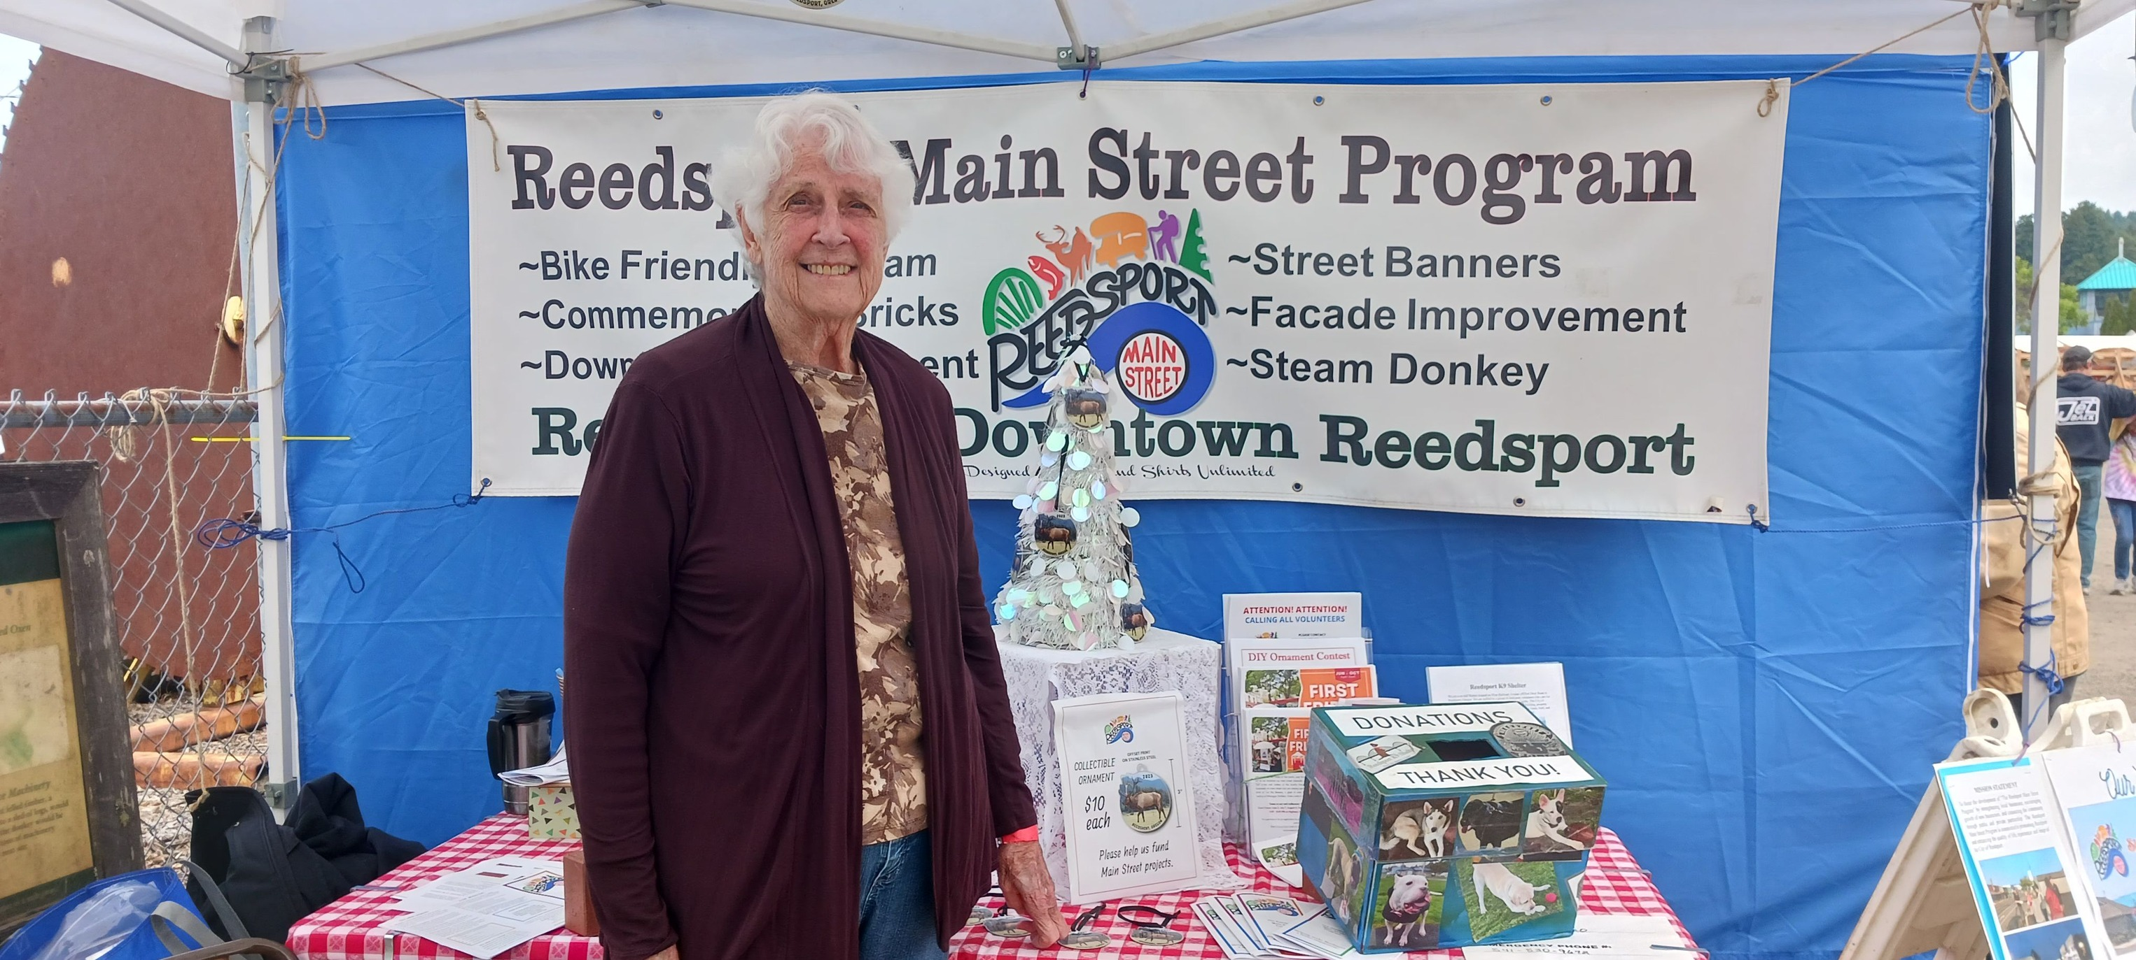

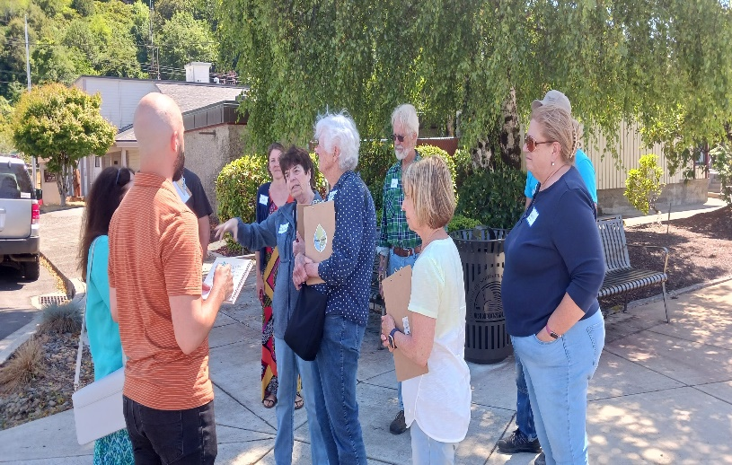

Board of Directors

Information Packet & Application

Reedsport Main Street Program

451 Winchester Avenue

Reedsport, OR 97467

(541) 271-3603 ext. 1008

mainstreet@cityofreedsport.org

About RMSP

The Reedsport Main Street Program (RMSP) is under the umbrella of the City of Reedsport and an affiliate of the National Main Street and Oregon Main Street programs. Among many principles, RMSP believes in downtown revitalization, historic preservation, shopping local and supporting the small businesses that are the cornerstone of our community.

Every day, we advocate on behalf of not only the downtown merchants, but the community as a whole, to ensure our community’s rich history is preserved and future generations are proud to call Reedsport home. Since 2017, RMSP has generated over $664 thousand in grant funding - all of which has been used to advocate for, enhance, and preserve our downtown.

As we work towards revitalization of our downtown, RMSP has been collaborating with other organizations to increase support for our community. In 2023, we started the First Friday Vendor Market to support our community businesses, along with homebased entrepreneurs. We have engaged volunteers to help with our events and activities. In addition, we were recognized with the Excellence on Main award for our efforts in communicating our mission to the community. We invite you to join us in our revitalization efforts! Are you ready to get involved?

Board Member Position Summary

Attends RMSP board meetings on the third Tuesday of every month and contributes ideas to better support and enhance downtown Reedsport. Also, attends regular RMSP functions and events as a volunteer and/or to represent the organization.

Participates as a member of at least one of RMSP’s committees.

Advocates on behalf of Downtown businesses in matters of economic development, Downtown design, historic preservation, and marketing/promotion.

Communicates the good work and value of RMSP to coworkers, community leaders, and other stakeholders to grow support for the organization.

Represents the interests of Downtown in the community and within other organizations.

Supports the organization’s finances and budget.

Works closely with the Main Street Director to help enhance RMSP’s projects.

Board Application and Selection

Board members are elected by RMSP’s board of directors. RMSP is comprised of nine Board

Members who serve three-year terms. Board members may be appointed or reelected to additional terms.

The Ideal Candidate

The ideal candidate:

• Possesses strong interpersonal and leadership qualities.

• Is well-connected, and has access to a network that will support and promote the work of RMSP.

• Supports inclusivity and diversity within RMSP’s board and within Downtown in general.

• Possesses a comprehensive skillset that will lend something unique to the organization.

• Has prior experience in economic development, historic preservation, or marketing/promotion

Reedsport Main Street Program

451 Winchester Avenue

Reedsport, OR 97467

(541) 271-3603 ext. 1008

**Reedsport Main Street Program - Board Member Application**

PROFILE

Applicant Name: ________________________ Organization: __________________________

Phone Number: _________________________ Email: ________________________________

Mailing Address: ______________________________ City: ________ State: _____ Zip: _____

Website: _______________________________ Business Facebook:_____________________

Please fill out this application if you wish to be considered for an appointment to a vacancy on the RMSP Board. Completion of this application does not guarantee appointment to a volunteer position with RMSP nor candidacy. Your application will be reviewed by existing Directors, after which you will be contacted to discuss next steps.

RMSP Board seeks to be representative of the community by including diverse business leaders, geographic and demographic representation, skills, and other forms of diversity.

**EXPERIENCE** *(use a blank page if necessary)*

Describe your business/organization:

List any boards committees you have served on or currently serve on and role in the organization:

What is your experience in leadership?

In which areas of industry and community do you have influence and connections?

Check all that apply

□ Arts & Culture □ Media □ Corporate □ Diverse Communities

□ Health Fields □ Political □Education (K-12) □ Higher Education (College +)

□ Small Business □ Social Services □ Technology Industries □ Other: _____________

Please describe any of the areas you checked in prior section.

Examples: network connections, role in an organization, etc.

In which areas do you have experience? (Check all that apply)

□ Capital campaigns □ Community engagement □ Creative industries

□ Database management □ Economic development □ Education (formal)

□ Education (informal) □ Entrepreneurship □ Event coordination

□ Finance □ Fundraising □ Government

□ Grant writing □ Human Resources □ Legal

□ Marketing & PR □ Nonprofit governance □ Outreach

□ Public speaking □ Real estate □ Social services

□ Sponsorship solicitation □ Strategic planning □ Sustainability/Environment

□ Technology □ Tourism □ Volunteer coordination

□ Other: _______________________________________________________________

Explain your motivation/intent to serve on the RMSP Board:

In addition to attending board meetings, how will you contribute to the RMSP?

What do you hope to achieve while serving on RMSP’s Board?

**COMMITTEES**

It is recommended that Directors serve in a secondary capacity within the organization. In which role(s) might you be interested in serving?

□ Organization/Development Chair □ Promotion/Marketing/Events Chair

□ Economic Revitalization Chair □ Downtown Design Chair

□ President of the Board □ Vice President of the Board

□ Secretary of the Board □ Treasurer of the Board

□ Other: _____________________________________________________________

Please share anything else you would like us to know about you.

**RMSP Board Candidate Agreement**

I request my name be submitted for consideration for possible election to the *Reedsport Main Street Program* board of directors. If elected, I agree to do the following:

1. Attend all regular board meetings held on the third Tuesday of every month and special meetings as deemed necessary
2. Attend RMSP monthly meetings as often as available
3. Attend Oregon Main Street Board Forum (offered twice per year)
4. Attend the RMSP Annual Community Open House
5. Support RMSP and downtown events through volunteering, promotion, and attendance. Events include; Vendor Markets, DIY Ornament Contest, Small Business Saturday, and Holiday Tree Lighting
6. Actively participate in at least one RMSP committee
7. Maintain the strictest of confidentiality as it pertains to RMSP business
8. Will not act as a spokesperson for RMSP unless authorized by the Main Street Director and/or the RMSP Executive Board
9. Will support RMSP in the endeavor of securing grant funding since a portion of RMSP’s budget comes from grants.
10. Positively represent RMSP in the community
11. Support the development of RMSP through a direct or indirect financial or other contribution (contribute yourself, recruit a member or sponsor, cultivate a donor relationship, etc.)

*Signature verifies that the applicant understands this application and all information is true and correct.*

_______________________________ ____________________________

Signature Date

_______________________________

Name (please print)