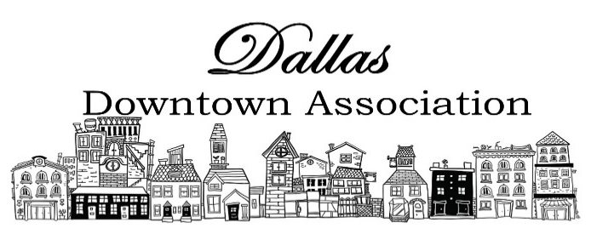
Employment Agreement

This Agreement is made between the Dallas Downtown Association, herein referred to as the DDA, and _______________________________________________________(employee name), herein referred to as the Employee.

- Employment; Hours of Work
DDA hereby employs Employee as _________________________ (insert job title) and Employee agrees to serve in that capacity according to the terms and conditions set forth in this Agreement. This is an Agreement for __________________________ (full-time, temporary, or part-time) employment. Work in excess of an average of _____________ (seventy (70) or 173.33) hours per month shall be deemed part of the professional responsibility for which Employee shall not be paid overtime, but for which Employee shall be allowed to offset, in part, by taking time off, subject to DDA’s approval, so long as Employee continues to fulfill Employee’s obligations to DDA under this Agreement. Review the DDA Policy & Procedure Manual for benefit eligibility.
- Term
This Agreement will commence on _________________, _______, and will continue until terminated by either party as provided herein.

- Services to Be Performed
Employee agrees to perform the following services:
- Manage daily operations and management of the DDA.
- Establish and maintain rapport with business owners, downtown stakeholders, elected officials, and developers to accomplish the established goals of the DDA. Avoid community schisms and appear as neutral as possible.
- Work to retain and increase DDA memberships
- Work in coordination and be a resource for board of directors and committees
- Work in concert with the City of Dallas, Chamber of Commerce, Urban Renewal District, and any other community organizations.
- Coordinate volunteers among events and various work projects. Track volunteer hours. Recruit and manage new volunteers, create recruiting materials, and work plans.
- Manage social media accounts including Facebook page, Instagram, DDA website, and any other emergent media the DDA decides to use.
- Maintain a quarterly newsletter to update members on DDA projects, new members, events, community information, etc.
- Complete required organizational paperwork, including quarterly reports to Oregon Main Street and City of Dallas.
- Attend city and county meetings, networking events, tourism meetings, and summits, and other training sessions deemed appropriate
- Work with board treasurer to ensure all financials and debts are current
- Work with board secretary to communicate board and general membership meetings
- Other duties as assigned
- Employee will report to the President. The two will meet and the Employee will provide activity report. The meeting will enable the Employee to report on work from the previous week, and for the President to set priorities for the coming week.

- Payment
the DDA agrees to pay the Employee the sum of $____________ per month, payable on the ______ day of each month, plus a ________ ($50) phone allowance.

- Business Licenses, Permits, and Certificates
Employee represents and warrants that they will comply with all federal, state, and local laws requiring drivers and other licenses, permits, and certificates required to carry out the services to be performed under this Agreement.

- Termination; At-will Employment
This is an Agreement for at-will employment. Either party may terminate this Agreement for no cause. If Employee terminates this Agreement, Employee will exercise their best efforts to give DDA at least 14 days’ notice in advance.

- Modifying the Agreement
This Agreement may be modified only by a writing signed by both parties.

- Confidentiality
Employee acknowledges that it will be necessary for the DDA to disclose certain confidential and proprietary information to Employee for Employee to perform duties under this Agreement. Employee acknowledges that disclosure to a third party or misuse of this proprietary or confidential information would irreparably harm the DDA. Accordingly, Employee will not disclose or use, either during or after the term of this Agreement, any proprietary or confidential information of the DDA without the DDA's prior written permission except to the extent necessary to perform services on the DDA's behalf.
Proprietary or confidential information includes:
- the written, printed, graphic, or electronically recorded materials furnished by the DDA for Employee to use
- any written or tangible information stamped “confidential,” “proprietary,” or with a similar legend, or any information that the DDA makes reasonable efforts to maintain the secrecy of
- business or marketing plans or strategies, customer lists, operating procedures, know-how and processes, computer programs and inventories, discoveries, and improvements of any kind, sales projections, and pricing information
- information belonging to customers and suppliers of the DDA about whom Employee gained knowledge because of Employee's services to the DDA.
- Upon termination of Employee's employment with the DDA, or at the DDA's request, Employee shall deliver to the DDA all materials, and equipment, in Employee's possession relating to the DDA's business.

- Proprietary Information.
- The product of all work performed under this Agreement (“Work Product”), including without limitation all notes, reports, documentation, drawings, computer programs, inventions, creations, works, devices, models, work-in-progress and deliverables will be the sole property of the DDA, and Employee hereby assigns to the DDA all right, title and interest therein, including but not limited to all audiovisual, literary, moral rights and other copyrights, patent rights, trade secret rights and other proprietary rights therein. Employee retains no right to use the Work Product and agrees not to challenge the validity of the DDA’s ownership in the Work Product.

- Employee hereby assigns to the DDA all right, title, and interest in any and all photographic images and videos or audio recordings made for the DDA during Employee’s work for them, including, but not limited to, any royalties, proceeds, or other benefits derived from such photographs or recordings.

- Applicable Law
This Agreement will be governed by the laws of the State of Oregon

- Equipment Received

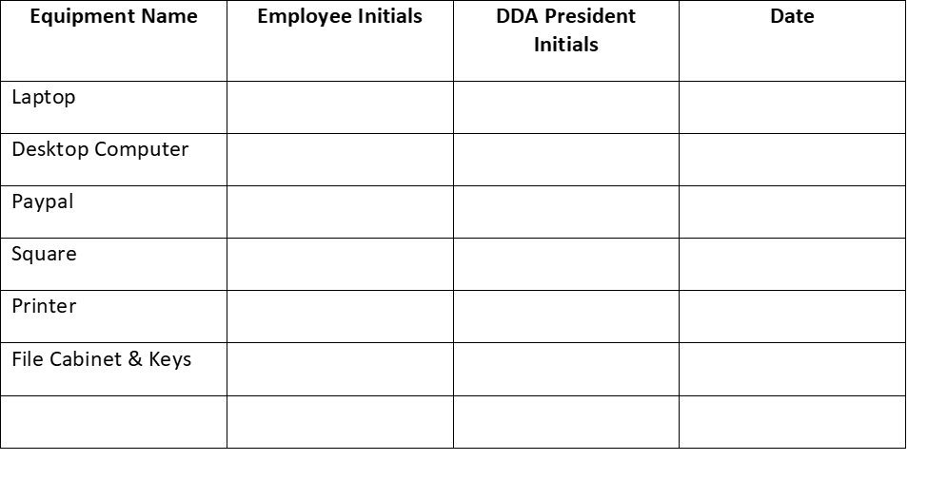

Signatures

Dallas Downtown Association:

_________________________________________________________
Dallas Downtown Association President

_________________________________________________________
Signature

_________________________________________________________
Date

Employee:

_________________________________________________________
Printed Name

_________________________________________________________
Signature

_________________________________________________________
Date
Approved and accepted by the DDA Board of Directors 12-15-2021

