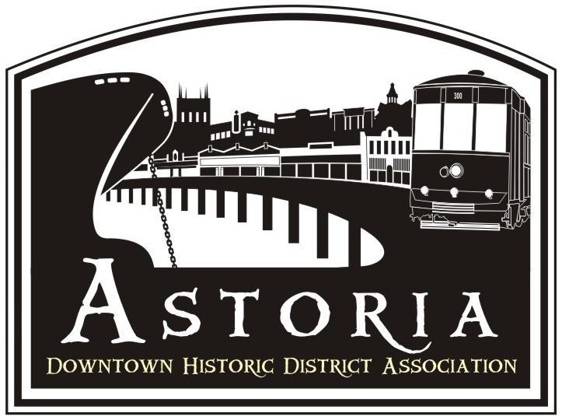

STREET LIGHT POLE BANNER DISPLAY PROGRAM
ASTORIA DOWNTOWN HISTORIC DISTRICT ASSOCIATION
EVENTS
The Astoria Downtown Historic District Association (ADHDA), in accordance with the City of Astoria, manages and processes permits for the installation of banners on downtown street light poles. Organizations will be allowed to display banners on these poles under certain conditions and specifications.
Banners may not be installed without a permit.
Contact: Janet Hutchings
Astoria Downtown Historic District Association (ADHDA)
c/o Light Pole Banner Program
Mailing: PO Box 261
Astoria, OR 97103
Contact: office@astoriadowntown.com

Goal and Purpose
ADHDA, with the City of Astoria, has a Street Light Pole Banner Program that allows area organizations to display banners on the street light poles currently installed along Commercial between 8th and 14th, Duane near 12th, on Marine Drive between 8th and 14th and 9th and 10th between Marine Drive and Astor Street.

The goal of this program is to increase awareness of downtown events, activities, and organizations as well as add color and excitement to the downtown streetscape.
The purpose of this program is to allow non-profit organizations to promote events, occasions, organizations, or relevant culture that has a direct and substantial civic benefit. The event or occasion should:
- be reasonably available to all citizens (as spectators or participants);
- benefit locally-based nonprofit organizations;
- be significant and broad enough that the theme or event will be of interest to many citizens;
- be appropriate for display on city-owned street light poles.
The banner program is open to non-profit organizations with a presence in the city of Astoria. Eligible banners are those that match the above stated goals of the Banner Program, at ADHDA’s sole discretion. Banners may not advertise or promote commercial products or services, or religious, political or social viewpoints.

The event or occasion using the banners should NOT be political, religious, or commercial, except for seasonal holiday decorations. Examples of eligible events or occasions include the Astoria Regatta, Astoria Scandinavian Festival, Astoria Sunday Market. In accordance with City Development Code Section 8.040.A.4, “Official informational signs, traffic signs, kiosks, signals, notices, and decorative and event banners” are exempt from the Sign Code regulation and do not require a Sign Permit.
Profit making organizations may hold permits if the organization is acting as the agent providing insurance, sponsorship, management, etc. for a nonprofit organization. Banners may display corporate logos or similar endorsements if they are not the dominant element in the composition of the banner.
The ADHDA Design Committee may regulate the composition, content of the banners, and impose other conditions or regulations necessary in the interest of the appearance of the street and the public's safety. The banners shall be in compliance with Oregon Department of Transportation rules and regulations.
Application Process
Banner installations will be allowed on a "first come, first serve" basis. Applicants for the permit must request banner locations three (3) months in advance of the event, to provide adequate processing time.
- A completed banner application (Exhibit A) must be submitted to ADHDA at least 60 days before the display period. The application must include a full color design of the banner artwork – front and back.
- Once the complete application is received, ADHDA staff and Design Committee will review and approve the design and schedule of the banners to be displayed.
- ADHDA will contact the applicant within 30 business days of receiving the complete application and inform the applicant of the ADHDA’s decision. Banner approval is based upon adherence to program guidelines in accordance with requirements established by the City of Astoria, Oregon.
- Upon approval, a Banner Use agreement will be issued to the applicant.
- Applicant should not begin fabricating banners until a banner agreement is in place signed by all parties.
- Once applicant has been approved, the time slot and banner space is reserved for a 3 year term.
- Organization must communicate with ADHDA annually to confirm the banner reservation, but the preferred dates are reserved for the full 3 year term. ADHDA will reach out to confirm reservation annually in January.

Applicant is responsible for all costs associated with production of the banners.
The request will be processed within 30 days of receipt. ADHDA will send a completed permit and acceptance of terms and conditions form (Exhibit B) and require the signature of the banner organization’s contact person.
Please sign and return the permit with the proper insurance certificate and additional insured endorsement. If the necessary documents (permit and insurance endorsement) are not in the possession of the ADHDA at least 14 days before the banners are to be installed, the permittee will not be allowed to hang the banners.
For the permit to be valid, it must be signed by the appropriate person at ADHDA.
Application Processing Fee
There is a $50 processing fee, payable to ADHDA.

Quantity needed:
• 37 poles total
- Commercial Street – 21
- Commercial and Duane Streets - 2
- Marine Drive – 5
- 9th and 10th Streets between Marine and Astor – 5
- Duane St – 4
Minimum Banner Quantity for permit on Commercial Street: 15

Specifications
Size: Height x Width ratio- 30” x 18”

Material: Banners should be made of at least 15 oz. rip-stop type vinyl that is weather resistant. Two double stitched 2.75” banner arm pockets must be included at top and bottom of banner, with grommets for attachment. Banners must be two sided. Cost + Materials form

Display Time
Hanging banners for one month is preferred. However, banners can be displayed for a minimum of 7 days and a maximum of 60 days. Extensions to the display period can be given if the applicant submits a written request to ADHDA stating the reasons for the extension. Scheduling of the banners will be done on a first come basis and in partnership with all organizations that regularly display banners.

Disclaimer
ADHDA reserves the right to revise or amend the guidelines of the Light Pole Banner Display program at any time. Additional fees or charges may be added if deemed necessary.
Banner Installation and Removal
Production of the banners is the responsibility of the permittee. Arrangements must be made with the ADHDA Design Committee for installation and removal timing. The Design Committee will be responsible for installation and removal. Permittee must deliver banners to Design Committee representative prior to the arranged installation date.
Banners should be removed the day after the approved banner display dates. Removal may be delayed by a few day If banners for another organization will be displayed immediately after. Removed banners will be returned to the permittee for storage. ADHDA will not be responsible for storing permittees banner when not in use.
Maintenance
The permittee will be responsible for the maintenance, replacement, and upkeep of quality banners while installed on the street light poles. Banners that are faded, ripped, or are in poor condition will not be installed and need to be replaced prior to installation.
Insurance Requirement
The permittee shall provide satisfactory evidence of public liability insurance, endorsed to name as additional insureds the City, its officers, agents, and employees as to any claim or claims for damage or injury resulting from or growing out of the operations of the applicant under the permit applied for, and containing a further endorsement that the policy shall not be canceled without 30 days prior written notice to the City Planner.
The endorsement shall be either (1) in the form attached with Exhibit B; or (2) in the form of Insurance Services Organization (ISO) Form CG 2012. The insurance shall provide coverage of not less than $1,000,000 (one million dollars) per occurrence. Proof of such insurance must be submitted to ADHDA and approved 2 weeks prior to installation of banners.
Revocable Permit
The permit will be revocable at any time at the discretion of the City Community Development Director or designee and/or by a vote of the ADHDA board. Should the permit be revoked, the ADHDA design committee shall remove banners from the street area as directed by and to the satisfaction of the City Community Development Director or designee and/or ADHDA board. Furthermore, if the permit is revoked, ADHDA shall not be liable for any costs of whatever nature incurred or suffered by the permittee or anyone else arising from the revocation of the permit.

Exhibit A

LIGHT POLE BANNER PROGRAM APPLICATION

Organization/Business: ______________________________________________________________________________________

Contact Person: _______________________________________________________________________________________________

Organization Address: _______________________________________________________________________________________

City/State/Zip: ________________________________________________________________________________________________

Applicant’s Phone (daytime): _______________________ Cell:_________________________________________________

Applicant’s Email: _____________________________________________________________________________________________

Event Name: ___________________________________________________________________________________________________

Briefly describe the event: ___________________________________________________________________________________
__________________________________________________________________________________________________________________
__________________________________________________________________________________________________________________

Event Date(s) From: _____________________ To: ____________________________

Banner display dates From: _____________________ To: ____________________________
(Min. of 7 days/Max. of 60 days)

Note: Attach a full color version of the banner design (front & back) with this application or email a PDF or Jpeg to office@astoriadowntown.com

I have reviewed this application and understand the Banner Display Program requirements and agree to the terms and conditions of the program as stated.

__________________________________________________________________________________________________________________
Signature Printed Name Date

Email or mail completed applications to:
Janet Hutchings office@astoriadowntown.com

Astoria Downtown Historic District Association (ADHDA)
c/o Light Pole Banner Program
Mailing: PO Box 261
Astoria, OR 97103
For Office Use

Date Received: _____________ Date Application Complete: Approved by: _______________________________
Payment Received: __________ on _________________________________________ Check # _____________________________________

Acceptance of Terms and Conditions
(To be completed by the Applicant)
I, ________________________________________, on behalf of ________________________________________, understand that __________________________________________ (organization) is responsible providing banners to be installed on City street light poles. Banners must meet the City's specifications; banners deemed to be a hazard will not be installed and will be returned to the permittee..
Banners will be displayed from_____________________________ to ____________________________.
Extensions to the display period can be given if the applicant submits a written request to ADHDA stating the reasons for the extension. Extensions will be approved as available.
The permittee/organization will be responsible for the maintenance, replacement, and upkeep of banners while installed on the street light poles. The permittee will be responsible for all costs to repair damages to the street lights caused by installation, while installed, and removal of the banners on the street light poles.

Insurance: ______________________________________________Policy #:______________________________________________

Organization/Business: _______________________________________________________________________________________

Event Name: ___________________________________________________________________________________________________

Applicant’s Signature: _____________________________________________________ Date: __________________________

Banner Program Permit
Exhibit B

(For Office Use)

Organization/Business: ______________________________________________________________________________________

Contact Person: _______________________________________________________________________________________

Event Name: ___________________________________________________________________________________________________

Annual Banner display dates From: _______________________ To: ___________________________________
(Min. of 7 days/Max. of 60 days)

Permit expiration date: _____________________________

ADHDA Approved by:________________________________________________________________ Date: __________________

