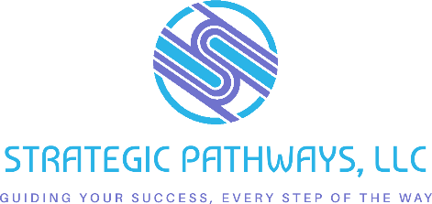

Board Diversity Objection Handling Guide
Purpose: Equip Main Street leaders with clear, empathetic, and effective responses to common objections to board diversity efforts.
Objection
  What It Really Means
  Suggested Response
  Pro Tip
“We can’t find qualified diverse candidates.” | Lack of outreach beyond usual networks.
  “Let’s expand where we’re looking—community leaders, young professionals, neighborhood associations, or alumni networks are great places to start.”
  Share the Board Matrix tool to identify missing voices and skills.
“We don’t want to do diversity for the sake of diversity.”
  We’re concerned about performative actions and not sure how to do this authentically.
  “We’re seeking diverse perspectives, not checking boxes. New voices enhance strategy and reflect the community we serve.”
  Focus on skills + lived experience as equally valuable assets.
“Everyone on the board gets along great as it is.” | Fear of disrupting harmony or culture. | “Groupthink can limit innovation. Constructive tension from different perspectives actually leads to better decisions.” | Share a success story from a diverse board that improved outcomes.

Objection
  What It Really Means
  Suggested Response
  Pro Tip
“We tried before and it didn’t work.” | Past efforts lacked structure or support. | “Let’s evaluate what didn’t work and try a new approach—with clear goals, onboarding, and mentorship.” | Introduce your Board Inclusivity Checklist and action plan template.
“They might not feel comfortable here.” | Unspoken awareness of non-inclusive dynamics. | “That’s a cue for us to build a more inclusive culture—so everyone feels welcomed and valued from day one.” | Use your Board Culture Brainstorm activity to address this head-on.
“We’re already diverse enough.” | Possibly defensive or unaware of gaps. | “Let’s review the board matrix together. Does it truly reflect the demographics and lived experiences of our whole community?” | Bring data or a visual snapshot of community demographics.
“We don’t know where to find diverse candidates.” | We’ve relied on the same networks for years and haven’t built new relationships. | Partner with local organizations, chambers of commerce, advocacy groups, and faith communities to identify emerging leaders from underrepresented groups. | Build a “community connections” map with your team. Assign board members to start building relationships now—not just when you need to recruit.

Objection
  What It Really Means
  Suggested Response
  Pro Tip
“We already have a strong board.” | We’re comfortable with the status quo and may not recognize what’s missing. | A diverse board doesn’t replace strength—it enhances it. Broader perspectives lead to better decisions and stronger community connections. | Highlight strengths and acknowledge blind spots. Diversity isn’t about deficiency—it’s about expansion.
“We’re a small town—there’s not a lot of diversity here.” | We’re defining diversity too narrowly. | Every community has diversity—of age, ability, income, background. Seek out people who haven’t traditionally been at the table and create space for them. | Look for “community connectors”—people who may not hold titles but are deeply trusted and engaged in everyday life.
“We need people who already know how boards work.” | We fear slowing down or disrupting board culture. | Diversity includes experience. New voices can energize your board and make it more responsive. Provide board training for all new members. | Rotate board meeting facilitation to encourage learning and inclusion. Everyone benefits from learning together.

