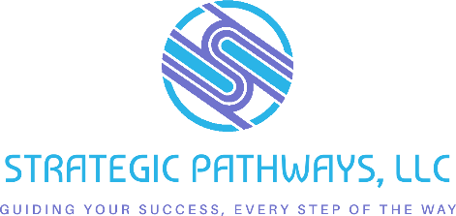

Handout: Board Member Outreach Email Scripts
Purpose: Help you confidently reach out to prospective board members from diverse backgrounds.

💬 Script 1: Initial Outreach to a Community Leader or Connector
Subject Line: Your Leadership Could Shape the Future of [Town/Org Name]
Hi [Name],
I’m reaching out on behalf of the [Your Organization Name] Board. We’re working to ensure our leadership reflects the community we serve—and we’d be honored to explore your interest in joining us.
We believe your [experience as a business owner / involvement in youth programs / leadership in the community] would bring valuable insight to our work revitalizing downtown [City Name].
Would you be open to a short conversation next week to learn more about the role and share your perspective?
Warm regards,
[Your Name]
[Title/Organization]
[Phone/Email]

💬 Script 2: Referral Request from a Peer or Partner Organization
Subject Line: Know Anyone Who’d Be a Great Board Member?
Hi [Name],
I hope you're well! We’re currently seeking board members who reflect the diversity of [City/Neighborhood]—across race, age, background, industry, and lived experience.
If you know someone who’s passionate about community development and could bring a fresh voice to the table, would you be willing to connect us?
Thanks in advance for helping us build a stronger, more inclusive board.
Best,
[Your Name]
[Phone/Email]

💬 Script 3: Follow-Up After Initial Conversation
Subject Line: Great Talking With You—Next Steps
Hi [Name],
Thank you again for taking the time to speak with me about joining the board. I appreciated hearing your perspective on [insert personal connection or community passion they shared].
As discussed, I’ve attached a board member info sheet with more about the commitment and onboarding. If you're still interested, we’d love to invite you to attend an upcoming board meeting to get a feel for our work.
Let me know if you have any questions—I’m happy to walk through the next steps at your pace.
Warmly,
[Your Name]

