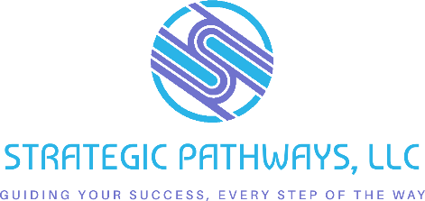

Community Partnership Mapping Exercise
Created by Strategic Pathways for Main Street Now 2025 Conference
Free to use with attribution. Not for rebranding.

Objective:
Identify local organizations, networks, and individuals that can serve as trusted bridges to underrepresented communities in your commercial district. These partnerships will help you diversify your board pipeline through relationship-based outreach.

Step-by-Step Instructions:

1. Define Your Community's Gaps
Refer to your Board Matrix or community demographics.
What voices or identities are underrepresented on your current board?
(e.g., youth, BIPOC, LGBTQIA+, disabled individuals, renters, immigrant communities)
___________________________________________ __________________________________________
___________________________________________ __________________________________________
___________________________________________ __________________________________________
__________________________________________ __________________________________________

2. Brainstorm Potential Partners
List organizations, groups, clubs, or community leaders that are trusted in each underrepresented population.
Underrepresented Group | Local Organizations or Leaders | Connection Point / Notes

3. Prioritize Relationship-Building Partners
Circle 2–3 organizations you already have a warm connection with—or that you feel most confident reaching out to first. These are your "early bridge" partners.

4. Plan Your First Touchpoint
For each partner, outline an intentional way to engage:
Partner Organization | Engagement Strategy | Timeline | Who Will Lead?

5. Follow Up Thoughtfully
Ask these groups:
- “How can we support your work?”
- “How can we ensure people from your community feel valued in leadership roles?”
- “Would you be willing to recommend someone for our board or a committee?”

Pro Tips:
- Don’t pitch—build. Focus on long-term relationships, not quick asks.
- Offer value first. Share event space, spotlight their work, or co-sponsor something.
- Create visibility. Invite partners to events and make board culture welcoming.

