
1501 Cherry St Philadelphia PA 19102
www.witnesstoinnocence.org

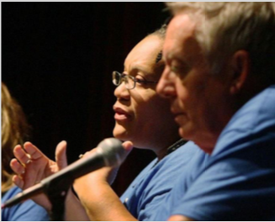

Accuracy & Justice:
Listening to Innocence

Workshop Guide
2019
Workshop Guide

- Introduction, Purpose, and Agenda

A. Witness to Innocence

Witness to Innocence (WTI) is dedicated to empowering exonerated death row survivors to be strong and effective voices in confronting problems in the criminal justice system in the United States. Through public speaking, testifying before state legislatures, strategic communications, and active participation in our nation’s cultural life, our members are particularly involved in educating the public about innocence and wrongful convictions. WTI also provides an essential network of peer support for the exonerated, most of whom received no compensation or access to reentry services when released from death row.

Witness to Innocence began in 2003 with the assistance of Sister Helen Prejean, renowned human rights activist, author, and Nobel Prize nominee. We launched our first national campaign in September 2005, when 25 exonerated death row survivors, family members, and allies came together in Georgia for a three-day gathering.

Since then our members have had a significant impact on the death penalty by educating tens of thousands of Americans through speaking events at colleges, professional associations, academic conferences, and many other venues. WTI members have also reached millions of people across the country and around the world through traditional and social media. Our exoneree members have testified before state legislatures, met with government officials and world leaders, and influenced individuals who are shaping criminal justice and death penalty policies.

B. Purpose of This Workshop

WTI is committed to reducing the number of wrongful convictions in capital cases. One way of accomplishing this goal would be to eliminate the death penalty entirely. However, the purpose of this workshop is not to engage in a debate about capital punishment. There are changes that should be made in the broader criminal justice system that would not only lessen the number of mistakes in capital cases, but would also strengthen the system for all involved.

WTI respects all those who work in the legal community—prosecutors, defense attorneys, judges, and others in law enforcement—and believes they hold the key to identifying and remedying problems wherever they exist. We do not claim to be legal experts, but our death-row exonerees bring an expertise in wrongful convictions rooted in their lived experience. In other forums, the exoneress share their experience with the public by emphasizing their time on death row and what led to their eventual release. For these workshops with representatives of the criminal justice community, we want to stress the mistakes that were made in the first place that led to the wrongful convictions of innocent men and women. These errors were made in the course of the legal process, and the reform of that process is also the key to preventing such errors in the future.

WTI respects the fact that those attending these workshops are skilled in their profession. All of the issues we raise are likely ones that the participants have heard before. Hopefully, they have already begun seeking ways to address areas where problems exist. Our role is to stimulate and encourage such activity by broaching these subjects on a personal level. The hard work of change will be up to the legal experts within this system. We are grateful for the opportunity to share in the discussion of these important matters.

WTI has contracted with attorneys specializing in criminal and death penalty law to facilitate the discussion of legal issues.

C. Workshop Agenda (Total Two Hours)
(More extensive formats are available to meet the needs of the participants)

AGENDA

  - Brief introduction of the WTI Team and other participants (5 min.)
  - The Legal Framework (10 min.— Attorney facilitator)
    - The meaning of innocence and exoneration in capital cases
    - The difficulty of re-opening the question of guilt
    - The changing landscape of forensic evidence
    - Commutations and Pardons
    - Compensation following exonerations

  - Presentations by Three Exonerees (30 min. total-Exonerees)
  - Questions for Exonerees
    - from facilitator (15 min.)
    - from other participants (15 min.)
  - Lessons Learned about the Causes of Wrongful Convictions (10 min. Discussion - facilitator)

  - Discussion of Remedies to the System of Justice (30 min.-Presenters and participants)

  - Closing (Evaluations-5 min.)

II. Bios of Presenters
Kwame Ajamu

Kwame Ajamu was a teenager in Cleveland, Ohio, when he was sentenced to death in 1975 for the murder-robbery of a money order salesman named Harold Franks. The sole evidence against Kwame, known as Ronnie Bridgeman at the time, and his co-defendants, brother Wiley Bridgeman and friend Ricky Jackson, was the false, coerced eyewitness testimony of a 13-year-old boy. No physical or forensic evidence linked any of them to the crime, none of them had any prior criminal record, and defense witnesses provided all three with credible alibis.

In 2011, Cleveland Scene magazine published a detailed examination of the case and highlighted the numerous inconsistencies in young witness’s testimony. The witness publicly recanted his story, setting in motion the exonerations of Kwame Ajamu, Wiley Bridgeman, and Ricky Jackson. In 2014, Kwame Ajamu's conviction was vacated, and the prosecution dismissed all charges against him.

Kirk Bloodsworth
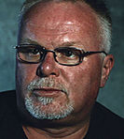
An honorably discharged former Marine, Kirk Bloodsworth was arrested in 1984 for the rape and murder of nine-year-old Dawn Hamilton. He was sentenced to death in Baltimore County, Maryland, in 1985.
In 1992, Kirk read about a new forensic breakthrough called DNA fingerprinting and lobbied successfully for prosecutors’ approval for its use on evidence collected at the crime scene. The tests incontrovertibly established Kirk’s innocence, and he was released in June 1993. In December 1994, Maryland Governor William Donald Schaefer granted Kirk a full pardon based on innocence, and he became the first person in the United States exonerated from death row by DNA testing. Another man would later be linked by DNA to the rape and murder of the child.
Gary Drinkard

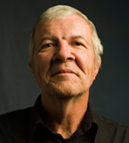
Gary Drinkard spent close to six years on Alabama’s death row before being exonerated in 2001. He was sentenced to death in 1995 for the robbery and murder of a 65-year-old automotive junk dealer in Decatur, Alabama. Unable to afford an attorney, he was assigned two lawyers with no experience trying criminal cases. Despite being at home at the time of the murders and suffering from a debilitating back injury, Gary was convicted and sentenced to death.

The conviction rested primarily on testimony by Gary’s half-sister and her common-law husband, both facing charges for unrelated crimes. In exchange for testifying, all the charges against Gary’s half-sister were dismissed. In 2000, the Alabama Supreme Court ordered a new trial because of prosecutorial misconduct, and with the help of the Southern Center for Human Rights, Gary won an acquittal in 2001.

Ray Krone

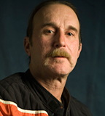
In 1991, a woman was murdered in a Phoenix bar where Ray was an occasional customer, and he was arrested for the crime. The case against him was based largely on the testimony of an “expert” witness, later discredited, who claimed bite marks found on the victim matched Ray’s teeth. He was sentenced to death in 1992. In 1995, he received a new trial but was again found guilty and sentenced to life in prison.

In 2002, his attorneys demonstrated that DNA found at the murder scene belonged to another man. Prosecutors dropped all charges against Ray, and he became the 100th person exonerated from death row in the United States since 1973. Ray Krone co-founded Witness to Innocence with Sister Helen Prejean in 2003.

Herman Lindsey
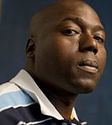
Herman Lindsey was sent to Florida’s death row in 2006 for the robbery and murder of a Ft. Lauderdale pawnshop owner back in 1994. In a unanimous verdict, the Florida Supreme Court ruled in 2009 that he did not receive a fair trial and that there wasn’t enough evidence to find Herman guilty of anything, much less sentence him to death.
The court said that “the state had failed to produce any evidence in this case placing Lindsey at the scene of the crime at the time of the murder,” and that the evidence presented was “equally consistent with a reasonable hypothesis of innocence.” Florida has the highest number of exonerations from death row of any state in the nation.
Debra Milke


Debra Milke was wrongfully convicted in 1990 of the murder of her own child. She had been accused of arranging for two men to kill her 4-year-old son so she could collect an insurance payout. She spent 22 years on Arizona's death row.

In 2013, her conviction was overturned because prosecutors failed to disclose the history of misconduct by the key homicide detective in the case, including his lying under oath. An Arizona appeals court barred the state from retrying Milke, and all charges were dismissed in 2015. She became the second woman exonerated from death row since 1973.

Sabrina Smith

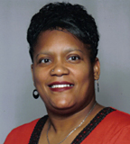
Sabrina Smith was a Mississippi teenager who was convicted of murder and child abuse in the death of her nine-month-old son. In 1989, Sabrina rushed her son to the hospital after he suddenly stopped breathing. Doctors had attempted to resuscitate the child for thirty minutes, but failed, and Sabrina's baby died the next day. The day of her son's death, Sabrina was arrested for child abuse due to the bruises left by her resuscitation attempts.

At the trial, prosecutors sought to prove that Sabrina's account of the events leading to her son's death were false, and that she had inflicted the fatal wounds intentionally. Sabrina did not testify at her trial, and was convicted of both murder and child abuse, becoming the only woman on Mississippi's Death Row at the time. The Mississippi courts reversed her conviction in 1992, declaring that the prosecution had failed to prove that the incident was anything more than an accident. In 1995, Sabrina was retried. The medical examiner changed his opinion about her son’s cause of death, which he newly attributed to a kidney malady. In 1995, Sabrina was acquitted of all charges. She is one of only two women in the United States exonerated from death row.

Randy Steidl

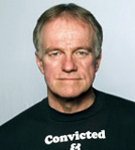
Randy Steidl spent 17 years in Illinois prisons, including 12 on death row, prior to his exoneration. He was wrongly convicted and sentenced to die for a double murder committed in 1986. When questioned, Randy cooperated with the police and gave a corroborated alibi for the night of the murders. Randy had poor legal representation, and witnesses fabricated testimony against him due to police misconduct.

An investigation by the Illinois State Police proved that local law enforcement and prosecutors had framed Randy. In 2003, a federal judge overturned Randy’s conviction and ordered a new trial. The state reinvestigated the case, tested DNA evidence, and found no link to him. All charges were dismissed in 2004.

FACILITATORS

Richard Dieter


Richard Dieter received his law degree from the Georgetown University Law Center, where he was named a Public Interest Law Scholar. He served as the Executive Director of the Death Penalty Information Center in Washington, D.C. from 1992 until 2015. He has authored 40 reports on the death penalty that have been widely cited in the national media and utilized at all levels of state and national government, including the U.S. Supreme Court. His most recent publication, Battle Scars: Military Veterans and the Death Penalty (2015), received the Congressional Black Caucus’s Veterans Braintrust Award. He also served as an Adjunct Professor at the Catholic University School of Law for 14 years.

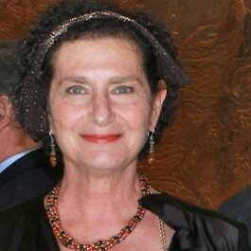
Elizabeth Zitrin
Elizabeth Zitrin is the former President of the World Coalition Against the Death Penalty, and she represents the organization Murder Victims’ Families for Human Rights on the World Coalition’s Steering Committee and Executive Board. A frequent speaker on the death penalty both in the US and internationally, Ms. Zitrin was chosen by her World Coalition colleagues to represent them at the opening session of the 4th World Congress Against the Death Penalty at the UN in Geneva in 2010. She has addressed the International Commission Against the Death Penalty and hosted their first mission to the USA. In addition, Ms. Zitrin previously worked with Death Penalty Focus in bringing the voices of exonerees and law enforcement professionals to the public debate during California’s statewide initiative SAFE Campaign to end the death penalty in 2012. She has pioneered the presentation of international forums on the death penalty held in the USA. She organized and convened the World Coalition’s only General Assembly in the United States. Ms. Zitrin practiced criminal defense law in San Francisco, California, and has continued to work with capital defense teams. She has served for many years on the Board of the Northern California Innocence Project. She holds a B.A. from Oberlin College and a J.D. from Northeastern University School of Law.

- RESOURCES
- Data on Exonerations (DPIC, as of 3/27/19)

Total Number of Death Row Exonerations Since 1973: 164

Number of Cases in which DNA played a major role in exoneration: 21

Race of Exonerees: Black 84 White 62 Latino 15 Other 3

Gender of Exonerees : Male 162 Female 2

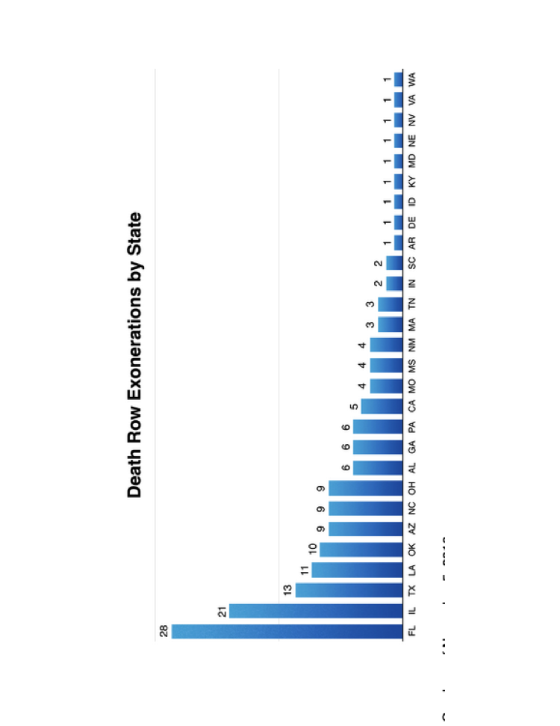

B. The Causes of Wrongful Convictions
Various research organizations have endeavored to pinpoint the causes of wrongful convictions and the relative frequency of each cause. These organizations typically have drawn from different pools of cases, depending on their research goals. The Center for Wrongful Convictions, based at Northwestern University in Illinois, has focused on death penalty cases. The National Registry of Exonerations, a project of the University of California-Irvine and the law schools of the Universities of Michigan and Michigan State, tracks reversals in all criminal cases since 1989, with an emphasis on felonies such as rape and murder. Finally, the Innocence Project, based in New York, has looked at all exonerations involving DNA evidence.

All three of these sources include at least some of the exonerations from death row that make up the core of Witness to Innocence members. The Death Penalty Information Center (DPIC) maintains a list of individuals exonerated from death row since 1973, and WTI utilizes this list in establishing its membership. The criteria for inclusion on this list are: Defendants must have been convicted, sentenced to death and subsequently either: a. Been acquitted of all charges related to the crime that placed them on death row, or b. Had all charges related to the crime that placed them on death row dismissed by the prosecution or the courts, or c. Been granted a complete pardon based on evidence of innocence.

Since all of the cases that these sources identify involve essentially the same legal process, it is not surprising that there is considerable overlap in the causes of wrongful convictions that they have found. The relative importance of each cause may differ from study to study.

It is also important to note that any one case can involve multiple causes of error. Thus, the total percentage attributed to all causes will exceed 100%. Citations and links are provided below for a more thorough reading of this research, along with other resources on this subject.

1. Center on Wrongful Convictions Study

In 2001, the Center on Wrongful Convictions at Northwestern University analyzed the cases of 86 death row exonerees. They found a number of reasons why innocent people are wrongly convicted in capital cases. The most prevalent cause among the cases was "eyewitness error." The reasons identified included:

- eyewitness error - from confusion or faulty memory.
- government error - by both the police and the prosecution
- inaccurate science - mishandled evidence or use of scientific opinions that are not longer considered accurate
- informant testimony - often given in exchange for a reduction in sentence and this is not always disclosed to the jury
- false confessions - resulting from a variety of causes, including mental illness, intellectual disability, and improper interrogation practices
- other - hearsay, questionable circumstantial evidence, etc.

Note: Nearly half of the cases included more than one reason for a wrongful conviction. Therefore the total of the cases in the chart equals more than 86.

2. The National Registry of Exonerations

The National Registry of Exonerations (NRE) was begun in 2012 and has tracked exonerations in criminal cases that have occurred since 1989. There are now over 2,000 cases in its database. Since their database includes the causes for the wrongful conviction, its analysis is kept up to date with each new entry.

The most prevalent cause of error for all cases in the Registry is "Perjury or False Accusation." However, in its latest report on exonerations in 2017, they noted that "Official Misconduct" (Government Error, below) was involved in 84% of the homicide cases for that year. NRE cannot track all exonerations and its database is partially dependent on cases that receive official scrutiny, such as that given by Conviction Integrity Units that have sprung up around the country. NRE states that it does not know the exact number of exonerations or the rate of exonerations from among all criminal cases. A study published by the National Academy of Sciences by Prof. Samuel Gross, founder of NRE, concluded: "[A] conservative estimate of the proportion of erroneous convictions of defendants sentenced to death in the United States from 1973 through 2004 [is] 4.1%."

NRE’s chart below is based on the causes of wrongful convictions for all cases in the database:

3. The Innocence Project

The Innocence Project, founded in 1992 by Peter Neufeld and Barry Scheck at Cardozo School of Law, works to exonerate the wrongly convicted through DNA testing and reform the criminal justice system to prevent future injustice. Their database includes 349 exonerations. The following is a list and description based on their website of the principal causes they have identified for the underlying wrongful convictions:

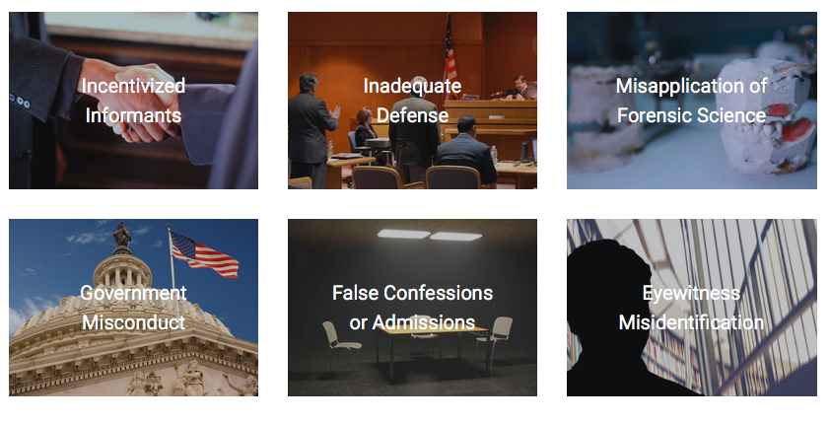
Incentivized Informants
In 15% of wrongful conviction cases overturned through DNA testing, statements from people with incentives to testify — particularly incentives that are not disclosed to the jury — were critical evidence used to convict an innocent person.

Inadequate Defense
A review of convictions overturned by DNA testing reveals a trail of sleeping, drunk, incompetent and overburdened defense attorneys, at the trial level and on appeal.

Misapplication of Forensic Science
Misapplication of forensic science is the second most common contributing factor to wrongful convictions, found in nearly half (46%) of DNA exoneration cases.

Government Misconduct (Error)
Evidence of fraud, negligence or misconduct by prosecutors or police is prevalent among the DNA exoneration cases.

False Confessions or Admissions
More than 1 out of 4 people wrongfully convicted but later exonerated by DNA evidence made a false confession or incriminating statement.

Eyewitness Misidentification
Eyewitness misidentification is the greatest contributing factor to wrongful convictions proven by DNA testing, playing a role in more than 70% of convictions overturned through DNA testing nationwide.

C. Resources and Links on Causes of Error
General:

"Convicting the Innocent: Aberration or Systemic Problem?" by Rodney Uphoff, University of Missouri School of Law— http://www.deathpenaltyinfo.org/documents/SSRN-id912310.pdf

"Exonerations in the United States, 1989 through 2003," by Samuel Gross, et al., Journal of Criminal Law and Criminology, Vol. 95, No. 2, 2005- http://papers.ssrn.com/sol3/papers.cfm?abstract_id=753084

"Conviction Integrity Units," National Registry of Exonerations- http://www.law.umich.edu/special/exoneration/Documents/2.2016_Newsletter_Art2.pdf

Government Error:

Government Error by the Innocence Project- https://www.innocenceproject.org/causes/government-misconduct/

Police Error by the Center on Wrongful Convictions- http://www.law.northwestern.edu/wrongfulconvictions/issues/causesandremedies/policemisconduct/

Informant Testimony:

The Snitch System by the Center on Wrongful Convictions— http://www.law.northwestern.edu/legalclinic/wrongfulconvictions/documents/SnitchSystemBooklet.pdf

Informants/Snitches by the Innocence Project- https://www.innocenceproject.org/causes/incentivized-informants/

Ineffective Defense Counsel:

Ineffective Assistance of Counsel by the Innocence Project-https://www.innocenceproject.org/wp-content/uploads/2016/05/Innocence_Project_IAC_Report.pdf

Eyewitness Error:

Tainted Identifications by National Registry of Exonerations- http://www.law.umich.edu/special/exoneration/Pages/taintedids.aspx

Eyewitness Misidentification by the Innocence Project- https://www.innocenceproject.org/causes/eyewitness-misidentification/

Erroneous Eyewitness I.D. by the Center on Wrongful Convictions- http://www.law.northwestern.edu/legalclinic/wrongfulconvictions/issues/erroneousid/index.html

Unreliable Forensic Science:

Forensic Science Misconduct by the Innocence Project- https://www.innocenceproject.org/causes/misapplication-forensic-science/

False Confessions:

False Confessions by the National Registry of Exonerations- http://www.law.umich.edu/special/exoneration/Documents/NRE.Guilty.Plea.Article4.pdf

False Confessions by the Innocence Project- https://www.innocenceproject.org/causes/false-confessions-admissions/

False Confessions by the Center on Wrongful Convictions- http://www.law.northwestern.edu/legalclinic/wrongfulconvictions/issues/falseconfessions/index.html

(drawn from DPIC and other sources)

D. Books on Innocence (chronological sample)
Examining Wrongful Convictions: Stepping Back, Moving Forward, A. Redlich, et al., Carolina Academic Press, 2014

The Wrong Carlos: Anatomy of a Wrongful Execution, J. Liebman, Columbia University Press, 2014

Life After Death Row: Exonerees’ Search for Community and Identity, by S. Westervelt and K. Cook, Rutgers University Press, September 2012

False Justice: Eight Myths that Convict the Innocent, Jim and Nancy Petro, Kaplan Publishing, 2010
Killing Time: An 18-Year Odyssey from Death Row to Freedom by John Hollway and Ronald M. Gauthier, Skyhorse Publishing, 2010 (story of John Thompson)
True Stories of False Confessions, R. Warden & S. Drizin, editors, Northwestern University Press, 2009

The Innocence Commission: Preventing Wrongful Convictions and Restoring the Criminal Justice System, by Jon B. Gould, NYU Press, 2008

Dead Wrong: Violence, Vengeance, and the Victims of Capital Punishment, by Richard Stack, American University, 2007

Jingle Jangle, by Jim Rix, Broken Bench Press, 2007 (story of Ray Krone)

The Dreams of Ada, by R. Mayer, Doubleday Broadway 1987, with new Afterword 2006

The Innocent Man, by John Grisham, Random House 2006 (non-fiction based on case of Ron Williamson)

Wilkie Collins's The Dead Alive: The Novel, the Case, and Wrongful Convictions, by Rob Warden, Northwestern University Press, 2005

Victims of Justice Revisited, by Thomas Frisbie and Randy Garrett, Northwestern University Press, 2005 (case of Rolando Cruz and co-defendants)

The Death of Innocents: An Eyewitness Account of Wrongful Executions, by Sister Helen Prejean, Random House, 2005

Innocent: Inside Wrongful Conviction Cases, by Scott Christianson, New York University Press, 2004

Bloodsworth: The True Story of the First Death Row Inmate Exonerated by DNA, by Tim Junkin, Algonquin Books, 2004
The Wrong Men: America's Epidemic of Wrongful Death Row Convictions, by Stanley Cohen, Carroll & Graf Publishers, 2003

An Expendable Man, by Margaret Edds, New York University Press, 2003 (case of Earl Washington)

Wrongly Convicted: Perspectives on Failed Justice, Saundra D. Westervelt and John A. Humphrey, eds., Rutgers University Press, 2001

The Wrong Man: A True Story of Innocence on Death Row, by Michael Mello, University of Minnesota Press, 2001 (case of Joe Spaziano)

Actual Innocence: Five Days to Execution and Other Dispatches from the Wrongly Convicted, by Barry Scheck, Peter Neufeld and Jim Dwyer, Doubleday, 2000

A Promise of Justice: The Eighteen-Year Fight to Save Four Innocent Men by Rob Warden and David L. Protess, Hyperion Press, 1998 (case of Dennis Williams and Verneal Jimerson)

May God Have Mercy: A True Story of Crime and Punishment, by John C. Tucker, Norton Press, 1997 (case of Roger Keith Coleman)

Triple jeopardy: a story of law at its best - and worst, by Roger Parloff, Little Brown and Company, New York, 1996

Circumstantial evidence: death, life, and justice in a Southern town, by Pete Early, Bantam Books, New York, 1995 (case of Walter McMillian)

White lies: rape, murder, and justice Texas style, by Nick Davies, Pantheon Books, New York, 1991

In Spite of Innocence, by Michael L.Radelet, Hugo Adam Bedau, and Constance Putnam, Northeastern University Press, 1992

Adams vs. Texas, Randall Dale Adams, et al., St. Martins Press, 1991

(Books selected from DPIC)

Articles: There are too many articles and law reviews on Innocence to adequately summarize here. The Death Penalty Information Center highlights many such pieces: http://www.deathpenaltyinfo.org. One article of note specifically written with judges in mind:

“Confronting Implicit Bias: An Imperative for Judges in Capital Prosecutions,” Vol. 42 No. 2, Human Rights Magazine 2016-17, by Gregory S. Parks, Hon. Andre M. Davis.

IV. Evaluation
Your feedback is very important to us. It helps us to modify the program to meet the needs of participants and can be useful in seeking support for these workshops.

1. Did the workshop provide valuable insights and perspectives on the causes and consequences of wrongful convictions?
___Yes ___No

2. How important were the personal stories of the exonerees to the overall goals of the workshop?
___Very important
___Somewhat important
___Not important

3. Was the length of this presentation appropriate for the goals envisioned?
___About right
___Should be longer, with more content on the issues
___Should be longer, with more discussion
___Should be shorter

4. Was the overall presentation fair and balanced?
___Yes
___Fair, but with a point of view
___Too biased

5. Would you recommend this type of workshop for other groups involved in the criminal justice system?

Judges ___Yes ___No
Prosecution Offices ___Yes ___No
Public Defender Offices ___Yes ___No
Police Departments ___Yes ___No
Professional Law Enforcement Organizations ___Yes ___No

Please add any comments or suggestions below. Thank you for your time and input.

Comments (Optional: Include your job title)

