DESCHUTES
NATIONAL
FOREST
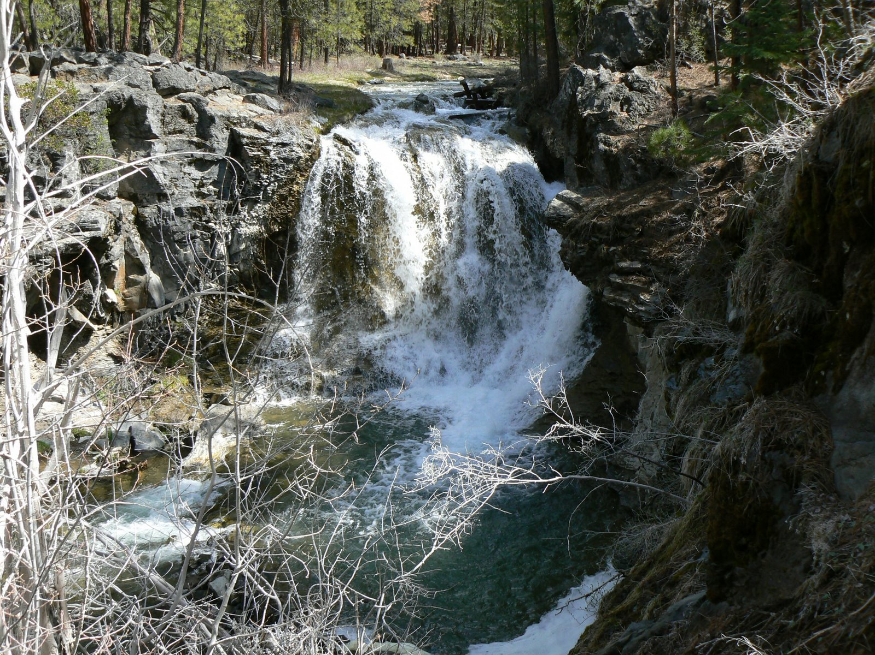

”Caring for the Land and Serving People”

OUTREACH NOTICE

Forest Archaeologist/Tribal Liaison
Supervisory Archaeologist

GS-0193-11/12

The Ochoco and Deschutes National Forests and Crooked River National Grassland will soon be advertising to fill a permanent, full-time, Forest Archaeologist/Tribal Liaison position as a GS-0193-11/12 career ladder position. The position will be located at the Deschutes National Forest Headquarters in Bend. This position will serve as the Forest Archaeologist and Heritage Program Manager for the two Forests and the Grassland. It will also serve as the Tribal Liaison for the Forests and Grassland with the Confederated Tribes of Warm Springs, the Klamath Tribe, and the Burns Paiute Tribe.

PLEASE NOTE: The purpose of this Outreach Notice is to determine the potential applicant pool for this position and to establish the appropriate recruitment method and area of consideration for the advertisement. Responses received from this outreach notice will be relied upon to make this determination. If you are interested in applying for this position, please respond on the enclosed Outreach Notice Form by November 20, 2009.

DUTIES OF THE POSITION:

The duties of the position include:

- Developing, coordinating, implementing, and monitoring the heritage program for the two Forests, including the heritage budget and project work plans;
- Formulating and implementing stewardship projects for protection, enhancement, and interpretation of cultural resources on the Forests, including partnership agreements and site stewardship programs;
- Coordinating with the local tribal governments, the State Historic Preservation Office, and other federal and state agencies on the heritage resources of the Forests and potential impacts from forest activities;
- Supervising the field-level archaeologists and archaeological technicians on the Deschutes NF, including the full range of supervisory duties;
- Providing technical oversight and review for the field-level archaeologists on the Ochoco NF and Crooked River NG;
- Providing tribal liaison services to the Forest Supervisors, District Rangers and Staff Officers on the Forests and Grassland, including offering oversight, advice and assistance in maintaining effective and position relations with the Tribes having interest and treaty rights within or adjacent to the Forests and Grassland, and maintaining contacts with the Tribes, the Region 6 Tribal Relations Specialist, and the WO Office of Tribal Relations, and
- Developing and administering contract specifications and requirements for heritage resource work, and as delegated, acts as COR and/or inspector on such contracts.

COMMUNITY INFORMATION:

ABOUT THE BEND AREA:

The City of Bend is located in the central part of the state of Oregon. The major highways intersecting in town are US97 and US20. The population is over 80,000 in the city and approximately 70,000 more living in the surrounding area. The largest draw of people to Central Oregon is the abundance of public lands with diverse, year-round outdoor recreation. The community has several movie theaters, an active concert schedule throughout the year, three community theatres, many excellent restaurants, hotels/resorts and bed-and-breakfasts. There are numerous city and county parks in and adjacent to town; a new public library; full service medical and dental facilities; four large shopping malls; a country club, 20+ public and private golf courses, numerous service clubs and churches.

SCHOOLS: The Deschutes County School System in Bend consists of 12 elementary schools, four middle schools and three senior high schools. Central Oregon Community College offers two-year degree programs. Four-year degrees are offered through the Cascades Campus of Oregon State University and the University of Oregon. There are several private schools and an active home-school program in the county.

HEALTH CARE: Bend has one major full-service hospital and numerous clinics. Bend features extensive medical specialist practices. Redmond (20 miles north) offers one community hospital.

TRAVEL: The Central Oregon area is serviced by the Redmond Municipal Airport, which has daily flights by Horizon Air (Alaska), United Express, and Delta Airlines. Daily flights link to Portland, Seattle, San Francisco, Salt Lake City, Denver, and Los Angeles, with regular flights to Las Vegas and Phoenix/Mesa. Amtrak serves Chemult, Oregon, 65 miles south of Bend.

WEATHER: Bend is located in the “High Desert” region of Central Oregon. Summers have warm days with highs generally in the upper 70’s to low 90’s. There can be a few weeks in August where the temperature may reach the low 100’s. Nights are cool, in the 30’s to 50’s. Summer afternoon thundershowers are common some years, depending upon how the weather patterns shape up. Winters are relatively mild with snowfall in the neighborhood of eight to ten inches—it usually melts quickly. Temperatures are normally in the 20’s and 30’s although we can get a week or two of sub zero temperatures in January. The growing season is relatively short as the elevation of Bend is 3,623 feet. (Gardeners—we do not have a “frost-free” month. Cold frames and plastic are Standard Operating Procedure.) The average yearly precipitation is about 12 inches.

HOUSING: There is no government housing available. Rental apartments and houses are available. The approximate range for the monthly cost of rentals in Bend is $600-$750 for a two bedroom, one bath unit and around $850+ for a three bedroom unit in either duplexes or apartments. The cost for a three bedroom single-family house runs $800 and up.

Bend is a rapidly growing community with many new subdivisions. The average price for a three-bedroom home in Bend is $300,000. The average price for a single-family residence on rural acreage is $450,000 and up. The value of rural property is determined to a large extent on the availability of water (both potable and irrigation.) Check the Bend Chamber site for the most up-to-date stats.

ANNUAL EVENTS: Pole, Pedal, Paddle race (May), Pacific Crest Triathlon (June), Old Fashioned Fourth of July Celebration (July), Bend Summer Festival (July), Sisters Rodeo (July), Deschutes County Fair (July), Sisters Quilt Show (July), Sun River Music Festival (August), Cascade Festival of Music (August), Downtown Tree Lighting (December), Christmas Parade (December), AttaBoy 300 Sled Dog Championships (January) and Bend Winter Fest (February).

More detailed information about the Bend/Central Oregon area may be obtained from the Bend Chamber of Commerce web site at www.bendchamber.org. Or visit the Forest website at http://www.fs.fed.us/r6/deschutes/welcome.html.

CONTACT INFORMATION

If you are interested in this position and want to receive a copy of the Vacancy Announcement, please complete the outreach response form by November 20th, 2009, and send via e-mail to Bob Deane at bdeane@fs.fed.us. If you are not a current Forest Service employee or do not have access to e-mail, please complete the form and mail Bob Deane, Deschutes National Forest, 1001 SW Emkay Drive, Bend, OR 97702, or FAX to 541-383-5531, attn: Bob Deane.

The U.S. Department of Agriculture (USDA) prohibits discrimination in all its programs and activities on the basis of race, color, national origin, age, disability, and where applicable, sex, marital status, familial status, parental status, religion, sexual orientation, genetic information, political beliefs, reprisal, or because all or part of an individual’s income is derived from any public assistance program. (Not all prohibited bases apply to all programs.) Persons with disabilities who require alternative means for communication of program information (Braille, large print, audiotape, etc.) should contact USDA’s TARGET Center at (202)720-2600 (voice and TDD). To file a complaint of discrimination, write to USDA, Director, Office of Civil Rights, 1400 Independence Avenue, S.W., Washington, DC 20250-9410, or call (800) 795-3272 (voice) or (202) 720-6382 (TDD). USDA is an equal opportunity provider and employer.

