Ancient Indian Village in Rhode Island Pits Preservation Against Property Rights

By ELIZABETH ABBOTT
Published: April 6, 2010
NARRAGANSETT, R.I. — Long before this town existed, there were Indians of that name who lived, camped, hunted, fished and grew maize in the woods and fields along the shoreline.
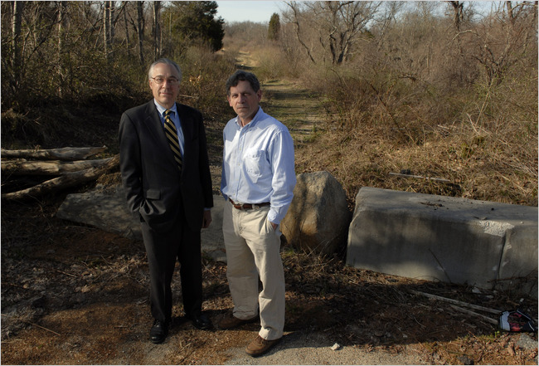

Mike Mergen for The New York Times
Edward F. Sanderson, left, of the historical commission, and Paul Robinson, the state archaeologist. “This is part of our history,” Mr. Sanderson said.
Now, archaeological evidence of the Narragansetts’ early presence in Rhode Island has ignited a debate over private development on a site that some consider to be culturally and historically significant. The state maintains it has the regulatory authority to stop development on the site. The developer says this amounts to a taking of his land, for which he is constitutionally entitled to compensation, a claim the state denies.
At issue is a 25-acre parcel in Narragansett, a town of about 16,500 people that hugs the southern coast of Rhode Island. The parcel is part of a 67-acre tract on which the developer, Downing Salt Pond Partners, wants to build 53 single-family houses.
Downing has a permit from the state dating from 1992 that allows the subdivision. The state says the permit was conditioned on the developer’s agreeing to respect the site’s archaeological significance, which was established in a preliminary survey in the 1980s. The developer has owned the property, originally 100 acres, since 1985 and has built a shopping plaza and 26 single-family homes on it.
A 2006 survey in preparation for the new subdivision revealed what archaeologists consider the remains of a Narragansett Indian village dating from 1100 to 1300. In 2007, the state Historical Preservation and Heritage Commission recommended that Rhode Island revoke the permit. The state says it has a right to protect its cultural and historic heritage and last summer issued a cease-and-desist order to stop bulldozing on the site.
The developer maintains it has sought clarification from the state about the status of the permit but could not get a response, prompting a lawsuit in federal court.
“This is part of our history,” said Edward F. Sanderson, the executive director of the historical commission. The agency has asked the Coastal Resources Management Council, which issued the permit, to conduct a public hearing on Downing’s request to continue work on the parcel, taking into consideration the site’s archaeological significance. That hearing is expected to take place within the next few weeks.
In the lawsuit, filed in Federal District Court in Providence in August, Downing claimed the measures the state had taken to prevent it from developing the subdivision had amounted to a “de facto” taking of the property.
The state is seeking to create a public archaeology park out of private land that Downing had already started to develop, not only violating the developer’s private property rights but also causing it considerable financial harm, the lawsuit states.
The federal court dismissed that complaint on March 19, saying that the case did not fall under federal jurisdiction. No decision has been made yet whether to appeal the decision, said William R. Landry, the lawyer for Downing, a limited partnership whose principal is Richard Baccari, a well-known developer in the state. Mr. Baccari declined to be interviewed.
“Our position is that the government can take land for parks and roads, but they have to pay for it,” Mr. Landry said. He said the property was worth at least $10 million, and while the state has discussed buying it as a means to preserve it, it has not made an offer.
The discovery of the Indian village has excited archaeologists because of the insights it may give into how Indians lived in pre-Columbian times. To find the remains of an entire village is rare, according to archaeologists; only one other village similar in scope and complexity has been found on the East Coast, in Virginia.
“The fact of the matter is most have been destroyed through the process of development over the last 200 to 300 years,” said Elizabeth S. Chilton, an archaeologist, who is the chairwoman of the anthropology department at the University of Massachusetts, Amherst.
Archaeologists have discovered evidence of individual homes, but nothing that would reveal how Indians lived, worked and worshiped together in a community before Europeans arrived, she said.
Preliminary surveys of the Narragansett tract, known as RI 110, have revealed a village with perhaps as many 22 structures, as well as three known human burial sites. There is also evidence of granaries, ceremonial areas and storage pits that may shed new light on the importance of maize agriculture to woodland tribes like the Narragansetts, Ms. Chilton and others said.
“Each and every time a layer of history has been peeled back, more history has been revealed,” said John Brown, the historic preservation officer for the Narragansett Indian tribe.
The first phase of construction on Downing’s property, which took place in the late 1980s and early 1990s, proceeded largely without controversy.
Not only did the developer obtain necessary permits, but it also complied with state requirements to conduct archaeological surveys of the site and confined construction to the eastern end of the parcel, which was considered less archaeologically risky.
Downing Salt Pond Partners’ suit did not dispute that the state has legitimate intellectual and cultural interest in the property, but it challenged the right of the state to take private land without payment, Mr. Landry said. The state has been unable to find the money to compensate Mr. Baccari, Mr. Sanderson of the historical commission said.
“There is no fund to acquire sites like this,” he added.
Legal questions aside, Ms. Chilton said, the real question was whether society valued heritage and knowledge as much as the rights of private property owners. In other countries, there is a more developed sense of stewardship of private lands for the benefit of the public, but that is not yet the case here, she said.
She and others said the Narragansett site represented a once-in-a-lifetime chance to learn about life hundreds of years ago. If Downing were to prevail in this case, Mr. Sanderson said, “it would be a tremendous loss.”

