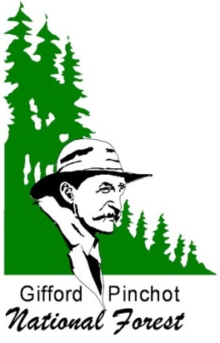Outreach

Heritage Resource Program

Archaeologist

GS-193-11

Posted: September 10, 2010

MT. ADAMS RANGER DISTRICT
Gifford Pinchot National Forest
2455 Highway 141, Trout Lake, WA

The Gifford Pinchot National Forest is conducting outreach to identify candidates for the position of Archaeologist. The position is located on the Mt. Adams Ranger District with a duty station in Trout Lake, Washington. This is a GS-193-11, permanent full-time position. The position will be advertised using USAJOBS (www.usajobs.com), the Federal Government’s official source for Federal jobs as both open to the public as well as Federal Government status employees.

The Position
This position serves as an archaeologist responsible for the inventory, evaluation, protection, and enhancement of historic and archaeological resources. Major duties include planning and executing surveys to identify and document these resources and assess potential project effects. The position requires a working professional knowledge of standard archaeological field, analysis, and technical writing procedures. Public education and involvement are also important aspects of the program.

This position is a member of the South Zone Planning Team responsible for ensuring that land management projects across the south-half of the Forest meet requirements of the National Historic Preservation Act (NHPA) and the National Environmental Policy Act (NEPA). The incumbent writes, edits, and prepares technical reports based on synthesis of archeological and historical research. In addition, the position coordinates with other agencies and tribal representatives on issues related to heritage resources.

We are seeking an individual who has:
- Demonstrated professional experience with historical research and standard archaeological data collection procedures.
- Experience meeting the requirements of NHPA and NEPA.
- Previous supervisory experience managing large field crews.
- Previous experience developing programs and/or interpretive products for a public audience.
- A safe and professional working attitude and good communication skills (orally and in writing).
- The ability to create a work environment that respects, appreciates, and accepts the contributions and perspectives of all employees.

For More information
Please contact Erin Black, at (509) 395-3411 or ekblack@fs.fed.us.

Gifford Pinchot National Forest

The Gifford Pinchot National Forest is one of the oldest National Forests in the United States. Included as part of the Mt Rainier Forest Reserve in 1897, this area was set aside as the Columbia National Forest in 1908, and subsequently renamed the Gifford Pinchot National Forest in 1949. Located in southwest Washington State, the forest comprises about 1.4 million acres and includes the Mount St. Helens National Volcanic Monument established by Congress in 1982. While Mt. Adams Ranger District is located in a rural setting, several of the larger metropolitan population areas in the Pacific Northwest access the forest for many types of recreational activities. The Portland-Vancouver metro area is located within a couple hours’ drive of the district.

Candidates may learn about the Forest, our programs, and our opportunities by visiting its award-winning web site. http://www.fs.fed.us/gpnf

Community and Locale

The Mt. Adams District Office is located in Trout Lake, Washington, along Highway 141, an important recreation and access route through Washington’s central Cascade Mountains. Trout Lake is a small community with a rural atmosphere that reflects the tremendous outdoor opportunities in the area. Klickitat County is a rural setting, with a population of 18,000.

Many employees live in nearby towns, including White Salmon, Carson, and Stevenson, WA, as well as Hood River, Oregon. The Trout Lake community, including outlying areas, has a population of approximately 500. This is a setting that appeals to candidates who are seeking a lifestyle provided by a small rural community. The town has a grocery, gas station, three restaurants, three churches, and a Buddhist temple. Accommodations are provided by a motel, several bed and breakfasts, rental cabins, and two RV parks. The Trout Lake School District provides K-12 education for about 150 students. The high school program offers learning center facilities with access to college-level courses. A community hospital is located in 23 miles away in White Salmon, where you can also find other essential services such as banks, drivers licensing, and utility offices.
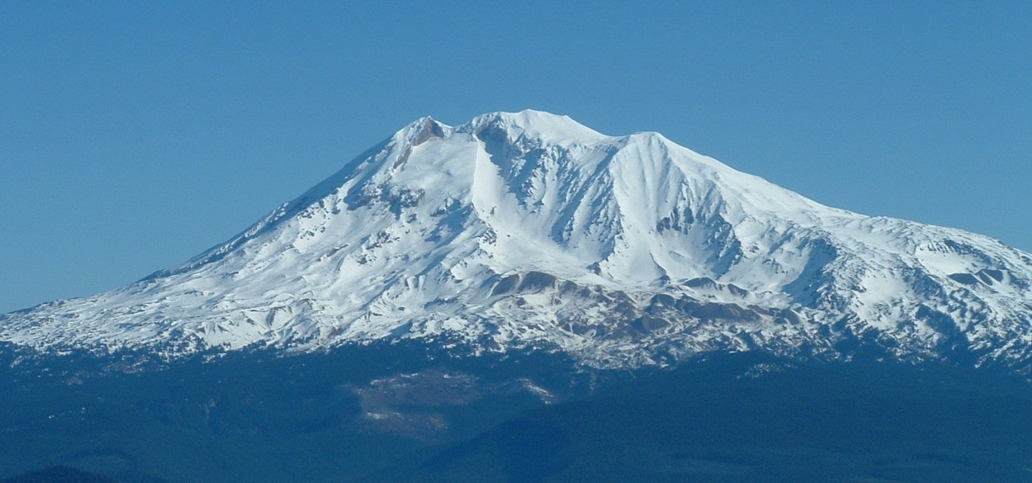
OUTREACH RESPONSE FORM
Mt. Adams, Elev. 12,276 ft

GS-193-11 Archeologist

Mt. Adams Ranger District

Gifford Pinchot National Forest, Region 6

PLEASE REPLY BY OCTOBER 15, 2010

NAME: ____________________________________________________________

EMAIL ADDRESS: __________________________________________

MAILING ADDRESS: __________________________________________________

TELEPHONE NUMBER: ________________________________

GOVERNMENT AGENCY EMPLOYED WITH: USFS____ BLM____ OTHER____

TYPE OF CURRENT APPOINTMENT: PERMANENT______ TEMPORARY_____
TERM______ OTHER_____

CURRENT AGENCY/REGION/FOREST/DISTRICT: _______________

CURRENT SERIES AND GRADE: ______________________________

CURRENT POSITION TITLE: ___________________________________

If not a current permanent (career or career conditional) employee, are you eligible to be hired under any of the following special authorities?

___ PERSON WITH DISABILITIES
___VETERANS READJUSTMENT
___DISABLED VETERAN W/ 30% COMPENSABLE DISABILITY
___VETERANS EMPLOYMENT OPPORTUNITIES ACT OF 1998
___FORMER PEACE CORPS VOLUNTEER
___STUDENT CAREER EXPERIENCE PROGRAM
___OTHER_________________________________

Please send this completed form to Erin Black, South Zone Planning Team Leader at ekblack@fs.fed.us or FAX to (509) 395-3424 or mail to: Erin Black, Mt. Adams Ranger District, 2455 Highway 141, Trout Lake, WA 98650.

Thank you for your interest in our vacancy.
USDA Gifford Pinchot National Forest is an equal opportunity employer.

