USDA Forest Service

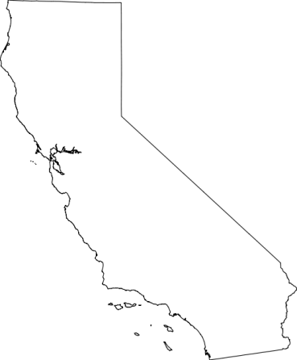
Pacific Southwest Region
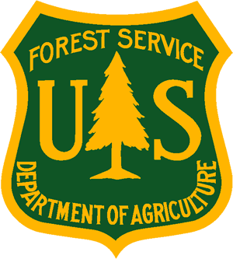
_______________________________
Outreach Notice
Klamath National Forest
Salmon/Scott River Ranger District
___________________________________

ARCHEOLOGICAL TECHNICIAN, GS-0102-06 or GS-0102-07
(Full Time-Temporary, Not to Exceed 6 Months)

The Klamath National Forest will soon be filling up to 2 full time, temporary (not to exceed 6 months) ARCHEOLOGICAL TECHNICIAN, GS-0102-06 or GS-0102-07, positions on the Salmon/Scott River District in Fort Jones, California. This notification is being circulated to inform prospective applicants of this upcoming opportunity.

These positions will be advertised under Open Continuous Recruitment (OCR) concurrently with this outreach period. The vacancy announcement information follows in this notice. The application deadline is February 27, 2012.

DUTIES ASSOCIATED WITH THIS POSITION:

Performs archeological field surveys to gather technical data and information. Identifiies and records the exact location and orientation of cultural sites and artifacts using maps, aerial photographs, digital cameras,and/or global positioining systems (GPS ) receivers. Monitors archeological projects to ensure sufficiency of on-site surveying and recording. Assists in the preparation of archeological reports, such as cultural resource inventories to document environmental and cultural backgrounds, methodologies, and findings. Assists in data management and performs routine data entry. Assists in the preparation of archeological and historical information for interpreting cultural sites.

For any questions regarding this position, please contact District Ranger Dave Hays at (530) 468-1235 or email at rdhays@fs.fed.us.

VACANCY ANNOUNCEMENT:

The following Vacancy Announcement for this position is available on the Office of Personnel Management's USAJOBS website at https://www.usajobs.opm.gov . The Forest Service uses AVUE Digital Services, an automated on-line application system, to fill positions at https://www.avuedigitalservices.com/usfs/applicant.html. Even if you have developed a resume in USAJOBS, you will need to access this on-line system to complete the application process.

Applicants should indicate their preference for Fort Jones, California as one of their geographic locations in order to be considered for a vacancy at the Klamath National Forest, Salmon River/Scott River Ranger District. The application deadline is February 27, 2012.

VACANCY ANNOUNCEMENT: OCRT-102-6-ARCH-DT
And/Or
VACANCY ANNOUNCEMENT: OCRT-102-7-ARCH-DT

ABOUT THE FOREST:

The Klamath National Forest covers an area of 1,700,000 acres located in Siskiyou County in Northern California and Jackson County in Oregon. The Forest includes all or part of five wilderness areas: Marble Mountain, Russian, Trinity Alps, Red Buttes and Siskiyou. Trailheads are numerous and hikes range from easy to arduous. If it's a wilderness experience you seek, the Klamath is the place to come!

There are 200 miles of river system for rafting and 152 miles of wild and scenic rivers in the Forest. In addition, the Klamath National Forest offers 28 campgrounds, hiking, fishing and wildlife viewing. With the Klamath, Salmon, and Scott Rivers meandering from one end of the Forest to the other, recreationists have found a playground that can meet the desires of all. This beautiful Forest is a haven for campers, hikers, wildlife watchers, hunters, fishermen, mountains bikers, white water enthusiasts and naturalists!

The Forest also helps to meet local and national needs for a variety of natural resources. Proactive vegetation management is an important element of caring for our public lands, and the professional staff of the Klamath leads the way by setting the standards for others to follow. With that, the preservation of biological diversity, and the sustainment of forest health are important to us.

More information on the Klamath National Forest is on our website: http://fs.usda.gov/klamath/ .

ABOUT THE COMMUNITY:

The Salmon/Scott River Ranger District main office is located in the town of Fort Jones, California in the Scott River Valley. The District is bisected by the Salmon River on the south and the Scott River on the north and has three wilderness areas, the Trinity Alps, Russian, and Marble Mountain wilderness areas. The District includes approximately 585,000 acres.

Scott Valley is a small, rural area dependent on agriculture and forest products. It encompasses several small communities, the largest being Etna and Fort Jones. The total population is about 5,000, many of which commute to Yreka for work. Scott Valley is primarily served by state Highway 3, connecting it to Yreka about 25 minutes away. Etna High School serves the Scott Valley area (Yreka High School serves the Yreka area). There are several elementary and middle schools within these areas. College of the Siskiyous, a two year community college, is located in Weed, CA with a satellite campus in Yreka.

Fairchild Medical Center is located in Yreka. There are several private doctor and dentist practices, including several specialties. There are also some family clinics including Scott Valley Rural Health Clinic. Scott Valley offers a basic selection of automotive, motels, restaurants, banking, food, and hardware stores and services. The Yreka area offers a fairly complete selection of shopping and service needs including a small shopping center on the south end of town. Additional choices and specialty stores are 1/2 to 1-1/2 hours away at Ashland, OR and Medford, OR, and Redding, CA.

The Klamath National Forest Supervisor’s Office is located in Yreka, California (pronounced Y-Reeka). Yreka is located twenty-two miles south of the California/Oregon border along Interstate 5. Yreka is a quiet little city located in an area rich in history and generous in natural resources, nestled in the northern most corner of the majestic Shasta Valley. Serving as the county seat of Siskiyou County, geographically the fifth largest county in the state, Yreka is the largest full service community between Ashland, Oregon and Redding, California. The population base provides support for professional services, medical facilities, all governmental offices and a full range of retail businesses which make Yreka the trade center for the county. Yreka is abundant in its intrinsic beauty and enjoys the diversity of all four seasons. Outdoor recreation opportunities are abundant and include fishing, hunting, camping, boating, whitewater rafting, Nordic and Alpine skiing, golf, and just about any other outdoor activity imaginable.
More information about the forest can be found on the Klamath National Forest website: http://fs.usda.gov/klamath/ . Information about Yreka can be found at the Yreka Chamber of Commerce website: http://www.yrekachamber.com/

The U.S. Department of Agriculture (USDA) prohibits discrimination on all its programs and activities on the basis of race, color, national origin, gender, religion, age, disability, political beliefs, sexual orientation, and marital or family status. (Not all prohibited bases apply to all programs.) Persons with disabilities who require alternative means for communication of program information (Braille, large print, audiotape, etc.) should contact USDA's TARGET Center at (202) 720-2600 (voice and TDD). To file a complaint of discrimination, write USDA, Director, Office of Civil Rights, Room 326-W, Whitten Building, 14th and Independence Avenue, SW, Washington, DC 20250-9410 or call (202) 720-5964 (voice and TDD). USDA is an equal opportunity provider and employer.

