Call for applicants for the Roche Harbor Homestead Field Project, San Juan Island, Washington.
Burke Museum of Natural History and Culture, August 17-24, 2015.
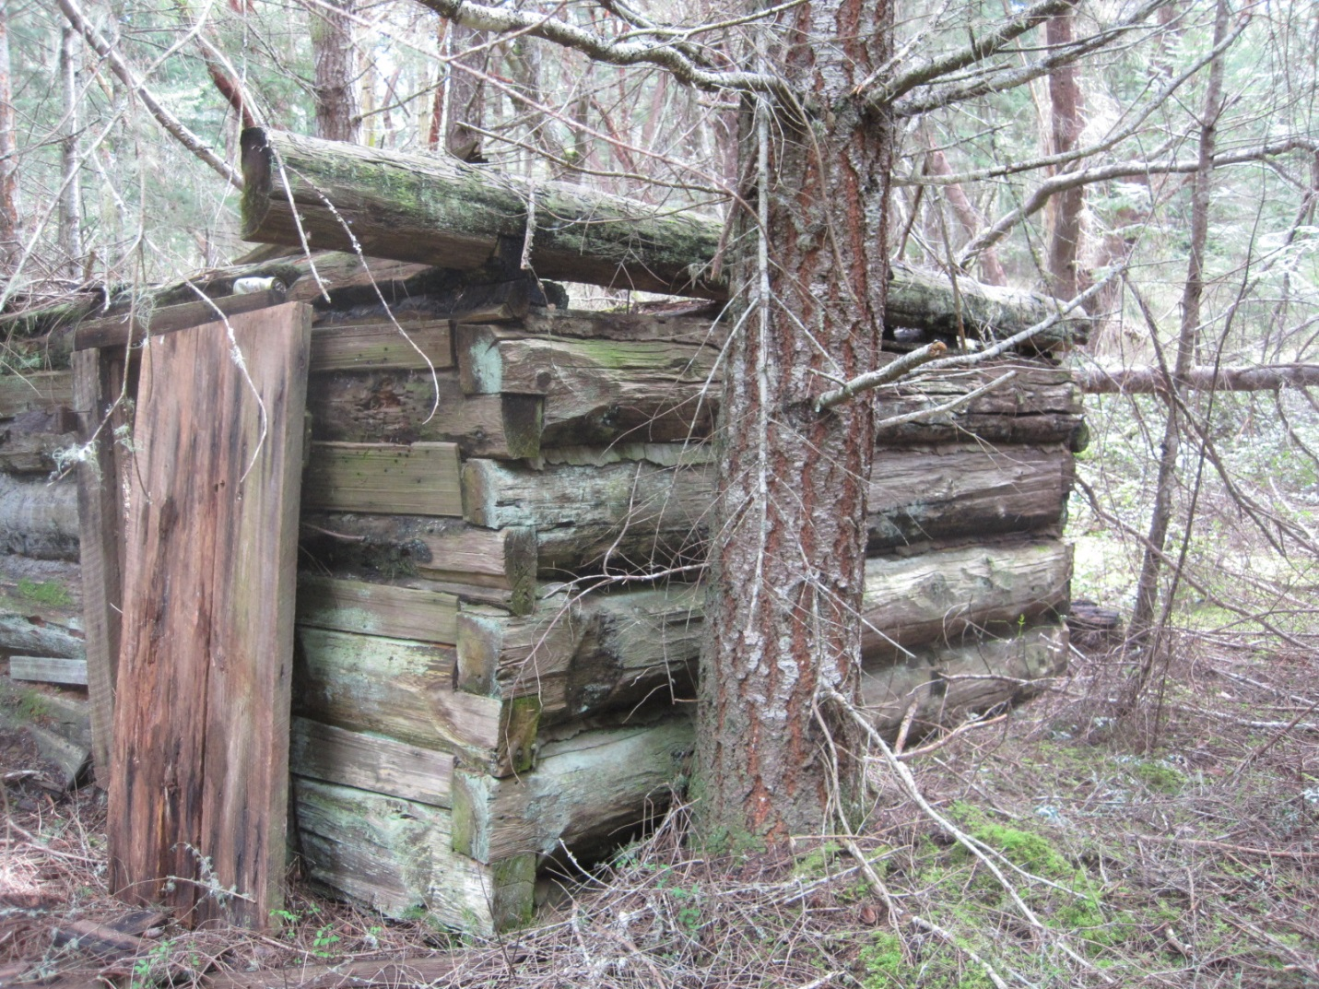
This field workshop will investigate a historic homestead on San Juan Island and provide a low-cost opportunity for undergraduates and recent graduates to learn field skills needed to pursue a career in archaeology or related disciplines. The program is aimed at students with no prior field experience who would not otherwise have an opportunity to complete a field school. Field modules include survey, mapping, shovel testing, and excavation. The project will be led by Dr. Amanda Taylor, Burke Museum Curatorial Associate/Visiting Professor of Anthropology at Pacific Lutheran University. Please contact at akt5321@gmail.com with any questions.
Dates: August 17-24, 2015.
Tuition: $490. Please inquire about scholarships if needed.
Transportation: Vans will leave the Burke Museum in Seattle on August 17 and return August 24. Students can also meet/leave the group at the Anacortes Ferry Terminal on those dates.
Amenities: Camping for a week near the project area on San Juan Island. Minimal cell phone reception, no electricity, irregular access to hot showers, porta-potties on site. Breakfast and lunch included with tuition. Camping gear required. Please inquire about gear for loan if needed.
To apply: Send a completed application and one letter of recommendation from an instructor, advisor, or employer in a sealed, signed envelope to the Archaeology Dept. at the Burke Museum by June 20, 2015. Recommendation form and application questions included below. Applicants considered for the program will be contacted by email to arrange phone interviews. Further questions and requirements will be addressed upon acceptance.
Mailing Address:

Amanda Taylor
Archaeology Department
Burke Museum of Natural History & Culture
University of Washington, Box 353010
Seattle, WA 98195

Roche Harbor Homestead Field Project Application
Full Name ________________________ Date _____________________________
Phone Number ______________________ Email ____________________________
College/University ___________________
Year in school/Graduation date _______________________
Write ‘Yes’ or ‘No’ for the following questions:
Are you an archaeology/anthropology major?
Do you have any camping experience?
Do you require financial assistance to participate in this field school?
Please answer the following questions in a few sentences to a paragraph:
- Describe your education in archaeology and your career aspirations.

- Why do you want to participate in this field project?

- What strengths will you bring to the Roche Harbor Field Project team?

Roche Harbor Homestead Field Project Recommendation Form
Name: ____________________________ Affiliation: ____________________________
Phone: ________________ Email: ________________
- In what capacity have you taught, mentored, or worked with this student?

- Please describe the student’s strengths in a field school setting.

- How would this field experience benefit this student’s education and career?

- Further comments?

Signature: ______________________________ Date: _______________________

