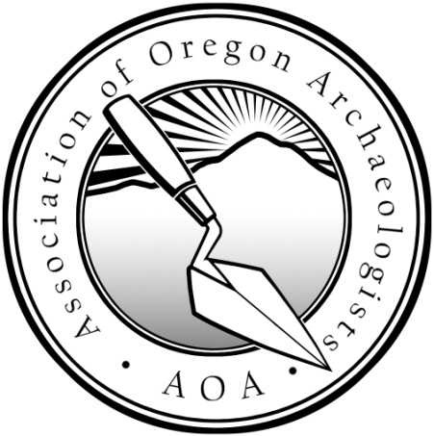
Hey Students!
Presenting at the
NW Anthropological Conference?

The AOA wants to award YOU $300!
The Association of Oregon Archaeologists (AOA) is offering a $300 Student Travel Award to a student presenting their research at the Northwest Anthropological Conference (NWAC).

Qualifications:
- Applicant must be a currently enrolled undergraduate/graduate student
- Research must directly contribute to and enhance the understanding of Oregon archaeology
- Applicant must present the research at the NWAC as a paper or poster
- Submit an application (see below) to the AOA by midnight, March 1st

The Award:
- $300 to help with travel expenses for the NWAC
- 1 ticket to the NWAC's Friday evening banquet
- 1 year's student membership to the AOA (awarded to all applicants!)
- Abstract published in the AOA's newsletter, Current Archaeological Happenings in Oregon (CAHO)

Application Requirements:
- Title of the presentation
- A copy of the abstract for the paper or poster
- An outline of the presentation (required for both a paper and poster presentation)
- Generally outline the presentation's research question, theory/methods used, results, and how this research contributes to and enhances the understanding of Oregon archaeology.
- Use the attached application form or download the form from our website
- Send your application form or information to the AOA Board at assocoregonarchaeologists@gmail.com

Deadline:
Applications are due by midnight, March 1st

Open to all students whose research directly contributes to and enhances the understanding of Oregon archaeology.
For questions and submissions, contact the AOA at assocoregonarchaeologists@gmail.com.
NWAC details can be found at: https://www.nwaconference.com/
AOA details can be found at our website: www.OregonArchaeology.com

