EPHT OTAG Meeting - 01/31/2011

**Heat-Related Illness Projects – Background Information**

**Defining Heat Waves**

Goal: Determine Oregon-specific heat wave definitions that are related to significant increases in health outcomes. At least two definitions will probably be needed for different climate regions in Oregon.

The climate regions might be similar to the regions shown below, which are based on major waterway basins and used by the algae program, ODFW and DEQ. For analysis purposes, the regions will need to follow county boundaries and may need to be combined, depending on how large the hospitalization counts are, to increase the power of our analyses.

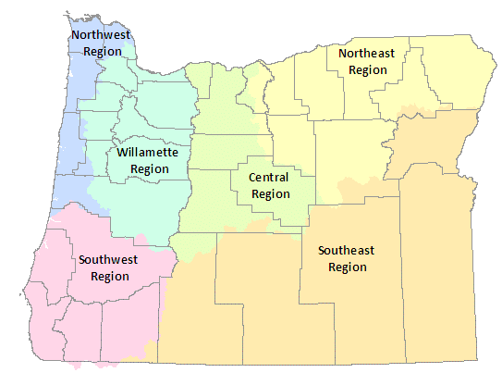

Questions for OTAG Members:

* What would a good health-based heat wave definition look like for Oregon?
* We’re planning to collaborate with WA EPHT. Would it be better to…
* Work on developing methods together but run separate analyses?
* Try to pool hospital discharge data to create definitions for contiguous climate regions?
* How many regions will we realistically be able to analyze?

**Future Heat Indicators**

Oregon EPHT proposed heat-related illness indicators:

* # of heat wave events and days
* Person days of exposure to heat waves
* # of excess hospitalizations during heat waves by age group
* Attributable risk of hospitalizations during heat waves by age group

The indicators will be summarized by county, climate region and for the entire state. We may look at different age groups, for example, 0-4, 5-64, 65+ and all ages. It is also possible for us to look at excesses in specific diagnosis groups that are related to heat. These include:

* All hospitalizations
* External causes (accidents, trauma)
* Internal causes (all else)
* Heat-related illness
* Electrolyte imbalance
* Nephritis
* Acute renal failure
* Cardiovascular diseases
* Acute myocardial infarction
* Cerebrovascular diseases
* Respiratory illnesses
* Diabetes

Questions for OTAG Members:

* Do these indicators seem useful?
* How could they be used to support public health actions?
* Should we be looking at deaths even though there won’t be many?
* What specific age groups should we look at, if any?
* Does attributable risk make sense as a measure? Other metrics (e.g. RR)?
* What specific diagnosis groups might we want to look at in addition to all hospitalizations?
* Should we have an indicator to track the intensity of heat waves?

**Attachments**

1. Heat-Related Illness Projects Presentation
2. Knowlton et al. 2009 – Describes a simple method for determining excess hospitalizations during a heat wave. Our proposed indicators of excess hospitalization and attributable risk will use similar methods.

**Presenter Info**

Dan Rubado | Epidemiologist

Environmental Public Health Tracking

Office of Environmental Public Health

Public Health Division | Oregon Health Authority

Phone: 971-673-1210

E-Mail: daniel.j.rubado@state.or.us