 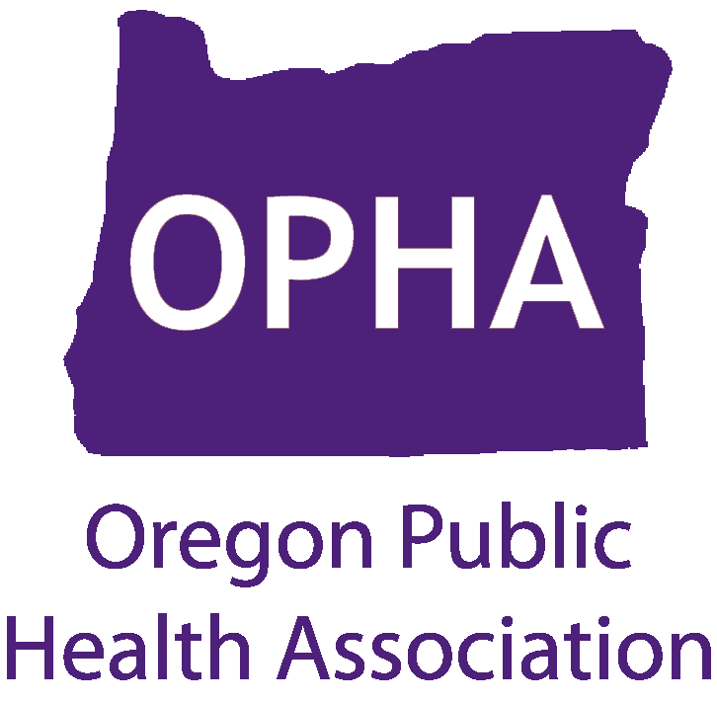

**Designing Healthy Communities**

by Richard Jackson, MD, MPH (formerly of CDC, now at UCLA)

**Portland State Office Building, 800 NE Oregon Street, Portland**

**Friday, June 8, 2012, 12:00n-1:00pm, Room 1E**

**Episode 2: “Rebuilding Places of the Heart”**

Parents and children under seige.  When U.S. industry and manufacturing collapsed or went elsewhere, cities like Elgin, IL, and Syracuse, NY (like many communities in the United States) were left with the task of redefining themselves for a new paradigm.  Leading the way to a greener, more sustainable Elgin is a group of high school students.  Despite many innovative programs to get Syracuse back on its feet, the city struggles with the larger problem of Lake Onondaga, the most polluted lake in our nation. Local Native American Onondaga tribal leader, Oren Lyons, serves as conscience in the movement to restore Lake Onondaga for “Seven Generations to come.”  And in Riverside, CA, 16-year old science prodigy, Otana Jakpor, has a personal reason for her war against air pollution. She takes her battle all the way to the White House.

**Friday, June 22, 2012, 12:00n-1:00pm, Room 1E**

**Episode 3: “Social Policy in Concrete”**

Dr. Jackson believes it is every citizen’s right to live in a clean, healthy environment. This isn’t the case for many low-income neighborhoods, built near big transportation hubs and struggling industrial cities like Oakland, CA and Detroit, MI.  We meet a morbidly obese grandmother struggling to raise seven grandchildren, all of whom have asthma as a result of living near the Port of Oakland.  The city of Detroit resembles an abandoned war zone. Yet, hope blossoms in both. Health officials, community activists and a new breed of young Urban Pioneers are working to fix their cities by transforming urban wilderness and food deserts into inspirational new models for other troubled communities.

**Friday, June 29, 2012, 12:00n-1:00pm, Room 1E**

**Episode 4: “Searching for Shangri La"**

Dr. Jackson searches past and present America for healthy, sustainable communities of all sizes and shapes that can serve as models for the rest of the nation. His journey takes him to Roseto, PA, Prairie Crossing, IL, New York City, Charleston, SC, and the forgotten 1960s urban renewal project of Lafayette Park in Detroit, MI, the brainchild of 4 men, including visionary architect, Mies van der Rohe.

This series appeared on many PBS television stations (not including Portland) in 2011. We watched Part 1 (“Retrofitting Suburbia”) during Public Health Week. For more information visit: [www.oregonpublichealth.org](http://www.oregonpublichealth.org)

e:\OPHA Designing Healthy Communities 2-3-4 flyer 2012-04-23