
Social Sciences Instructional Materials Regional Caravan
November/December 2018 Regional Caravan
The Oregon Department of Education is partnering with 7 ESDs in the state to host the regional caravan for adopted Social Sciences instructional materials. This opportunity is aimed at providing K-12 classroom teachers and school district staff a look at approved instructional materials in Social Sciences. Publishers will give presentations and have samples of their adopted materials on site.
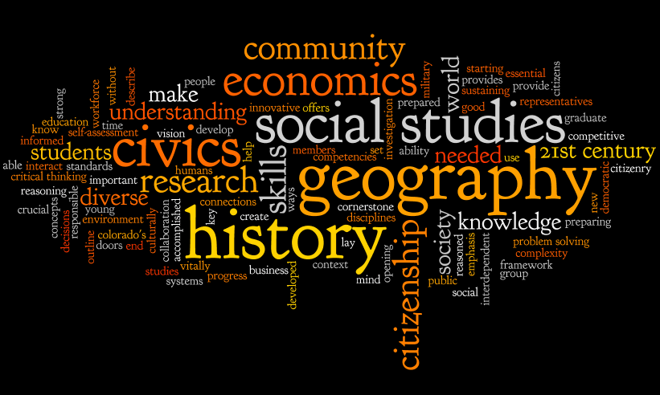
Please see the list of dates, times, and locations below:
- November 26: Clackamas ESD, Portland
- November 28: Willamette ESD, Salem
- December 6: Southern Oregon ESD @ Medford School District
- December 7: Douglas ESD, Roseburg
- December 10: Intermountain ESD
- December 11: Malheur ESD
- December 18: Lane ESD, Eugene


Publishers Participating in the Caravan:
National Geographic Learning/Cengage
Houghton Mifflin Harcourt
McGraw-Hill School Education
Pearson Education
Social Studies School Service

Sample Agenda for Caravan
8:00AM-8:30AM – Registration/Network
*8:00AM-4:00PM – Publisher Displays*
8:45AM-12:00PM – Publisher Presentations
12:00PM-1:15PM – Lunch (on your own)
1:15PM-3:45PM – Publisher Presentations
3:45PM-4:00PM – ODE Wrap Up

*Registration is recommended to attend any of the caravan stops. You may register at: https://www.surveymonkey.com/r/9D7WW3J
*For more information, please contact Jeremy A. Wartz at Jeremy.wartz@state.or.us

