Hello,

Agencies tracking time in response to the Coronavirus pandemic can set up a “Hot Key” within the OSPA to ease the confusion for employees entering within ePayroll.  See instructions below to set up the hot key within OSPA, followed by instructions for the employee on entering the time.

Payroll:

OSPS Screen: PCHG

Code: COVD (alphabetic characters)

Agency: (insert your agency)

Work Charge: PJTCOVID119

Type: C

Description: CORONAVIRUS 19

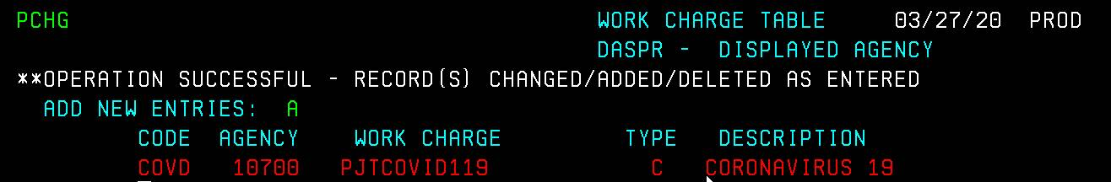

When the employee is entering within ePayroll:

Under the Work Charge: COVD (alphabetic characters)

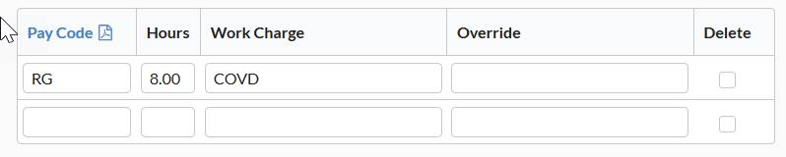

Save and Next

When the employee goes back to that day the work charge automatically changes to the work charge set up from the OSPS PCHG screen.

