As we come closer to the year’s end, we have a few timely reminders for everyone.

[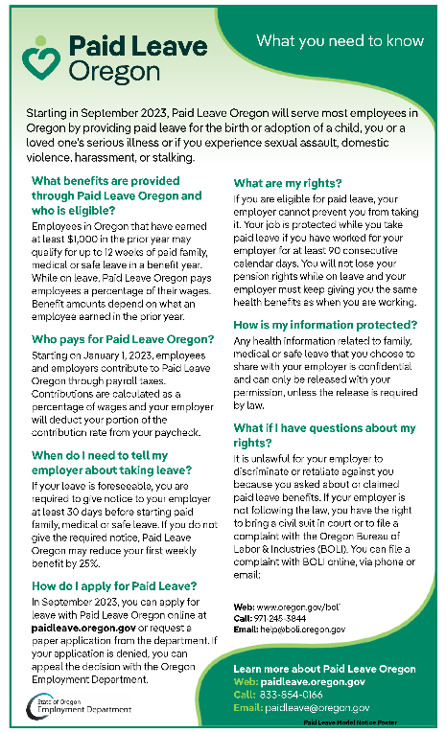](https://paidleave.oregon.gov/DocumentsForms/Paid-Leave-ModelNotice-Poster-EN.pdf)**Paid Leave Oregon**

Contributions to Paid Leave Oregon will begin with your January 3, 2023, pay. The image on the right is a required notice to employees with additional information about Paid Leave Oregon. It is a clickable link, so you can click anywhere on the image, and it will take you to a larger, more reader-friendly version. Additionally, you can find this poster in other languages on [Paid Leave Oregon’s website](https://paidleave.oregon.gov/pages/resources.aspx).

**Workday Maintenance**

In preparation for our first payroll run since implementing Workday Payroll, it will be necessary to lock all users out of Workday for a 24-hour period: starting at 5:00 a.m. on December 27 through 5:00 a.m. on December 28.

This will include the Employee Site, External Career Site, and Extended Enterprise Learners. Please plan any required training, or Workday actions accordingly.

**Information for W-2s**

In Workday, it is important that your personal information is up to date. Please take a moment to look over your information with particular attention to your “Home Contact.” This address is where we will send your W-2s for your 2022 taxes. Please make sure that is accurate by January 5, 2023.

**Remote and Hybrid Work Agreements**

If you are a full-time remote or hybrid worker, please ensure that you have a remote work agreement in place in Workday and that it is accurate and up to date. This information could have an impact on important things like your taxes, so it is imperative that this information is accurate.

**Out-of-State Full-Time Remote Employees**

If you are a full-time, out-of-state worker, you will need to set up your W-4 for the state you reside in. To activate this W-4 process, you must fill out a proper remote work agreement that indicates you are out-of-state and are a full-time remote worker. If your remote work agreement is filled out and you do not see the W-4 option within the tax election section of Workday, please contact your human resources office. It could be that your human resources office has not yet completed the additional steps that are needed for your profile to activate the W-4 option.

**Out-of-State Hybrid Employees**

If you are a hybrid out-of-state worker, you will have the option to pay income taxes for the state you currently reside in by following a similar process as stated for full-time remote out-of-state workers above. Paying state taxes only for the state you reside in will not relieve you of any obligation you may have in paying Oregon income taxes owed.

NOTE: For any tax-related decisions, please make sure you are consulting with your tax professional. As an employer, Oregon is unable to provide tax advice to employees.