## **Sample Communication - Message to Employees from Agency Payroll**

## **Communication Topic:** Available Now! Verify My Information App Audience: Agency Employees

## **Target Send Date:** Dec. 19 – Dec. 23, 2023

## **Method of Communication:** Internal Communications (intranet, internal email, ect.)

Good afternoon,

As we close out 2023 and prepare for the new year, please verify your Workday profile information, including your current PEBB benefits in the “Verify My Information” app.

Open enrollment benefits are loaded into Workday can be verified in the “Benefit Elections” table. If you see discrepancies with your open enrollment benefits, please contact your agency payroll office.

“Election Status” will show current benefits and/or future benefits (defined below):

* Current = Open enrollment benefits that are ongoing from a prior year and have not changed
* Future = New or changes in benefits that were elected in this year's open enrollment
* Employee Cost per Benefit = Deductions from pay starting Jan. 1, 2024

To access the “Verify My Information” app, please follow the steps below:

1. Log in to Workday
2. Select “Verify My Information” from the app list on the left side menu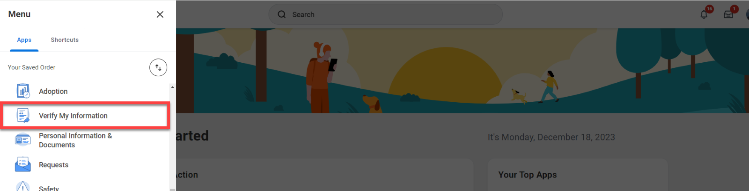
3. Open the “Verify My Information” app to have your profile information display
4. Review the information and if it is accurate, check the “I am verifying that above information is correct” box
5. Click “OK” to complete verification

For additional information refer to the “[How To Use the Verify My Information App](https://wd5.myworkday.com/oregon/email-universal/inst/21037$16331/rel-task/2998$33471.htmld)”

If you have any questions, related to the “Verify My Information” app, please contact your [agency payroll office](https://www.oregon.gov/das/HR/Pages/WD-Payroll-Contacts.aspx) or [human resources office](https://www.oregon.gov/das/HR/Pages/wd-helpdesk.aspx).

Thank you,

[Agency Signature]