# Workday Announcement Message – Feb. 1, 2024:

[Jeff to select Workday stock image for graphic]

Workday Payroll has updated the “Print Payslip Image” view in the “Pay” app. There are no changes to what you’ll see within Workday. The updated payslip is only when you select the “Print Payslip Image” button at the top of the screen.

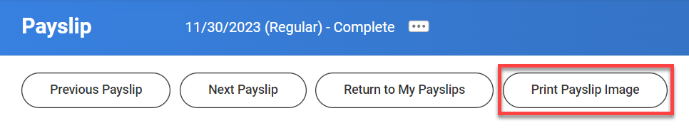

The enhancements are listed below:

1. Add company name, address, phone number to upper left.
2. In the upper right corner, added: “*If you have questions contact your agency payroll office.*”
3. Time Off Balances Box removed.
4. Increased space to allow all pay and deductions the employee had to be displayed.

The resources below are available to help you navigate reading your payslip and how to view current time off balances.

* Knowledge Article: How to Read Your Payslip
  + <https://wd5.myworkday.com/oregon/email-universal/inst/25755$1155/rel-task/2998$40834.htmld>
* Knowledge Article: How to view Time Off Balances
  + <https://wd5.myworkday.com/oregon/email-universal/inst/25755$1599/rel-task/2998$40834.htmld>