Reminders:
- Deadline for check entry is close of business the day prior
- Payments cannot be back-dated
- Please ensure your payment is ready to be processed with an anticipated gross amount before putting it on the spreadsheet
- Be mindful that all communication from the OSPS Helpdesk regarding a payment needs a response by 10am in order for us to run settlement
The spreadsheet has four tabs for agency entry that can be split into two groups: payments based on period and payments based on category.
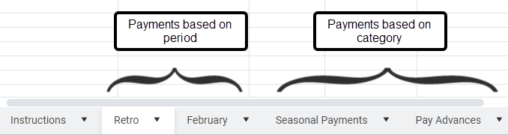

The retro and current month tabs are for most payments, the two exceptions being seasonal payments and pay advances.
We have a separate tab for any seasonal payment so that we can be sure we are paying attention to pay group and NRPPT date issues that are prevalent with seasonal employees.
If the payment you are requesting does not fall into one of those categories, it should go on the retro or current month tab depending on what period you are paying from.
Remember that once payroll run 1 has been processed, that month is now a retro period and the following month is the open period.
If you are trying to pay funds from a retro period, please put the payment on the retro tab.
Use the drop down menu in the pay period column and if you are paying retro from multiple periods, please put that in the agency comment field. This information helps us to troubleshoot the payment if the amount on the spreadsheet doesn’t match what Workday is showing. It also helps us diagnose the situation and determine how to process the payment.
The current month tab is for current month payments like terminations or reissuing a reversed payment from the open period. Another example would be a payment for a retro period but an NRPPT date stops retro from paying naturally. Those payments would also go onto the current month tab because the pay input entries would be in the current month. Please include a comment that pay input entries have been made due to the NRPPT date stopping retro from processing.

Thank you for your cooperation. Using the correct tabs and including all of the information we ask for is extremely helpful to us as we process payments each morning.

