**Expiring State Tax Elections Report for Exempt Workers**

**Step 1:** Search for the “Pay | Expiring Exempt Tax Elections” report in Workday

* **Report:** Pay | Expiring Exempt Tax Elections
* **Include MSRR Exempt:** (Leave blank)
* **Tax Authority Type for Expiring Exempt:** State
* **As of Date:** Today’s date
* **Company:** (Your Agency)
* **Tax Authorities:** Oregon
* **Include Terminated Workers:** leave unchecked
* **Select:** “OK” to run the report

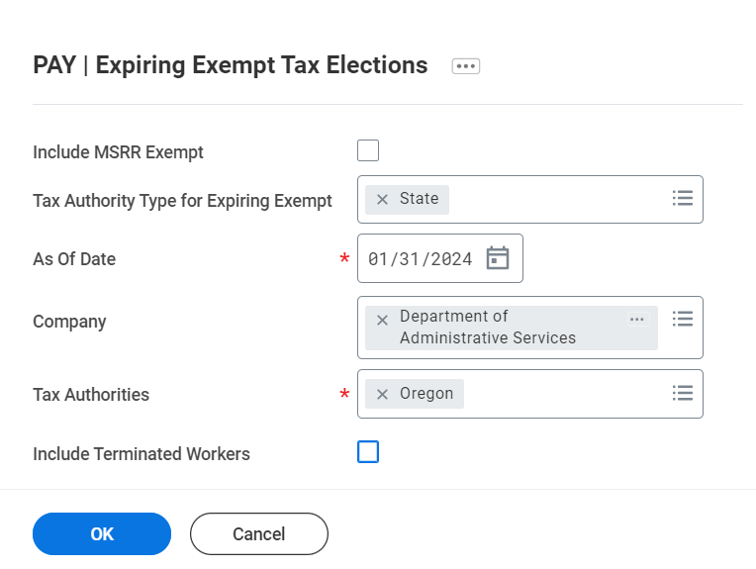

**Step 2:** On the report, filter the “Effective Date” column

**Filter Condition:** is on or before

**Value:** 12/31/23

**Select:** “Filter”

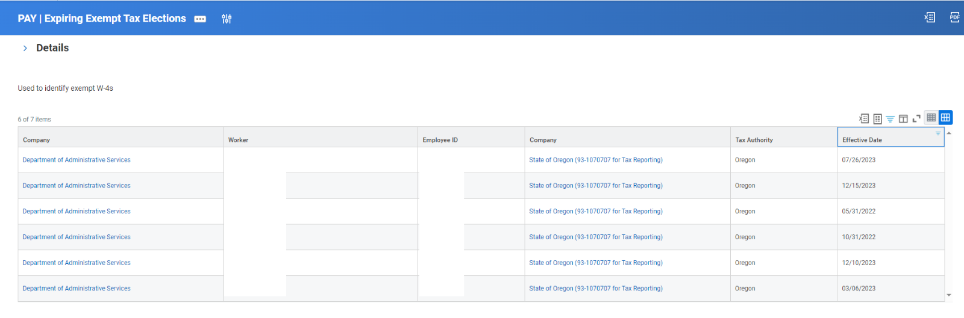

**Step 3:** Once filtered you will see every employee that needs to update their Oregon W-4 exempt status by Feb. 15, 2024. Failure to do so will result in an automatic change to the default of Single and Zero.

Workday Payroll plans to do the mass default for Federal and State (Oregon) on the morning of Feb. 16, 2024. If payroll offices want to see the pay results of the change, they will need to recalculate or wait until Feb. 17, 2024, after the nightly recalculation. Out of State requirement to follow at a later time.