**Tips for New Audit (AUD) Reports**

**AUD | Monthly Time Variance Report**

**Tip:** “First Day of Month for Review” If you enter any other date in the month, it will default to only bring back results for that month (example: entering “04/09/2024” will display results for April).

**Tip:** “Organizations (Pay Group, Supervisory Org. Company” If you type in the manager’s name it will bring up their program/team.

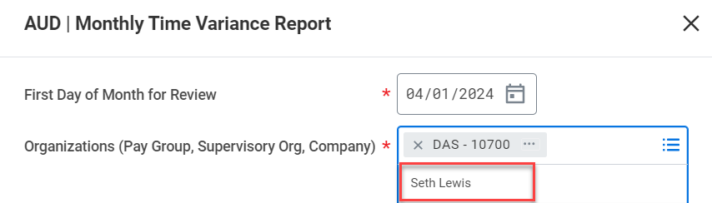

**AUD | Time Block Audit**

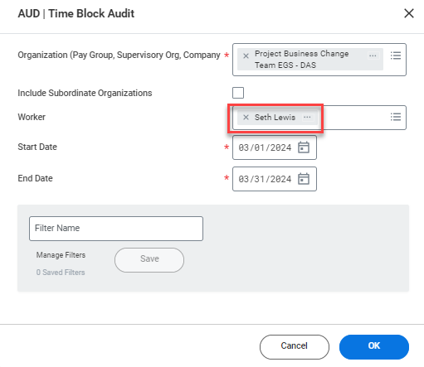

**Tip:** It is ideal to run this report for an individual employee. Do not run this report for large programs or agencies.

Some columns to note:

**Worker’s Cost Center** – Default cost center

**Time Block Comment** – There are three comments in this report:

1. Employee comment on time entry or time off
2. Manager comment if sending time or time off back
3. Manager comment if sending time back

**Approved By** – “Mass Approval” means that time was approved as part of the mid-month payroll process completed by DAS.

**Cost Center, Project or Grant Override** – Time entries through worktags