Create Leave Payout, Employee (Sample Communication):

Good afternoon,
As of Dec. 2, 2024, the Leave Payout process was updated in Workday for all State of Oregon Executive Branch employees. The “Create Leave Payout Request' page will display based on your union or representation on your Workday profile. The updated “Create Leave Payout Request, Employee” Help Article will be available to assist you with navigating the new process:
To create a leave payout request, follow these steps:
- Navigate to your Workday profile
- Select “Absence” in the menu
- Select the “Leave Payout” tab
- Select “Create Leave Payout Request”
- Select the applicable option from the “Union” dropdown
- Select applicable option from the “Time Type” dropdown
- Select the applicable option from the “Payout Details” dropdown
- Enter a reason (optional) and upload any supporting documents related to the request
- Click “OK” to complete the Leave Payout Request

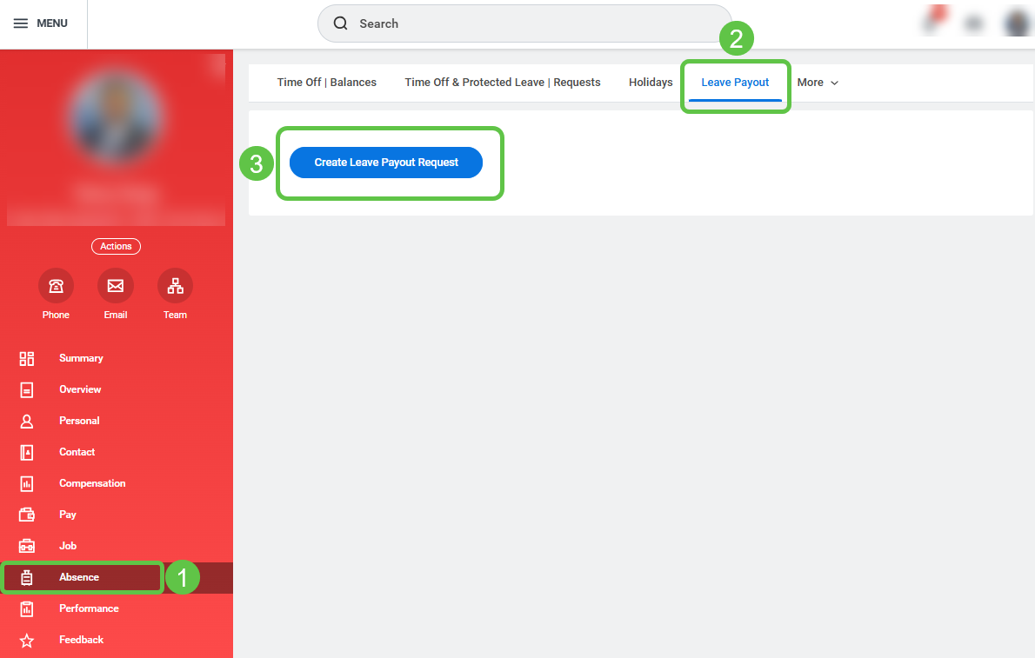

Once submitted, your request will be routed to your manager for review and approval then, the request will be sent to agency payroll for a final review and approval. When the request has completed final review, the payment will be processed.
If you have questions about the new “Create Leave Payout Request” process, please reach out to your agency payroll or consult the Workday Help Article.
Sincerely,
(Insert Agency Name and Payroll Contact)

