Approve Leave Payout, Manager (Sample Communication):

Good afternoon,
The Leave Payout business process has been updated in Workday for all State of Oregon Executive Branch employees. The “Create Leave Payout Request” page will now display options to employees that are eligible based on their union or representation. This will reduce the manual input required to process a request.
Managers are responsible for validating if the leave request meets collective bargaining agreements and/or state policy 60.000.05 Vacation Leave (j) Annual Cashout Option. A new “Approve Leave Payout Request, Manager" Help Article is available to help you with navigating your role in the new process:
Approve Leave Payout Request, Manager Help Article:
Step 1: From your Workday homepage, Click on the "My Tasks" button at the top right.
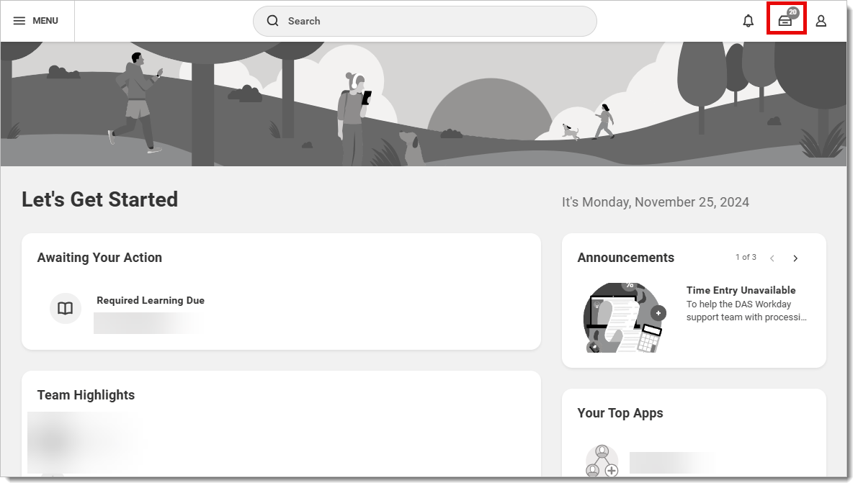
Step 2: From the "My Tasks" page, (A) click on the item, "Request Payout Review: (Employee's Name)" (B) Important: Review the details of the payout request to ensure the requested hours meet the requirements of the leave payout, (C) choose to "Approve," "Send Back," or "Deny" the payout request based on your review.
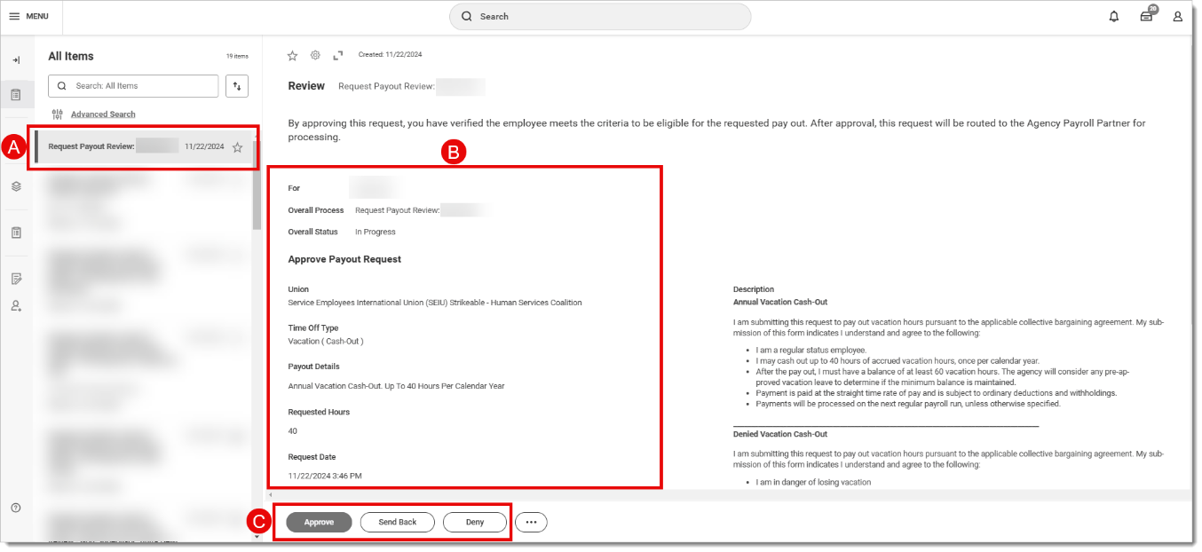
If the leave payout request is approved, a pop-up will appear with "Success! Event approved" then the request will go to the Agency Payroll Partner for final review and processing.
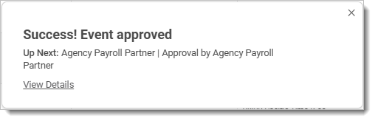
Note: Approved requests will route to agency payroll for final review and entry of the leave payout request. Requests that are approved but don’t meet the requirement will still go to your Agency Payroll for review.
If you have questions about this new business process, please reach out to your Agency Payroll or consult the Workday Help Article.
Sincerely,
(Insert Agency Name and Payroll Contact)

