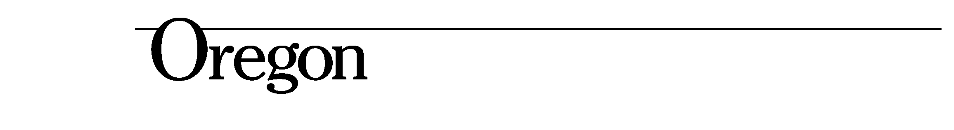
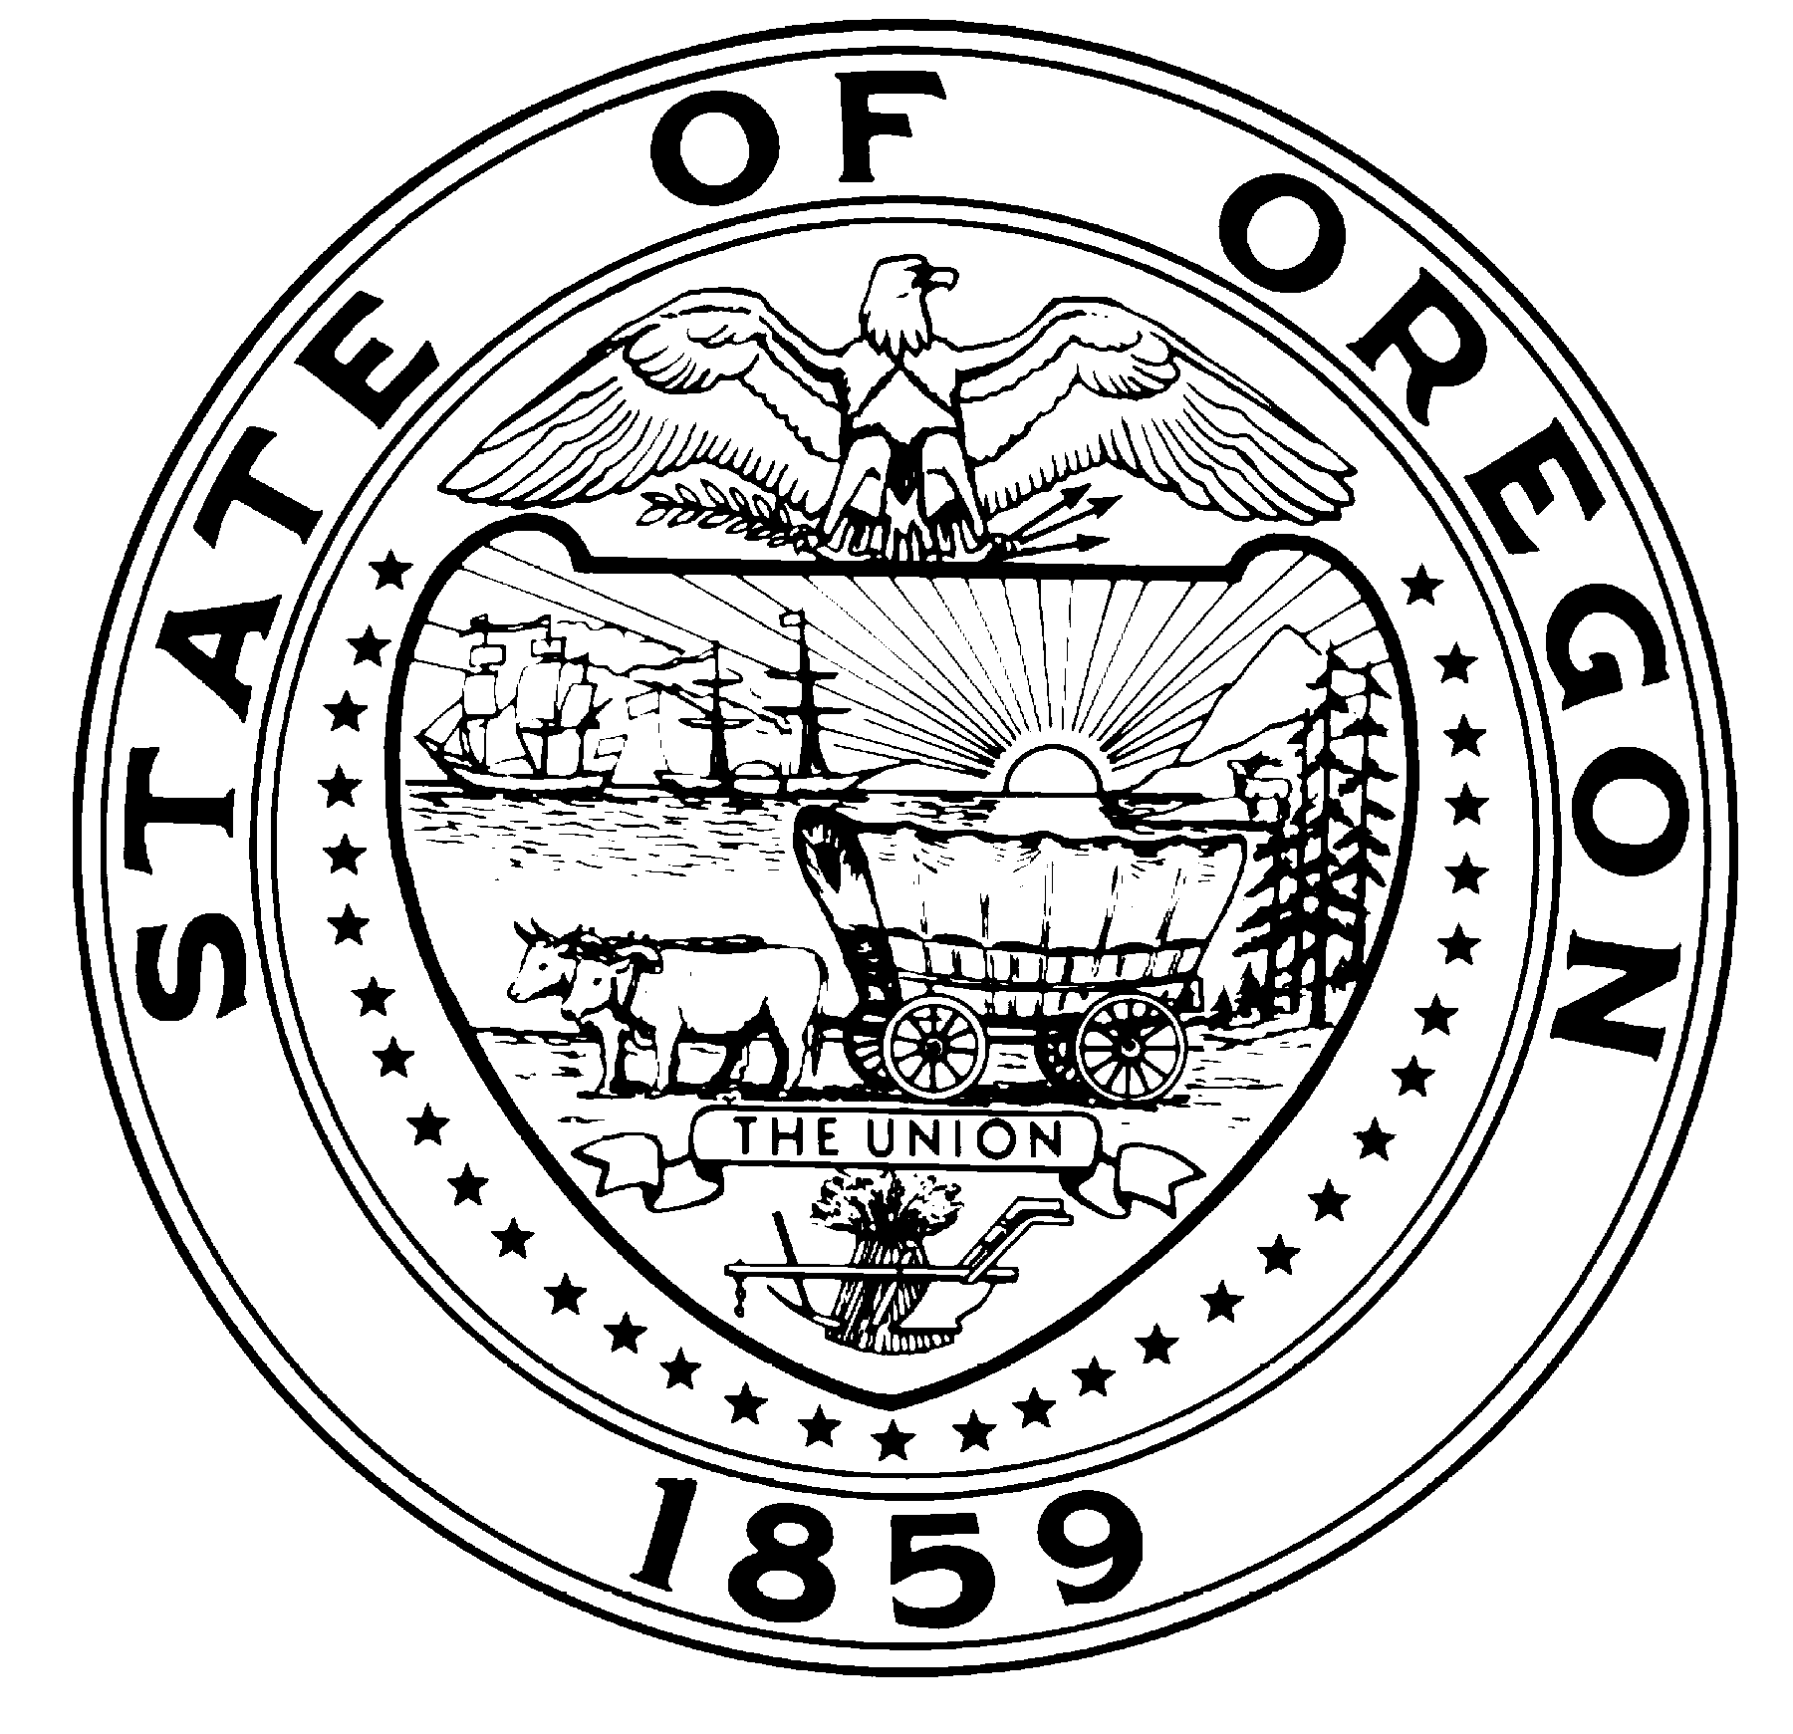

State Library
250 Winter St. NE
Salem, OR 97301-3950
(503) 378-2528

John A. Kitzhaber, MD, Governor

2016 Youth Services Grant Application Guidelines

The vision of the Youth Services Grant program is that children are ready to learn to read when they start kindergarten, read at grade level by 3rd grade, continue to build literacy skills through 12th grade, graduate from high school ready to enter the work force or higher education, and develop a love of reading and life-long learning. Legally established public libraries in Oregon are eligible to apply for this grant.

Enclosed is the “2016 Proposed Youth Services Grants” showing the grants that will be made this grant cycle, assuming all eligible libraries submit applications that meet the grant criteria listed below. As the chart indicates, a total of $(not determined yet) state general funds is available. Enclosed is a list of definitions and descriptions of evaluation options that may help you complete this application.

Youth Services Grants shall be awarded based on all of the following criteria:
- Did you explain how your activities will achieve the outcomes stated at the top of the application for each project you are applying to fund with this grant? If your library would like to develop your own outcomes, please email Katie.Anderson@state.or.us to request an outcome exception form to complete and submit by August 1st.

- Did you explain how you selected one or more specific group of underserved youth your library plans to reach out to or list what organization are you partnering with to reach a specific group of underserved youth? Read the definitions sheet included in this packet to learn who is considered underserved and visit URL to learn how to identify one or more group of underserved youth in your community.

- Did you explain what your library is going to do to make an extra effort to engage that group of underserved youth in your grant funded activities?

- If you are applying to fund summer reading with this grant, are you using the statewide summer reading program (Collaborative Summer Library Program)? If your library would like to use a different summer reading theme and slogan because there is a special occasion in your community next summer, please email Katie.Anderson@state.or.us to request a summer reading exception form to complete and submit by August 1st.

- Did the library director and/or appropriate local official sign page 4?

- Did you put your application in the mail so it will be postmarked by August 31st?
Oregon State Library
Attn: Ready to Read
250 Winter St. NE
Salem, OR 97301.
Funding requirements:
- Grant funds must be separately accounted for and may be used only to provide funding for the purposes described in this application. Here are two examples of ways grant funds may be accounted for separately, 1) have a separate line in your library budget specifically for the Youth Services Grant, or 2) have a ‘Grants’ line in your library budget for all the grants your library receives, including the Youth Services Grant.
- 2016 funding will be distributed by December 31, 2015 to successful applicants contingent on the State Library receiving your 2014-2015 final report.
- 2016 grant funds must be spent by December 31, 2016. Carrying over leftover grant funds to the next grant cycle is not permitted. Contact Katie.Anderson@state.or.us if you are concerned you may not be able to meet this requirement.

Requesting changes to your grant:
- If you shift funding among activities included in this application, then you do not need to get approval from the State Library nor describe it as a change to your grant activities in your report at the end of the year. Applications are based on estimates, actual expenditures will likely change during implementation.
- If you want to change the activities described in your application, then you must email Katie.Anderson@state.or.us to request approval of the change prior to implementing it. You can request a change to your grant at anytime and it will be approved if it meets the grant criteria listed on the front of this cover letter. Having an email trail documenting your request and approval of the change from the State Library is good protection when your library and the State Library get audited.

Dates to mark on your calendar:
- Applications due August 31, 2015
- Grant awards announced November 1, 2015
- State Library Board meeting to hear appeals and approve grants in December XX, 2015
- Checks distributed by December 31, 2015
- Report forms made available October 1, 2016
- Reports due December 1, 2016
- Grant must be spent by December 31, 2016

Outstanding Project Awards:
Two awards per project will be awarded, one selected from larger libraries and one selected from smaller libraries. Award recipients will receive a framed certificate signed by the State Librarian and Chair of the State Library Board of Trustees presented in person by State Library staff or member of the Board of Trustees. Award recipients will make local arrangements for the certificate to be presented at a city council/county commissioners/library board meeting or another local special event at which the library’s key stakeholders will be attending. Award recipients are also encouraged to arrange other activities to leverage local support and public relations for the library. Awards recipients will be selected based on one or more of the following criteria: achieved project outcomes, implemented an innovative project, established a good model for other libraries, and/or developed strong partnerships to more effectively reach underserved youth.

