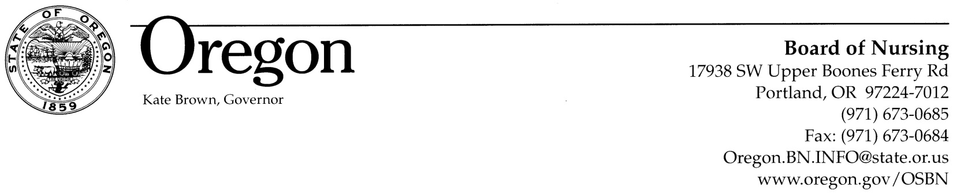

Oregon State Board of Nursing
Meeting Notice

Meeting Date:
Monday, August 17, 2015 – 9:00 am – 11:00 am

Facilitators:
Gretchen Koch MSN, RN
Policy Analyst, Nursing Practice and Evaluation

Christy Cowgill, MNA, CRNA, APRN
Policy Analyst, Advanced Practice Nursing

General Topic:
Division 45: Proposed amendments include setting-neutral language, newly defined terms, codification of the licensee’s responsibility to professional practice and performance standards.

Division 52: Certified Registered Nurse Anesthetists. This division is undergoing important proposed revisions to include office sedation language (in response to HB 3326, 2015 session) and re-entry of CRNA into practice. The proposed language also modernizes this division to guide regulation of the profession, educational standards, and continuing safe practice.

Registration Required:
Registration is required due to limited seating. To register, contact Nancy Goodding at nancy.goodding@state.or.us. Meeting materials will be sent with registration confirmation and will not be available online.

Public Attendance and Location:
Oregon State Board of Nursing Conference Room. The Board offices are located at 17938 SW Upper Boones Ferry Road, Portland, Oregon.

The meeting location is accessible to persons with disabilities. A request for an interpreter for the hearing impaired or for other accommodations for persons with disabilities should be made at least 48 hours before the meeting to Peggy Lightfoot, 971-673-0638. For individuals with hearing or speech impairments, the Oregon Relay System provides free assistance for all telephone communications. If initiating a call by TTY, dial 1/800-735-1232. The Oregon Relay Service can also be reached by dialing 711 on your TTY or telephone within Oregon.

