For questions the group had:
For Text Messages most don’t put an automated note into ONE for workers, exception is returned mail. However the worker portal portion of ONE that staff use has a View SMS Reminders section. And workers can look up by phone number or other items the messages that were sent to individuals. Here is a screen shot of the search function:
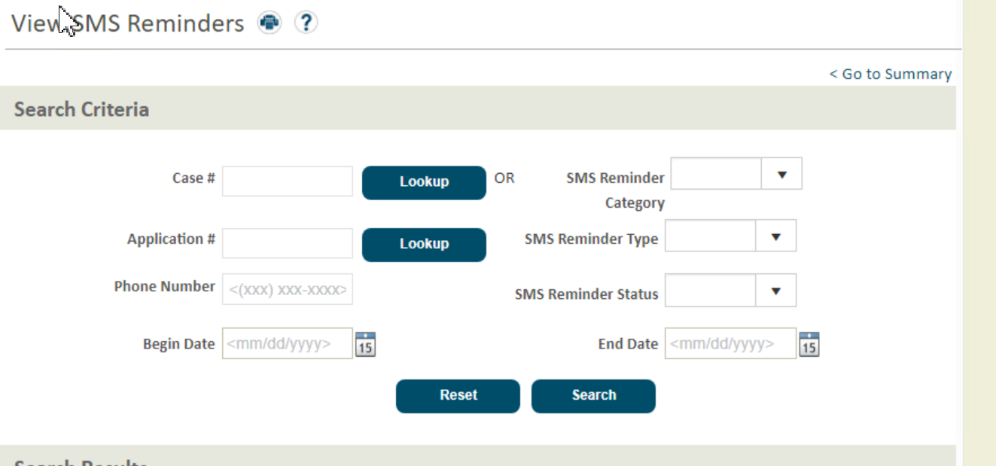

On the Dashboard updates:
Are target is by May 23 to release an update that has the dashboard having County and Demographic level information.
June 21 we would then add details around closure reasons, where individuals transitioned to (marketplace, medicare savings program, etc), and where we are awaiting action for an application and whether these counts are for system action, worker action, or Oregonian action.
Finally, hoping for early July to add operational production and timeliness information.

Thanks!

Nathan Singer
Director, Oregon Eligibility Partnership (OEP)
Oregon Department of Human Services
nathan.m.singer@dhsoha.state.or.us

