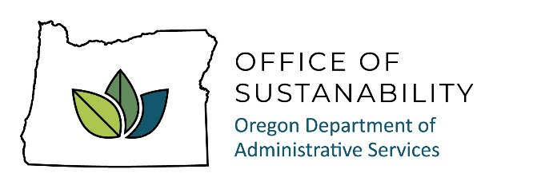
AGENDA

Interagency Sustainability Coordinators Network (ISCN)
Meeting Date: Wednesday, February 18, 2025

Time: 1:30 to 3:00 pm

Microsoft Teams – See Calendar Invite

ITEM | PRESENTER | TIME | ACTION/NOTES
Welcome
Welcome, introductions to new members.  Quick announcements. Refresher on ISCN. Schedule for 2025. | Dave Wortman, DAS, All | 1:30-1:50 | Convene group, introductions, review agenda.
Oregon Sustainability Board | Josh Proudfoot, Board Member (tentative) | 1:50-2:15 | Purpose of the Sustainability Board, work planning, support for agencies. Questions from agencies.
Office of Sustainability 2025 work plan and statewide policy recap  2025 legislative session and sustainability-related bills | Dave Wortman, DAS | 2:15-2:30
Breakout discussion and report out: what are your challenges? Where do you need support? | Dave Wortman, DAS | 2:30-3:00
Adjourn |  | 3:00

Next meeting: Wednesday, April 2, 1:30 pm, Teams

