Live Web Streaming Instructions

It is recommended that you test your computer workstation regularly to ensure you can access the live video stream. See below for instructions.

Setting up and Testing Your System:
  - Open your browser and enter: http://codian.utahtelehealth.net on the address line.
  - Enter 999 in the ‘Recording ID’ field (this is a test recording).
  - Leave the ‘PIN’ field blank.
  - Select ‘Highest Rate’ using your preferred media (Real Player, Quick Time, or Windows Media) in the Media field.
  - Press the ‘Stream this Recording’ button.
  - Wait a few moments. If the recording begins and you have good audio, your system is ready. No other set up is necessary.
  - If the video screen remains blank, click the link to download the necessary software to view the stream. This software is downloaded directly from the Utah Telehealth Network Codian Web Streamer and has been verified as safe.

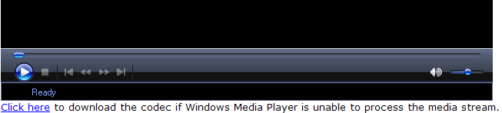

  - Click Run and follow the on-screen directions to install this software.
  - Close your browser and begin this procedure from the beginning. You need not reboot your machine.
  - If you are unable to install this software, contact your computer support person.

If you do not see the video stream or have no audio:
      - Check with your system administrator and ensure that Web Streaming & software downloading is allowed on your network.
      - Your computer support contact may call the Utah Telehealth Network at (801) 585-2426.

Connecting to a live presentation:
You can connect up to 15 minutes before the live presentation starts.
- Open your internet browser and enter: http://codian.utahtelehealth.net on the address line.
- On the Codian web page: Enter the appropriate ‘Recording ID’. Call the UTN Scheduling Coordinator for the recording ID.
- Leave the ‘PIN’ field blank
- Select ‘Highest Rate’ using your preferred media in the Media field.
- Press the ‘Stream this recording’ button.

