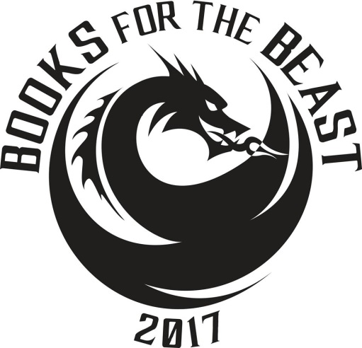

**WHAT?** The 14th Margaret Edwards Day: Books for the Beast 2017 Young Adult Literature Conference.

**WHEN?** Saturday October 28th, 2017

**WHERE?** Roland Park Country School, 5204 Roland Avenue, Baltimore MD, 21210

**Teen readers are highly encouraged to attend and are free of charge!**

**PROGRAM SCHEDULE:**

**8:30 a.m.** Registration Packets & Refreshments

**9:30 a.m.** Keynote: Ellen Oh

Author of *The Prophecy Series* and the editor of *Flying Lessons*

**10:45 a.m.** Discussion Groups

**12:15 p.m**. Lunch, Author and Artist Signing

**1:15 p.m.** Afternoon Discussion Groups

**2:40 p.m.** Non-Fiction Graphic Novels Jim Ottaviani

Author of graphic novels *Primates and Imitation Game,* and

Maris Wicks, illustrator of *Primates* and *Science Comics: Coral Reefs*

**3:40 p.m.** Evaluations & Reception to Go.

**Registration for adult readers: non-refundable $100 (includes lunch, coffee breaks, and Reception to Go)**

**For More Information: Teen Readers Welcome Contact:**

**Web:** [www.prattlibrary.org/beast](http://www.prattlibrary.org/beast) Jennifer Ralston

**Facebook:** Books for the BeastTelephone: 410-273-5654

**Email:** [beast@prattlibrary.org](mailto:beast@prattlibrary.org)Fax: 410-273-5606

**Telephone:** 410-396-5356 [ralston@hcplonline.org](mailto:ralston@hcplonline.org)

**Fax:** 866-286-1567

**BOOK LIST**

(each participant will select two theme discussion groups)

IT’S NEVER TOO LATE:

***Primates: The Fearless Science of Jane Goodall, Dian Fossey, and Biruté Galdikas***

Jim Ottaviani** and Maris Wicks**

***Every Falling Star: The True Story of How I Survived and Escaped North Korea***

Sungju Lee and Susan McClelland

***Dumplin’*** Julie Murphy

***Ten Days a Madwoman: The Daring Life and Turbulent Times of the Original “Girl” Reporter, Nellie Bly*** Deborah Noyes

***If I Was Your Girl*** Meredith Russo

AT ODDS:

***Prophecy*** Ellen Oh**\***

***Lucy and Linh*** Alice Pung

***Scythe*** Neal Shusterman

***Nimona*** Noelle Stevenson

***The Hate U Give*** Angie Thomas

OWN WHO YOU ARE:

***Flying Lessons & Other Stories*** Edited by Ellen Oh**\***

***Bright Lights, Dark Nights*** Stephen Emond

***Air*** Ryan Gattis

***The Porcupine of Truth*** Bill Konigsberg

***The Sun Is Also a Star*** Nicola Yoon

EVERY MOMENT MATTERS:

***Imitation Game: Alan Turing Decoded*** Jim Ottaviani**, Illustrated by Leland Purvis

***The Wrath & the Dawn*** Renee Ahdieh

***Under a Painted Sky*** Stacey Lee

***Burn Baby Burn*** Meg Medina

***Out of Darkness*** Ashley Perez

*Keynote Speaker

**Featured Speaker

SINK OR SWIM:

***Breakfast Served Anytime*** Sarah Combs

***Girl At War*** Sara Nović

***Gabi, A Girl in Pieces*** Isabel Quintero

***History Is All You Left Me*** Adam Silvera

***The Serpent King*** Jeff Zentner

DON’T GIVE UP:

***Black Panther: A Nation Under Our Feet, Book One***

Ta-Nehisi Coates, Illustrated by Brian Stelfreeze

***It Ain’t So Awful, Falafel*** Firoozeh Dumas

***Girl In the Blue Coat*** Monica Hesse

***Salt to the Sea*** Ruta Sepetys

***Samurai Rising: The Epic Life of Minamoto Yoshitsune***

Pamela S. Turner,Illustrated by Gareth Hinds

